SWCD Board of Directors’ Meeting September 12, 2022
In attendance:
Directors: Meg Kennedy (Ch), Helene Kraham, Jennifer Mickle, Ed Lentz, Darin Hickling District staff: Karl Jiroux, Chris Andreassen, Dan Zimmerman Others:
Minutes taken by Ed Lentz. Agenda is attached.
Vice Chair Darin Hickling opened the meeting at approximately 8:35.
Motion by Helene, seconded by Jennifer, to go into executive session to discuss the employment history of particular persons and matters leading to the employment of particular persons including to interview candidates for the District Manager position with each candidate present during their interview. Motion passed 4-0 with Meg absent. Meg joined the meeting at approximately 8:38.
Motion by Ed, seconded by Jennifer was made to close the executive session at 11:06. Motion passed 5-0.
Karl, Dan and Chris gave verbal reports of activities. Chris, who provided a written summary activity report, attached, reported that he has been doing soil samples for Round 16 AEM, assisting with the closeout of the Buffer grant, doing WRP monitoring for NRCS in addition to other activities in the written summary. Karl reported that he has been working on grant closeouts, helping Chris with the soil sampling, and doing ag assessments. Karl did not have the AEM hour tracker as per the board’s request but he is keeping it current and will provide it to the board. Karl reported that the cover crop program is getting under way. Dan reported that he has been mowing a weed-wacking around the cabin and office in addition to working on management plans. Planning and logging in Hickory Hills (15), Cooperstown Junction (11), and OC Forest #12 are impeded by a lack survey markers and property deeds. Dan handed out a NYFO paper describing the perils of logging without surveyed boundaries.
Meg will talk to Hank Schecher and Kathy Gardner about getting copies of the deeds to 11, 12, and 15.
Chris and Dan left when staff reports were completed.
Motion by Jennifer, seconded by Darin, to approve invoices bearing voucher numbers 26 to 33 (Abstract # 2 of 2022) totaling $11,673.46. (Voucher # 33 comprised two Green Circle invoices) was discussed. Motion passed 5-0.
Motion by Jennifer, seconded by Daring, to approve the minutes of the 8/8/22 and 8/22/22 meetings. Motion passed 5-0.
Review of the July financial reports was deferred pending resolution of Ed’s questions from the prior meeting. No reports were available for August. Ed reported balances available for general operations as follows:
SWCD, Cash, 9/8/22
 | Most Recent Statements | 9/8/22
Checking (0768) | $40,967.29 | $17,711.95
Savings (9344) | $188,018.94
Savings (1271) | $5,234.31
Other (approx.) | $6,976
TOTAL | $241,196.81
Motion by Helene, seconded by Darin, to approve the cash report was discussed. Motion passed 5-0.
Ed has not been able to transfer money from Savings to checking on line and needs to resolve the issue with the bank. Ed reminded the board that we should put out an RFP for banking services as soon as practicable.
Meg reported that AGM officially closed out the Tafel grant. That bank account, which has ~$1K in it, can now be closed and the money transferred to checking. AGM also “owes” the district ~$1K in reimbursement for the Tafel project.
The McGrath closeout was updated and is under review by AGM.
Beecher is also under review by AGM.
Hughes and Buffer are in progress. Karl is meeting with Jordan Bros this week. Karl will seek Scott’s guidance re: making a payment to Seamon and come back to the board with a recommendation (and, if he requests that a payment be made, with a Procurement Checklist and Payment Request).
Karl submitted a request for 25% of AEM Round 17 funding ($230K).
Meg also reported that P.J. Emerick will provide another training session at our 9/26 meeting.
Meg reminded the board that we do not have a finalized 2022 budget but that we need to prepare one for 2023. Ed requested that we use the QB line items rather than the line items in previous budgets.
Jennifer reported that Westford is requesting reimbursement in the amount of $4,113 for culvert work that was to be paid for out of a grant from Assemblyman Miller’s office. Meg will speak with Assemblyman Miller’s office about this.
Meg will ask Chris to put the upcoming September and October meetings (9/23 @
1:00pm, 9/26 @ 1:00pm, 10/10 @ 10:00am, 10/24 @ 1:00pm, all at The Meadows, Classroom B) on the website. Karl will post notice on the District bulletin board. Meg will post notice on the county bulletin board. Ed will notify the DS.
Motion by Helene, seconded by Jennifer, to adjourn. Motion passed 5-0.
Meeting was adjourned at 12:38.
Next Meeting: 9/23 @ 1:00pm, Meadows, Classroom B.

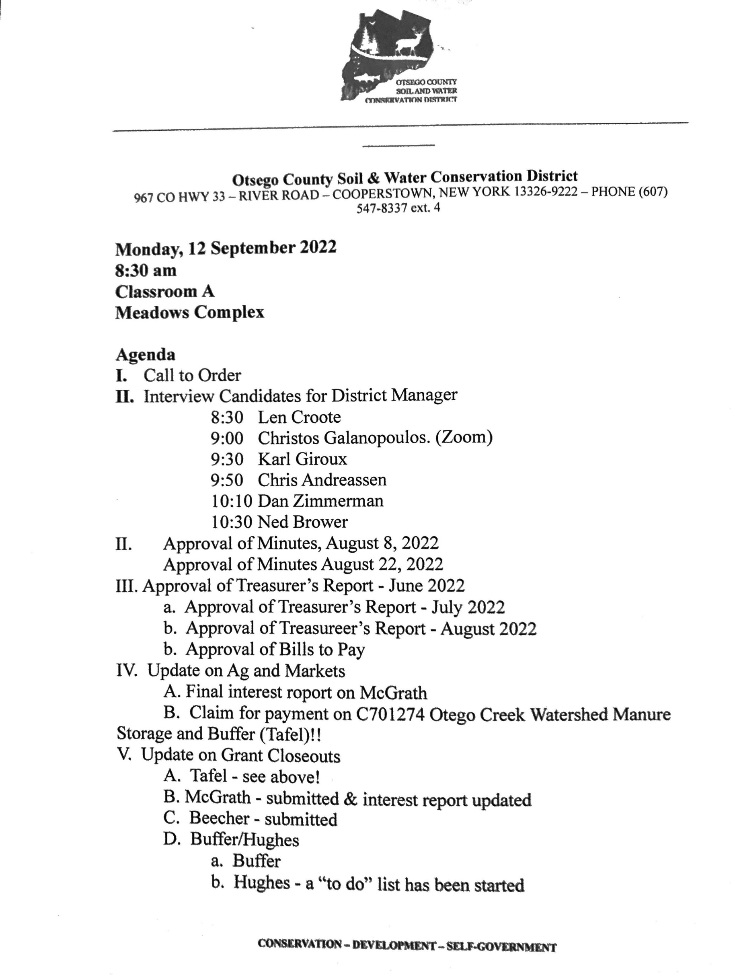
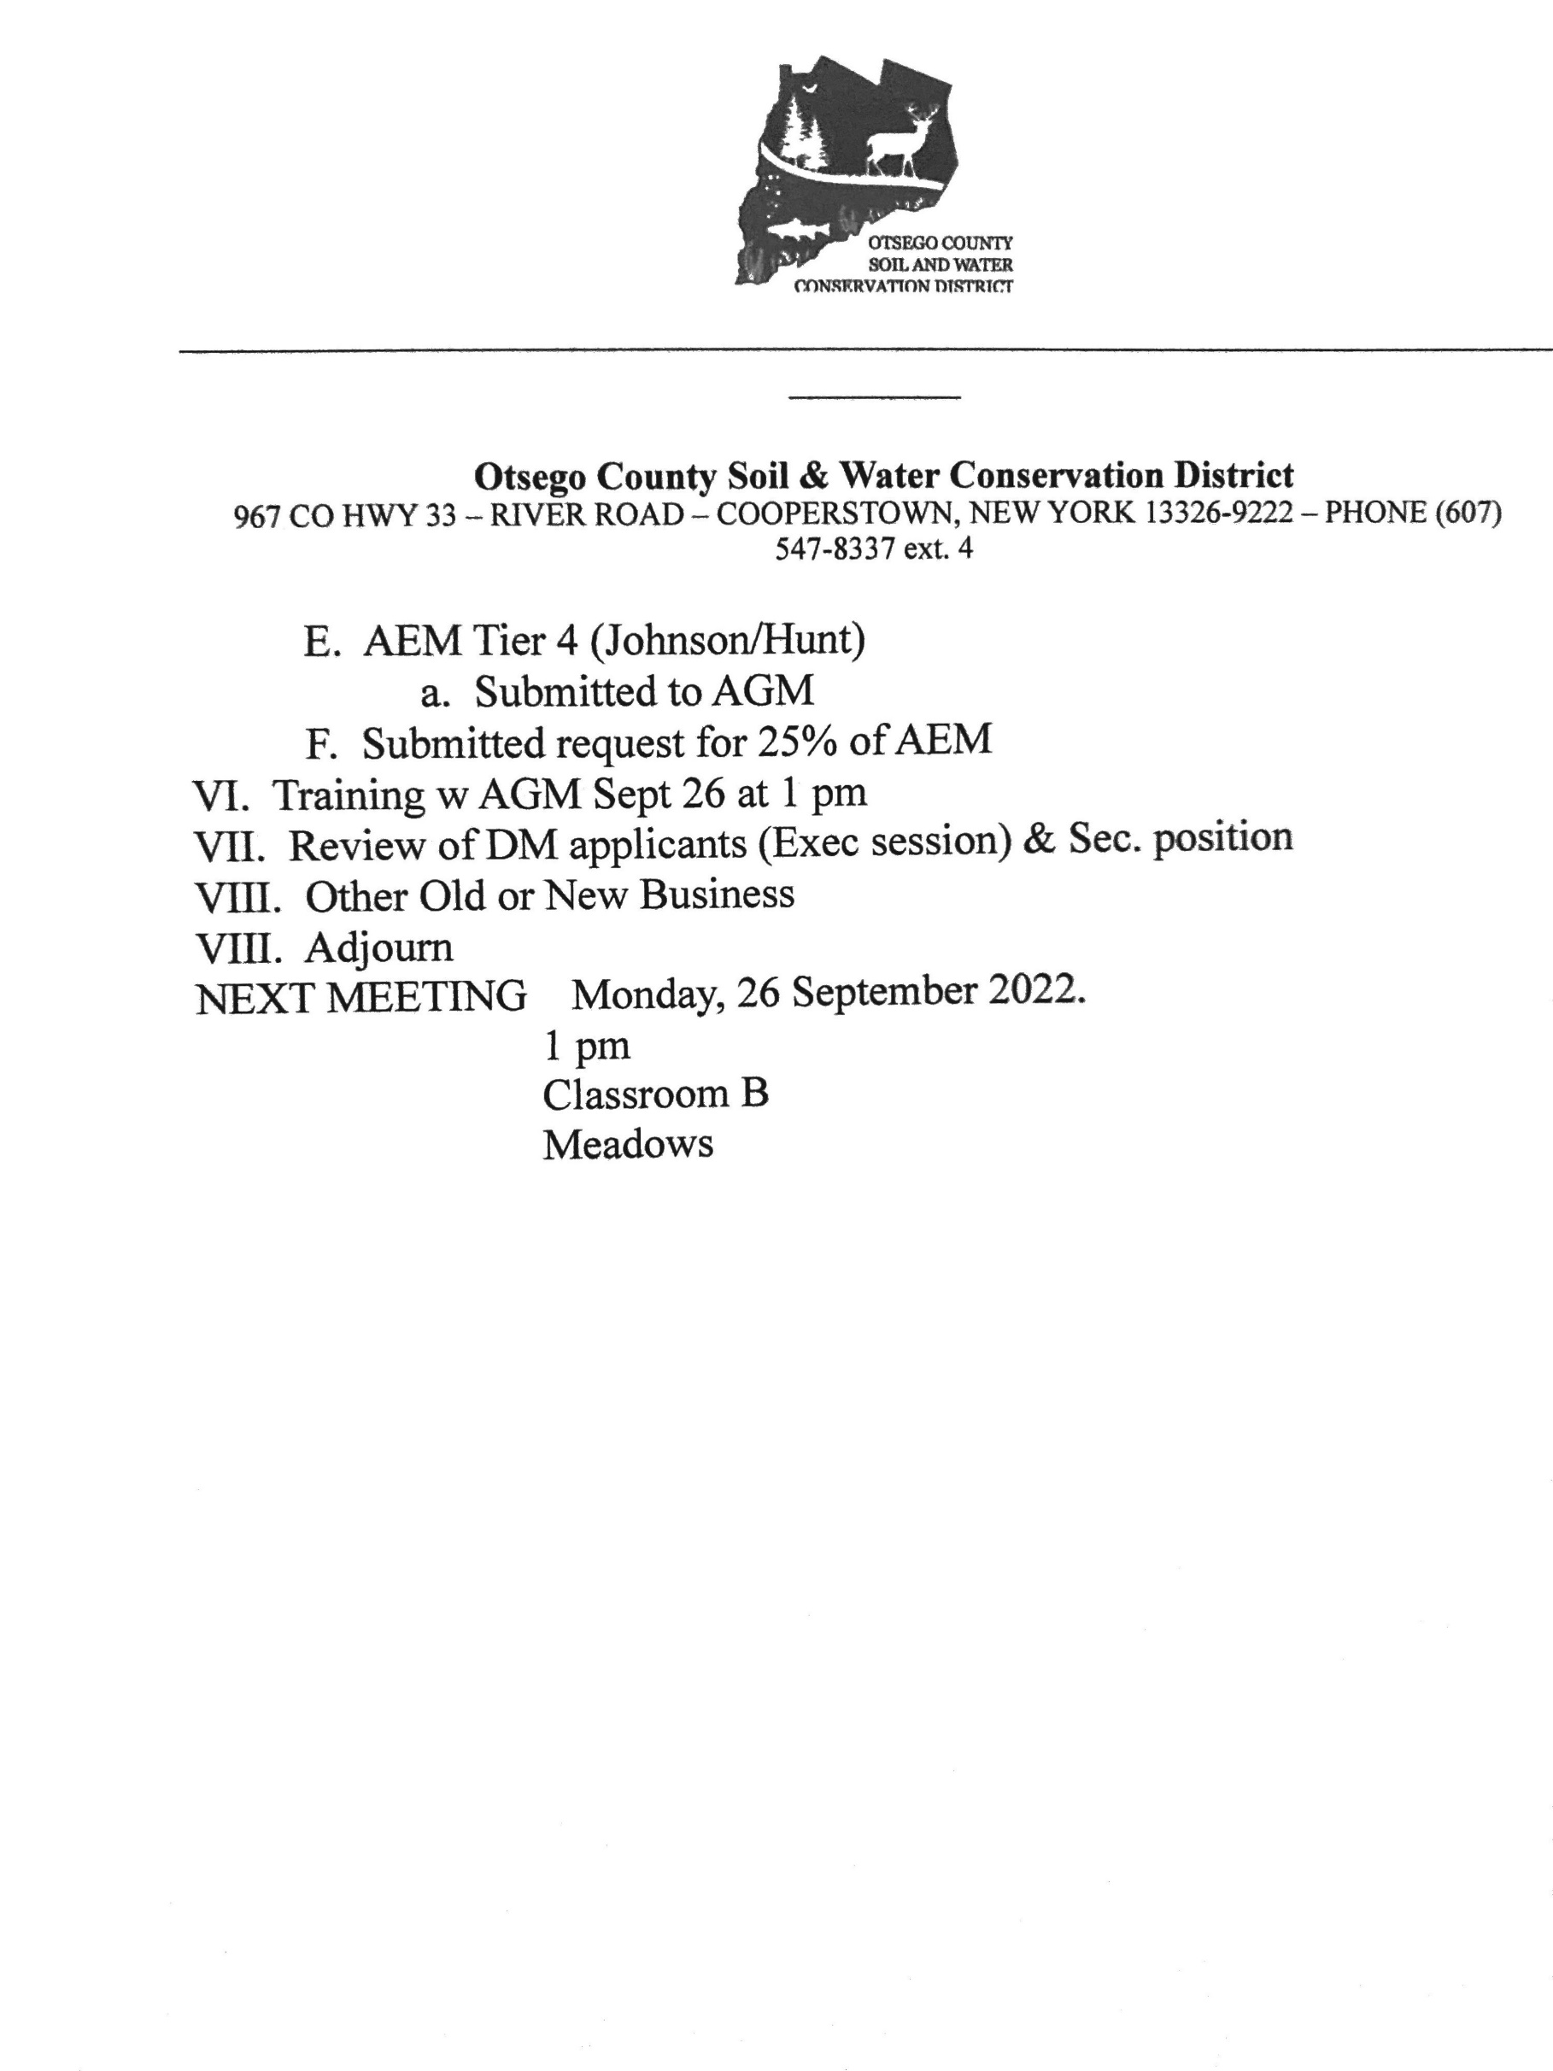

OCSWCD Abstract #2 - September 12, 2022
Invoice # | Invoice $ | Vendor
26 | $482.34 | Leaf
27 | $966.00 | United Concordia
28 | $509.88 | Verizon
29 | $4,641.39 | Excellus
30 | $87.49 | Otsego Coounty
31 | $2,529.86 | Cincinnati Insurance
32 | $725.00 | Mike Ross Cleaner
TOTAL | $9,941.96
Approved for payment by Board of Directors on Sept. 12, 2022
1
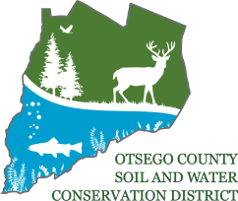
_________________________________________________________________________________

Otsego County Soil & Water Conservation District 967 CO HWY 33 – RIVER ROAD – COOPERSTOWN, NEW YORK 13326-9222 – PHONE (607) 547-8337 ext. 4

Chris Andreassen
Board Report
8/5-9/8/2022

AEM #077-0536 CNMP:
- Animal Waste Management plan
- Manure Spreading Setback Maps (7 farms)
- Spreadable Acres calculations
- Farm visit/inventory

AEM #077-0538 CNMP:
- Tier 1
- Tier 2
- Farm maps/ environmental resource maps
- Brewery Sludge data collection/communication with Cornell
- Animal Waste Management plan
- Nutrient Management Planning (Cropware)
- Soil erosion prediction (RUSLE2)
- Cropland planning/maps (17 farms)
- Farm visit/inventory Misc.
- Buffer Grant (Seamon, Jordan, Mitchell)
- WRP monitoring completed and billing statement created/submitted
- USDA Lincpass update

Trainings:
- 2022 Sustainable Agronomy Conference: Exploring the Present and Future of Carbon and
Ecosystem Services Markets (CCA)
- Understanding Biologicals for Row Crop Production (CCA)
- Implementing AEM on New York State Grown and Certified Farms 4. CAFO Webinar
CONSERVATION – DEVELOPMENT – SELF-GOVERNMENT

SWCD Minutes 9/23/22 Approved, 9/26/22
SWCD Board of Directors’ Meeting September 23, 2022
In attendance:
Directors: Meg Kennedy (Ch), Helene Kraham, Jennifer Mickle, Ed Lentz, Darin Hickling District staff: Karl Jiroux Others:
Minutes taken by Ed Lentz.
Chair Meg Kennedy opened the meeting at 1:10pm.
Meg reported that Jenna Utter is still undecided about taking the DS position over concerns about the salary and days off. A motion by Helene seconded by Meg to improve the offer was discussed and passed unanimously.
A motion by Darin seconded by Ed to increase the salary offer to $54K and to provide two additional personal days during the first year, bringing the total days off from 6 to 9 during the first year, was discussed and passed unanimously.
Meg reported that she will be attending the NYACD meeting in Cazenovia on 10/19. Helene offered to attend so the district will have two directors present.
Karl reported that progress is being made on the Buffer grant closeout. Chris Has been very effective and efficient at gathering needed information and documents from landowners.
The board discussed the draft tentative budget and completed the revenues section and made a start on the appropriations section.
A motion by Meg seconded by Darin to go into executive session to discuss the employment history of particular persons and matters leading to the employment of particular persons including to interview candidates for the District Manager position with each candidate (Christos Galanopoulis and Karl Giroux) present during their interview was passed unanimously.
The board entered executive session at 2:30.
The board exited executive session and then adjourned the board meeting on motions by Meg, seconded by Darin and approved unanimously.
The meeting was adjourned at 4:45pm.
Next meeting: September 26, 1:00pm, Meadows Classroom B.

SWCD Board of Directors’ Meeting September 26, 2022
In attendance:
Directors: Meg Kennedy (Ch), Helene Kraham, Jennifer Mickle, Ed Lentz District staff: Karl Jiroux Others:
Minutes taken by Ed Lentz.
Chair Meg Kennedy opened the meeting at 1:00pm.
The cost of renewing the subscription to the Daily Star was discussed. It was generally agreed that while it has become expensive, we should renew it.
A motion was made and seconded to approve the minutes of the 9/12/22 and 9/23/22 meetings and approved unanimously.
Ed presented the August 2022 YTD P&L. A motion to approve the P&L was made by Jennifer, seconded by Helene and, following discussion, approved by unanimous vote.
A motion to approve payment of bills 30-32 on Abstract 3-2022 totaling $456.74 was made by Jennifer, seconded by Helene and, following discussion, approved by unanimous vote.
The grant close outs were discussed. Meg emphasized the importance of accelerating progress with the two remaining close outs Buffer (277, Mitchell, Seamon, Jordan Bros) and Hughes (275).
Karl reported that Buffer is ~90% ready. He will meet with Scott for advice on Wednesday (9/25) and expects that we can submit it the week of October 10. He will use the procurement checklist for board review and approval of payment requests and the closeout checklist for board review and approval of grant close out submission. Karl will have a complete package for review by Meg and Ed on Thursday, 10/6, at 10:00am at the district offices.
Karl reported that progress on Hughes is more difficult. Foundational documents, information and progress reports/records are lacking. Karl and Chris are having to build the kind of file that should have been in place from the beginning. NRCS is being very helpful.
Meg reported that there was a miscommunication re: training and so there would be no training session today. Meg will advise Scott that we would like to receive District Law training at our meeting on 10/24.
Regarding reimbursement by the state of culvert work by the Town of Westford, Meg has reached out to Assemblyman Miller’s office and expects to speak with them soon.
Progress towards achievement of the 2022 Performance Measures was discussed. We are well positioned to achieve and likely will achieve PM’s 1 and 5 but discussion focused on PM’s 2-4 because there are no points for PM’s 1 and 5 this year due to COVID. The form is unclear but it appears that Criteria 2 (a) and (b) are combined for 2022 and we have achieved three or more of these criteria.
PM 2c): We intend to submit an APOW by November 1.
PM 3: Achievements include DEC permitting on a project in Unadilla; cooperation with the Otsego Lake Association; collaboration with NRCS; AEM work; and collaboration with USC.
PM 4: Achievements include AEM; Ag Value Assessments; Stream Corridor Management (Mark); CRF.
Ed circulated by email our 2021 Performance Measure Evaluation Report for Conservation Financial Assistance.
Karl reported on achievement of our AEM goals. The board discussed realistic expectations for hours this year and next. We should have no trouble earning at least the 25% that we’ve requested. The board settled on $23K as a reasonable projection of AEM revenue in 2023.
2023 Revenue and appropriations were discussed and progress was made on developing a 2023 budget. . See, draft budget, attached. (The insurance premium amount was added post-meeting because there was insufficient information available during the meeting.) Questions remain for further clarification and discussion before budget can be adopted.
There was consensus that we should have the building inspected by a building inspector to identify problems before they become major problems and that we should begin undertaking more routine maintenance of the building such as painting, replacing carpets, repairing/replacing doors and windows, repairing/replacing gutters, etc. The value of setting up a reserve(s) for anticipated future expenses, e.g., for vehicles, equipment, buildings, etc., was recognized. The board agreed that in 2023 we should replace the Equinox with a new SUV. Consideration will be given to replacing it with an EV.
Meg reported that Dan elected not to put himself forward as a candidate for the DM position.
A motion by Ed seconded by Jennifer to go into executive session to discuss the employment history of particular persons and matters leading to the employment of particular persons was passed unanimously at about 3:15pm. Karl left the meeting.
A motion to end the executive session was made by Ed, seconded by Jennifer and passed unanimously at 3:45pm.
The policy on vacation time and personal days was discussed. A motion was made by Helene and seconded by Jennifer to set vacation at:
- five days per year during year one;
- ten days per year during years two through five;
- 15 days during years six through ten;
- 20 days years during year 11 and each year thereafter and to allow three personal leave days per year on hiring.
After discussion, the motion was passed unanimously.
(No changes to the policy regarding carry over and unused vacations days was made.)
A motion was made by Jennifer and seconded by Helene to off the DM position to Christos Galanopolous at $60K/y subject to reference checks. After discussion, the motion passed unanimously.
Meg will advise Jenna Utter about the changes to the vacation and personal leave policies.
The board discussed awarding stipends to Karl, Chris, and Dan in consideration for the added work taken on during the time since Jordan left and whether or not the district had sufficient funds to give such stipends. A motion was made by Jennifer and seconded by Helene to award stipends to Karl, Chris, and Dan in the amounts of $6K, $4K, and $3K, respectively. After further discussion, the motion was approved unanimously.
Meg will follow up with the two candidates for the open board seats.
In view of the fact that October 11 is a holiday, it was agreed to hold the October 11 meeting at the district office. A note will be placed on the classroom door director attendees to the district office.
The meeting was adjourned following a motion by Jennifer, seconded by Ed and passed unanimously at 4:10pm.
Next Meeting: October 11, 10:00am, District Office

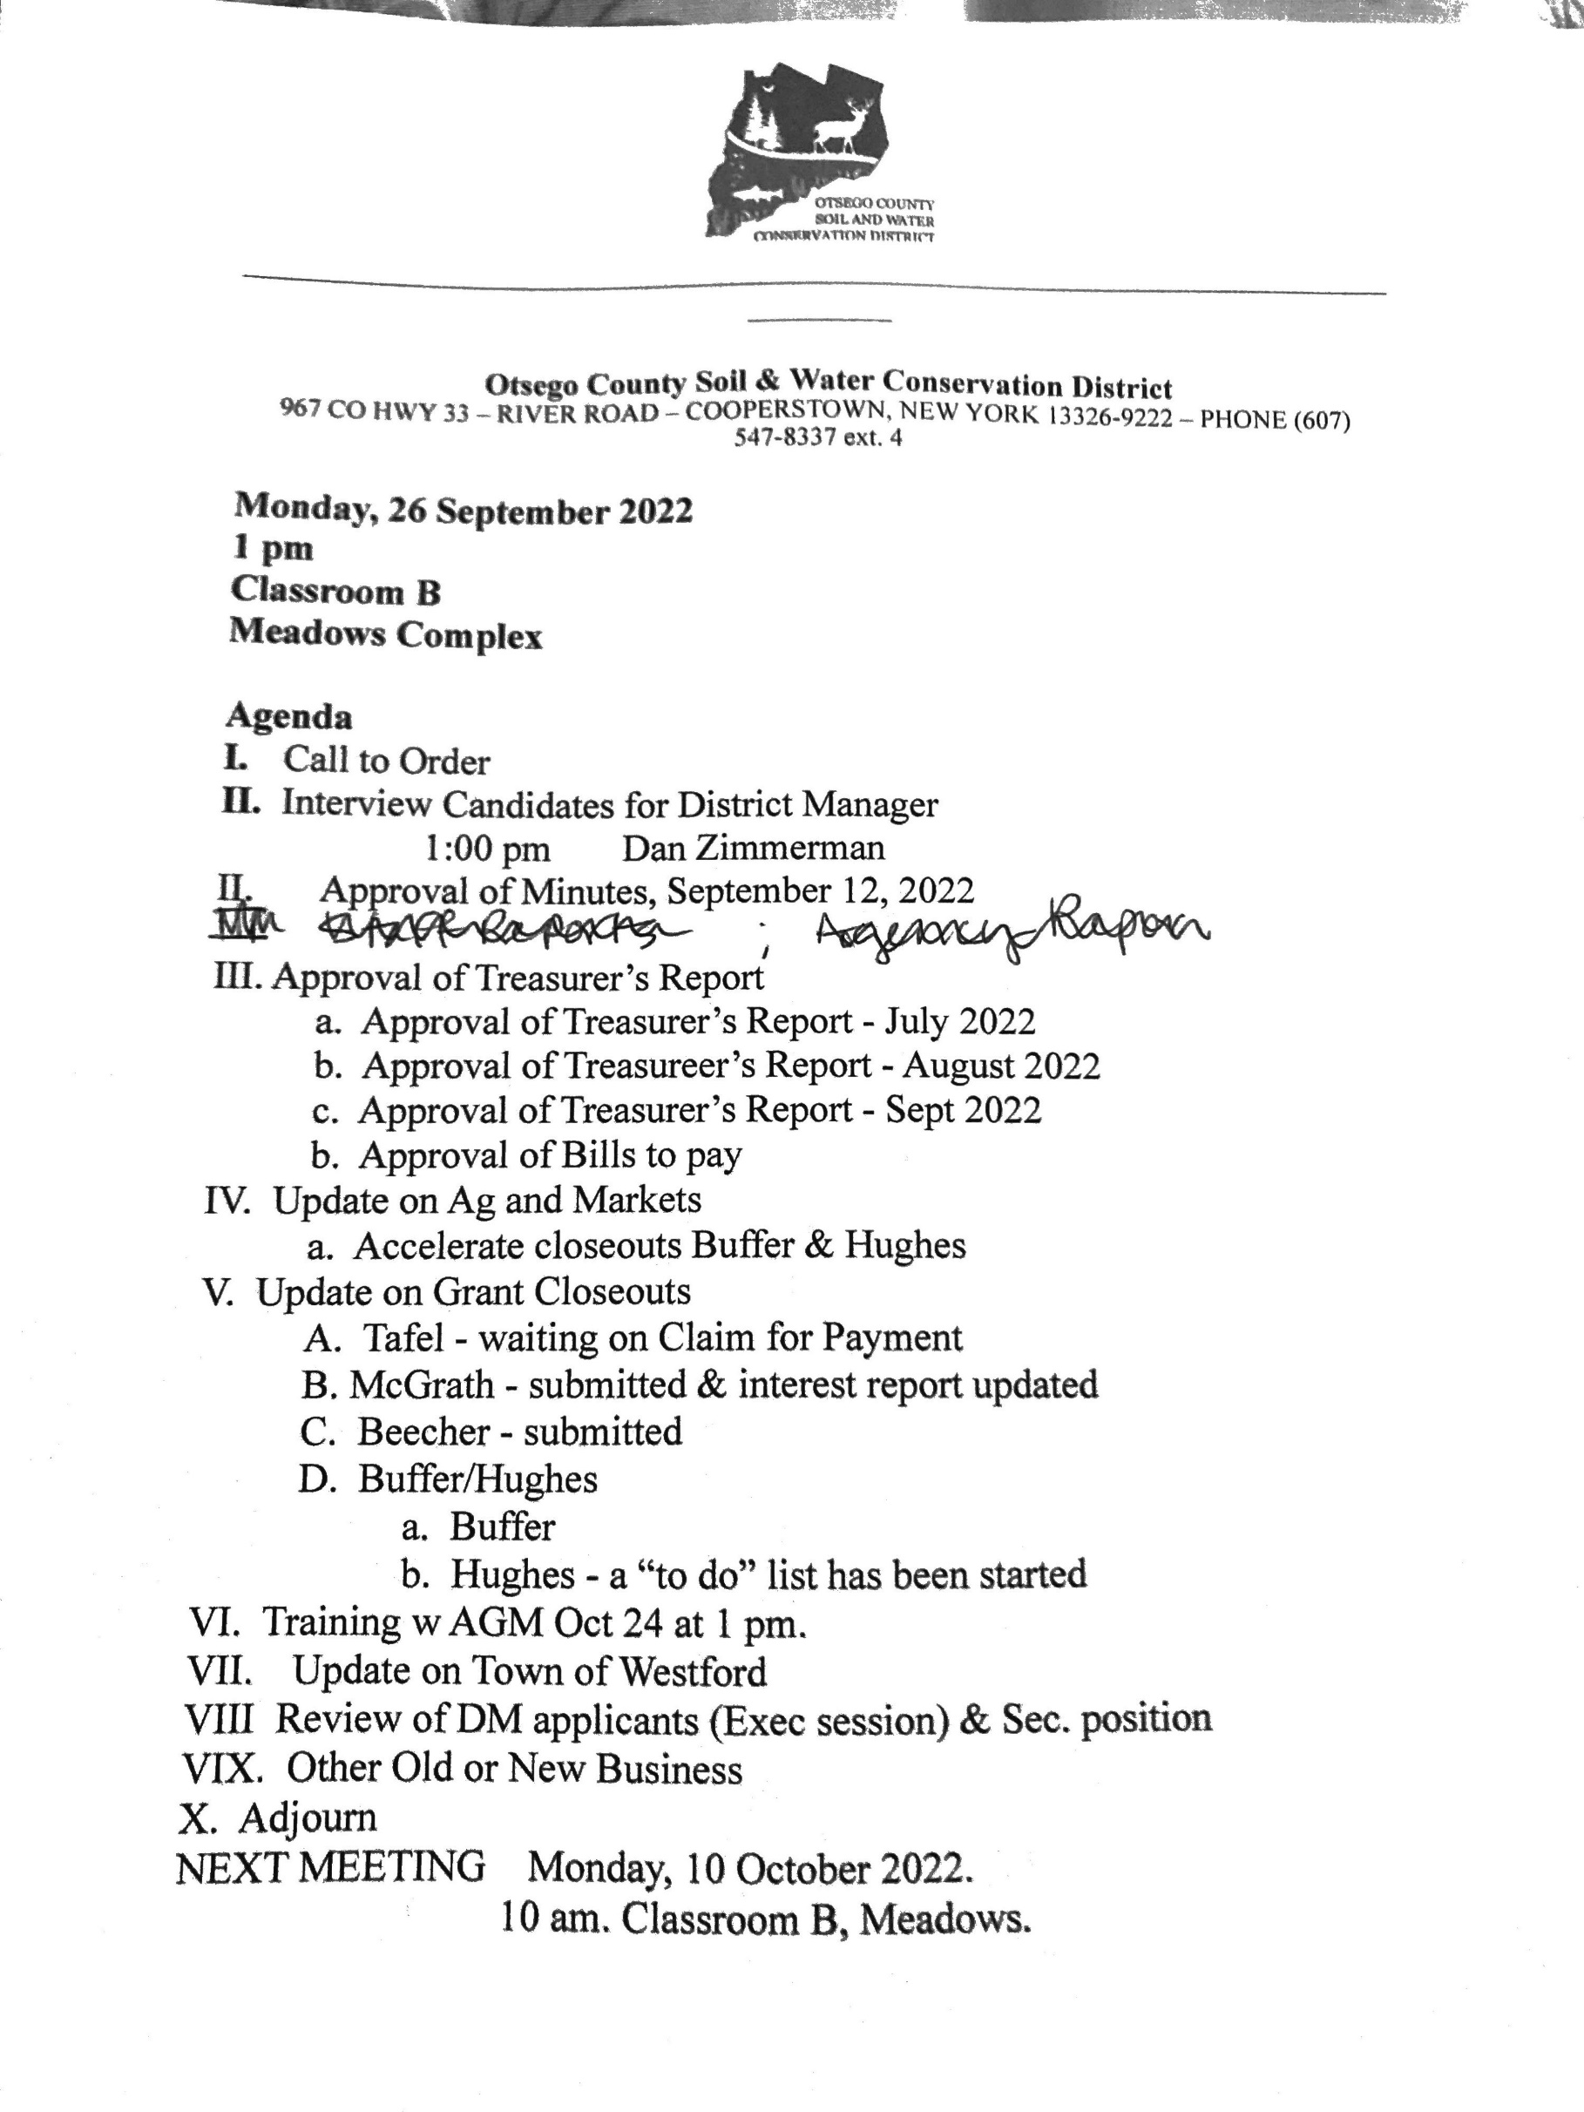

OCSWCD Abstract #3 - September 26, 2022
Invoice # | Invoice $ | Vendor
30 | $139.98 | Spectrum
31 | $26.76 | Ed & Ed
32 | $290.00 | The Daily Star
TOTAL | $456.74
Approved for payment by Board of Directors on Sept. 26, 2022
1

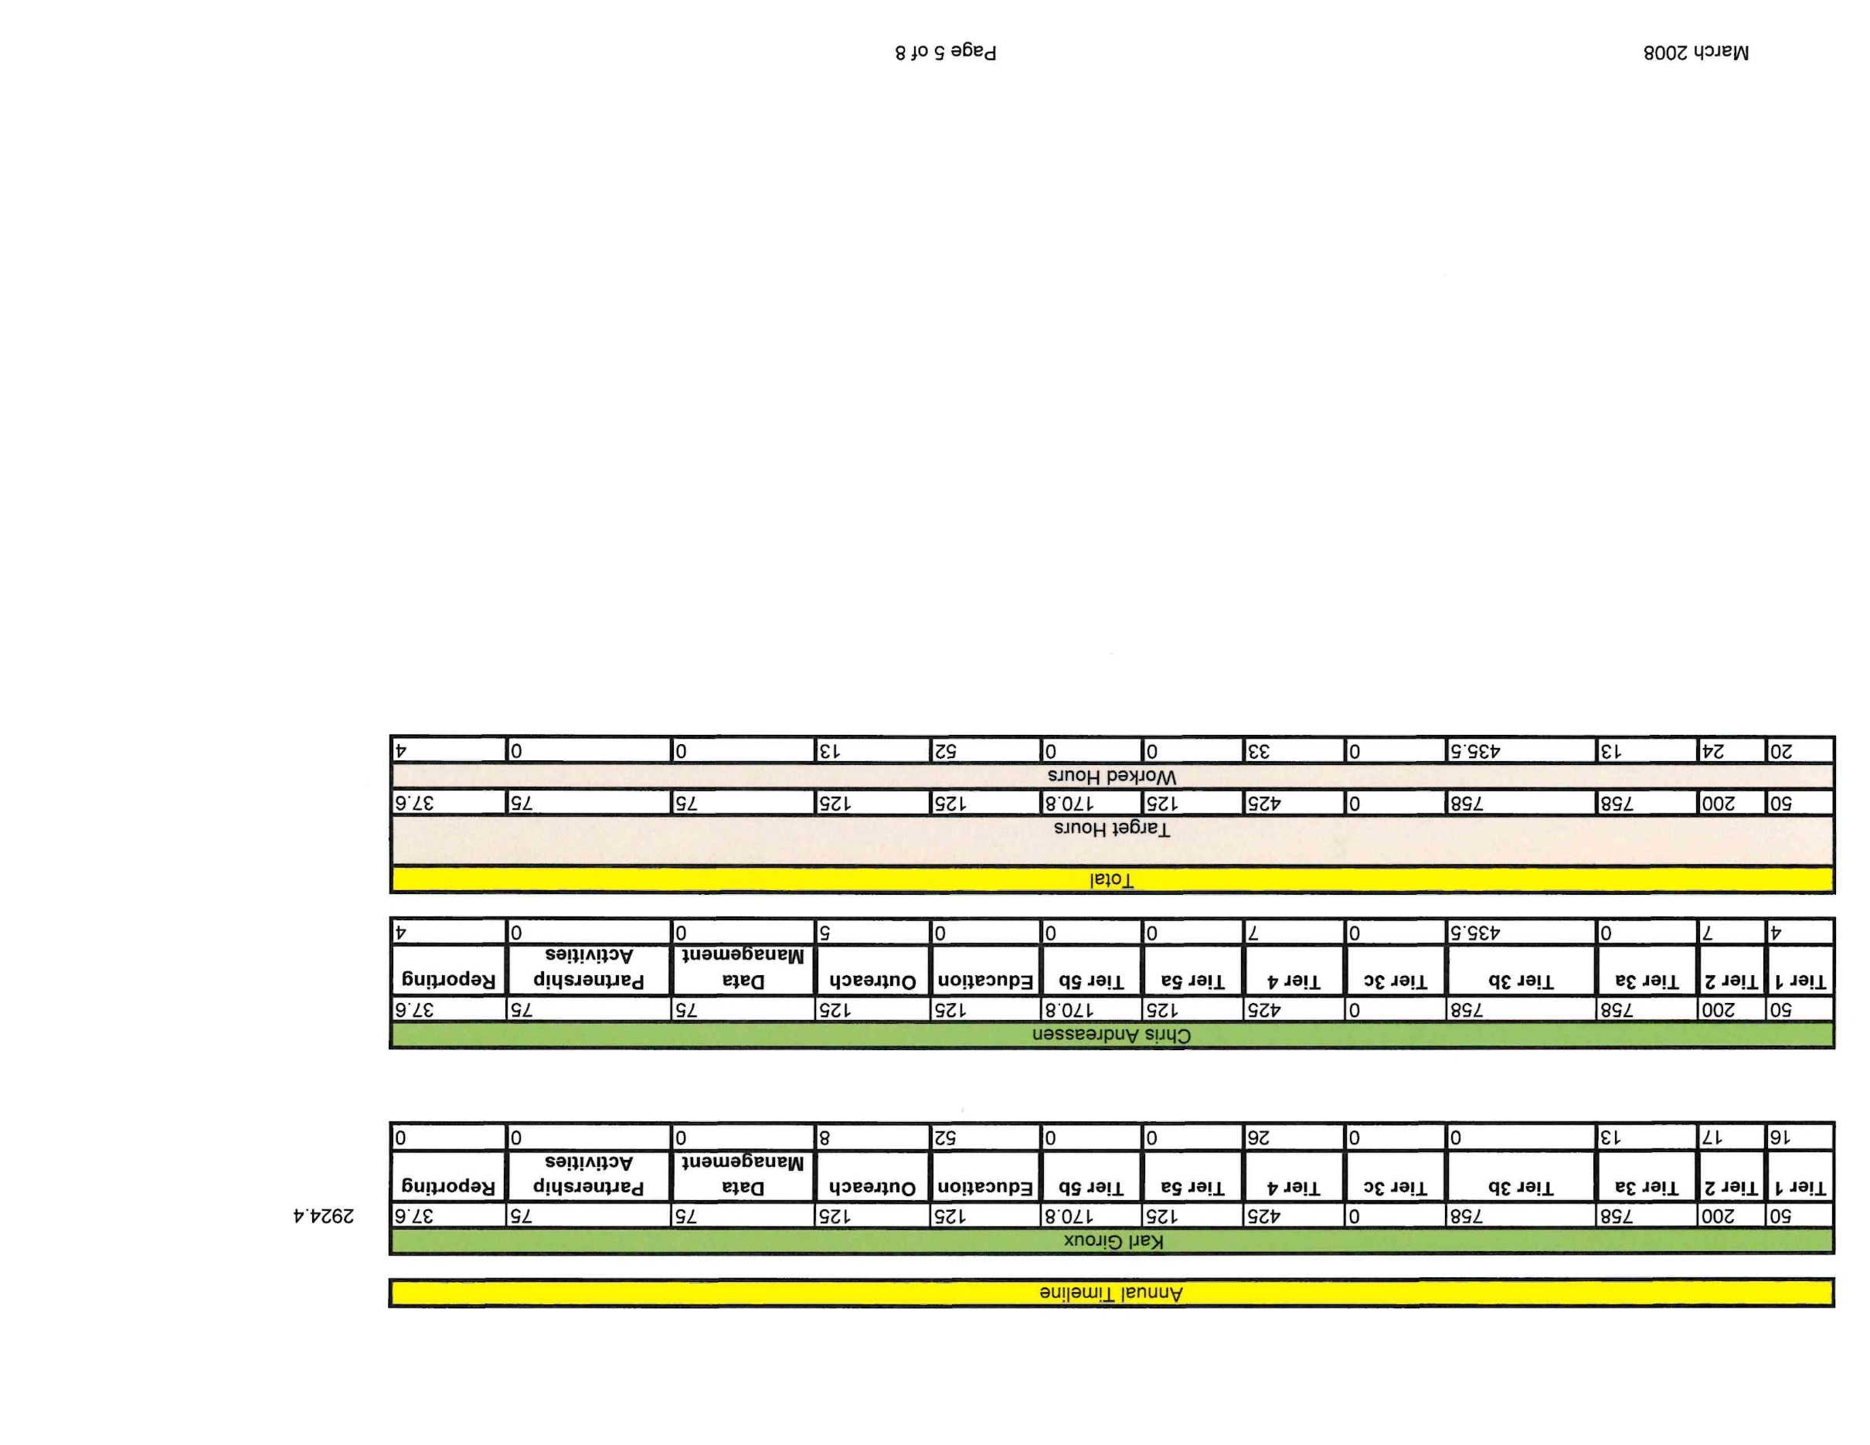
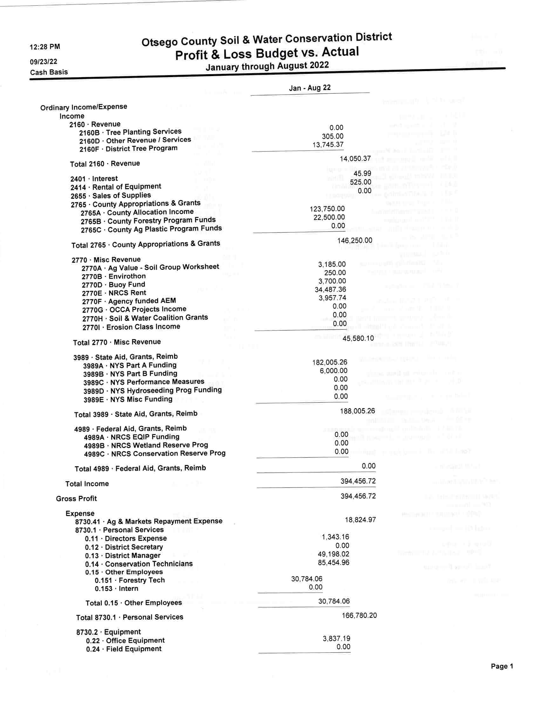
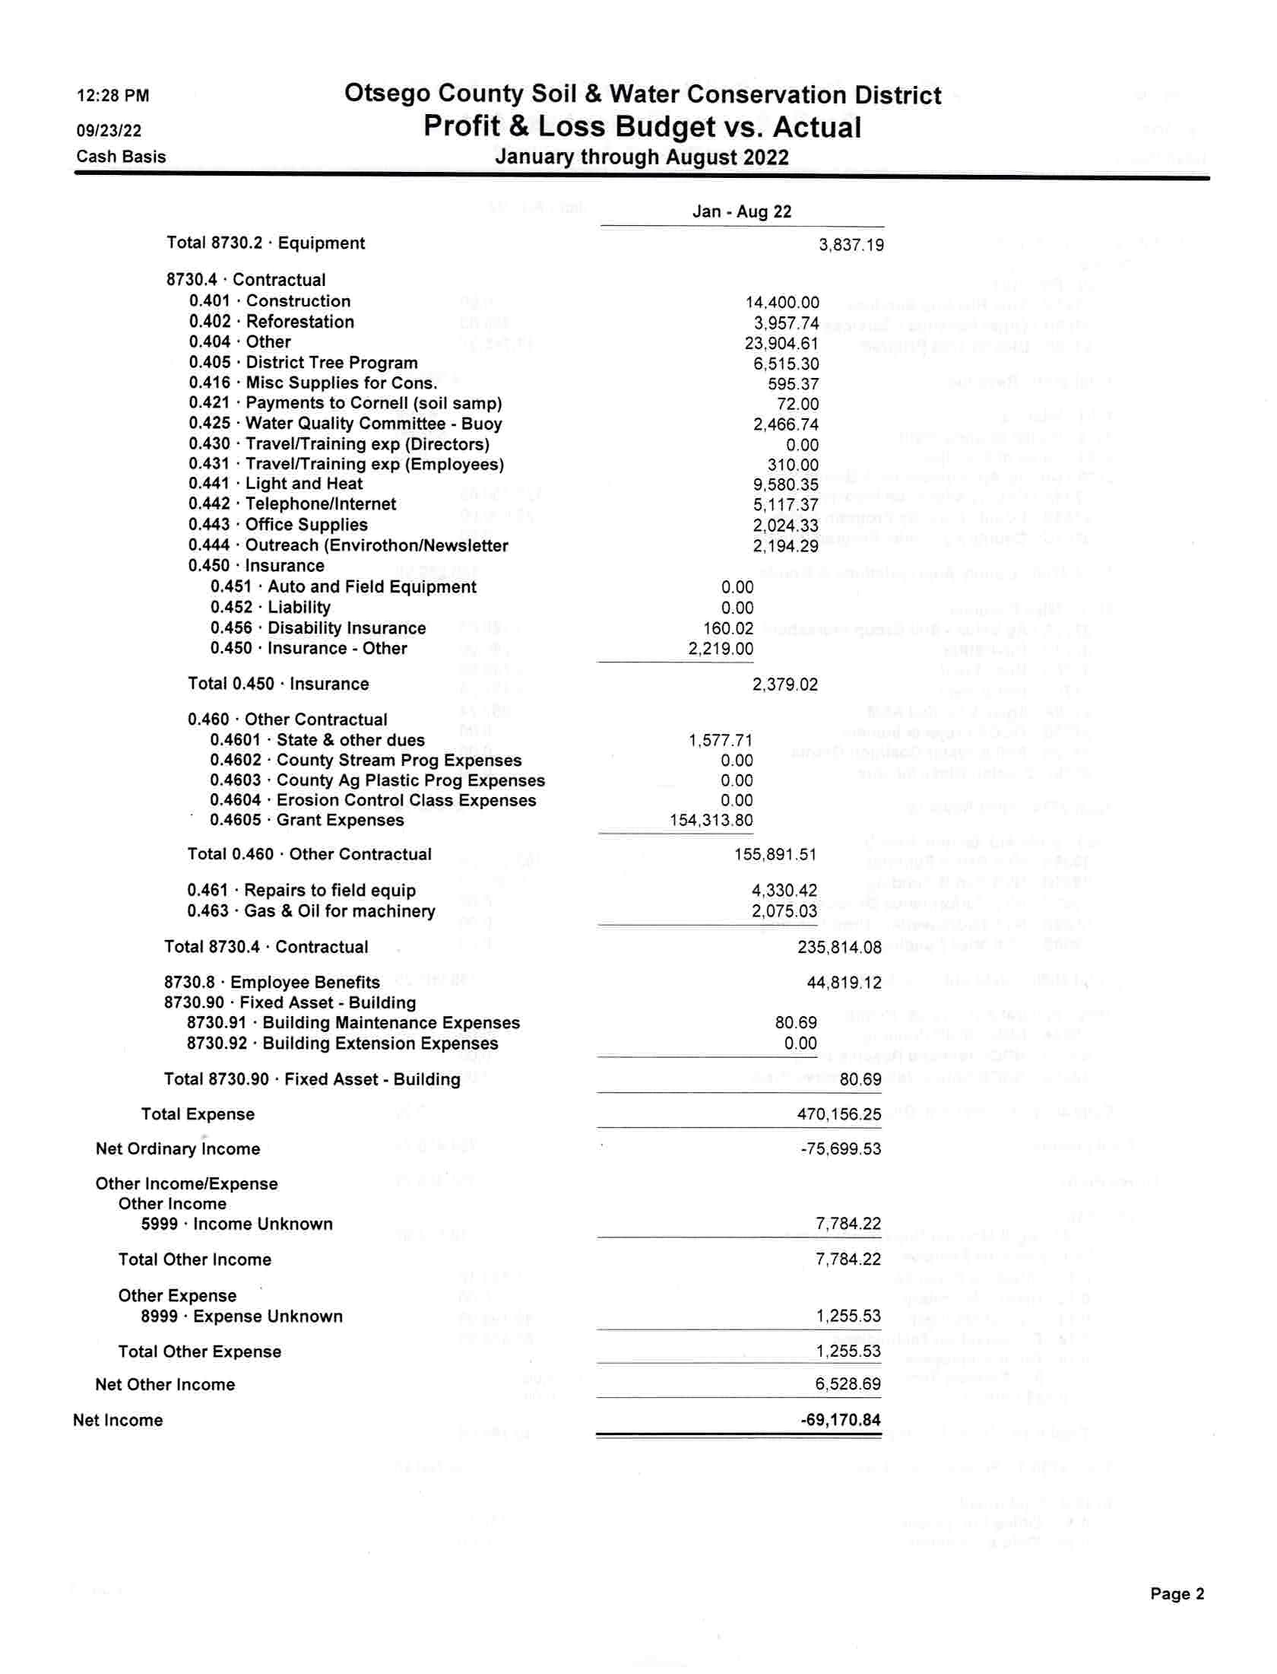
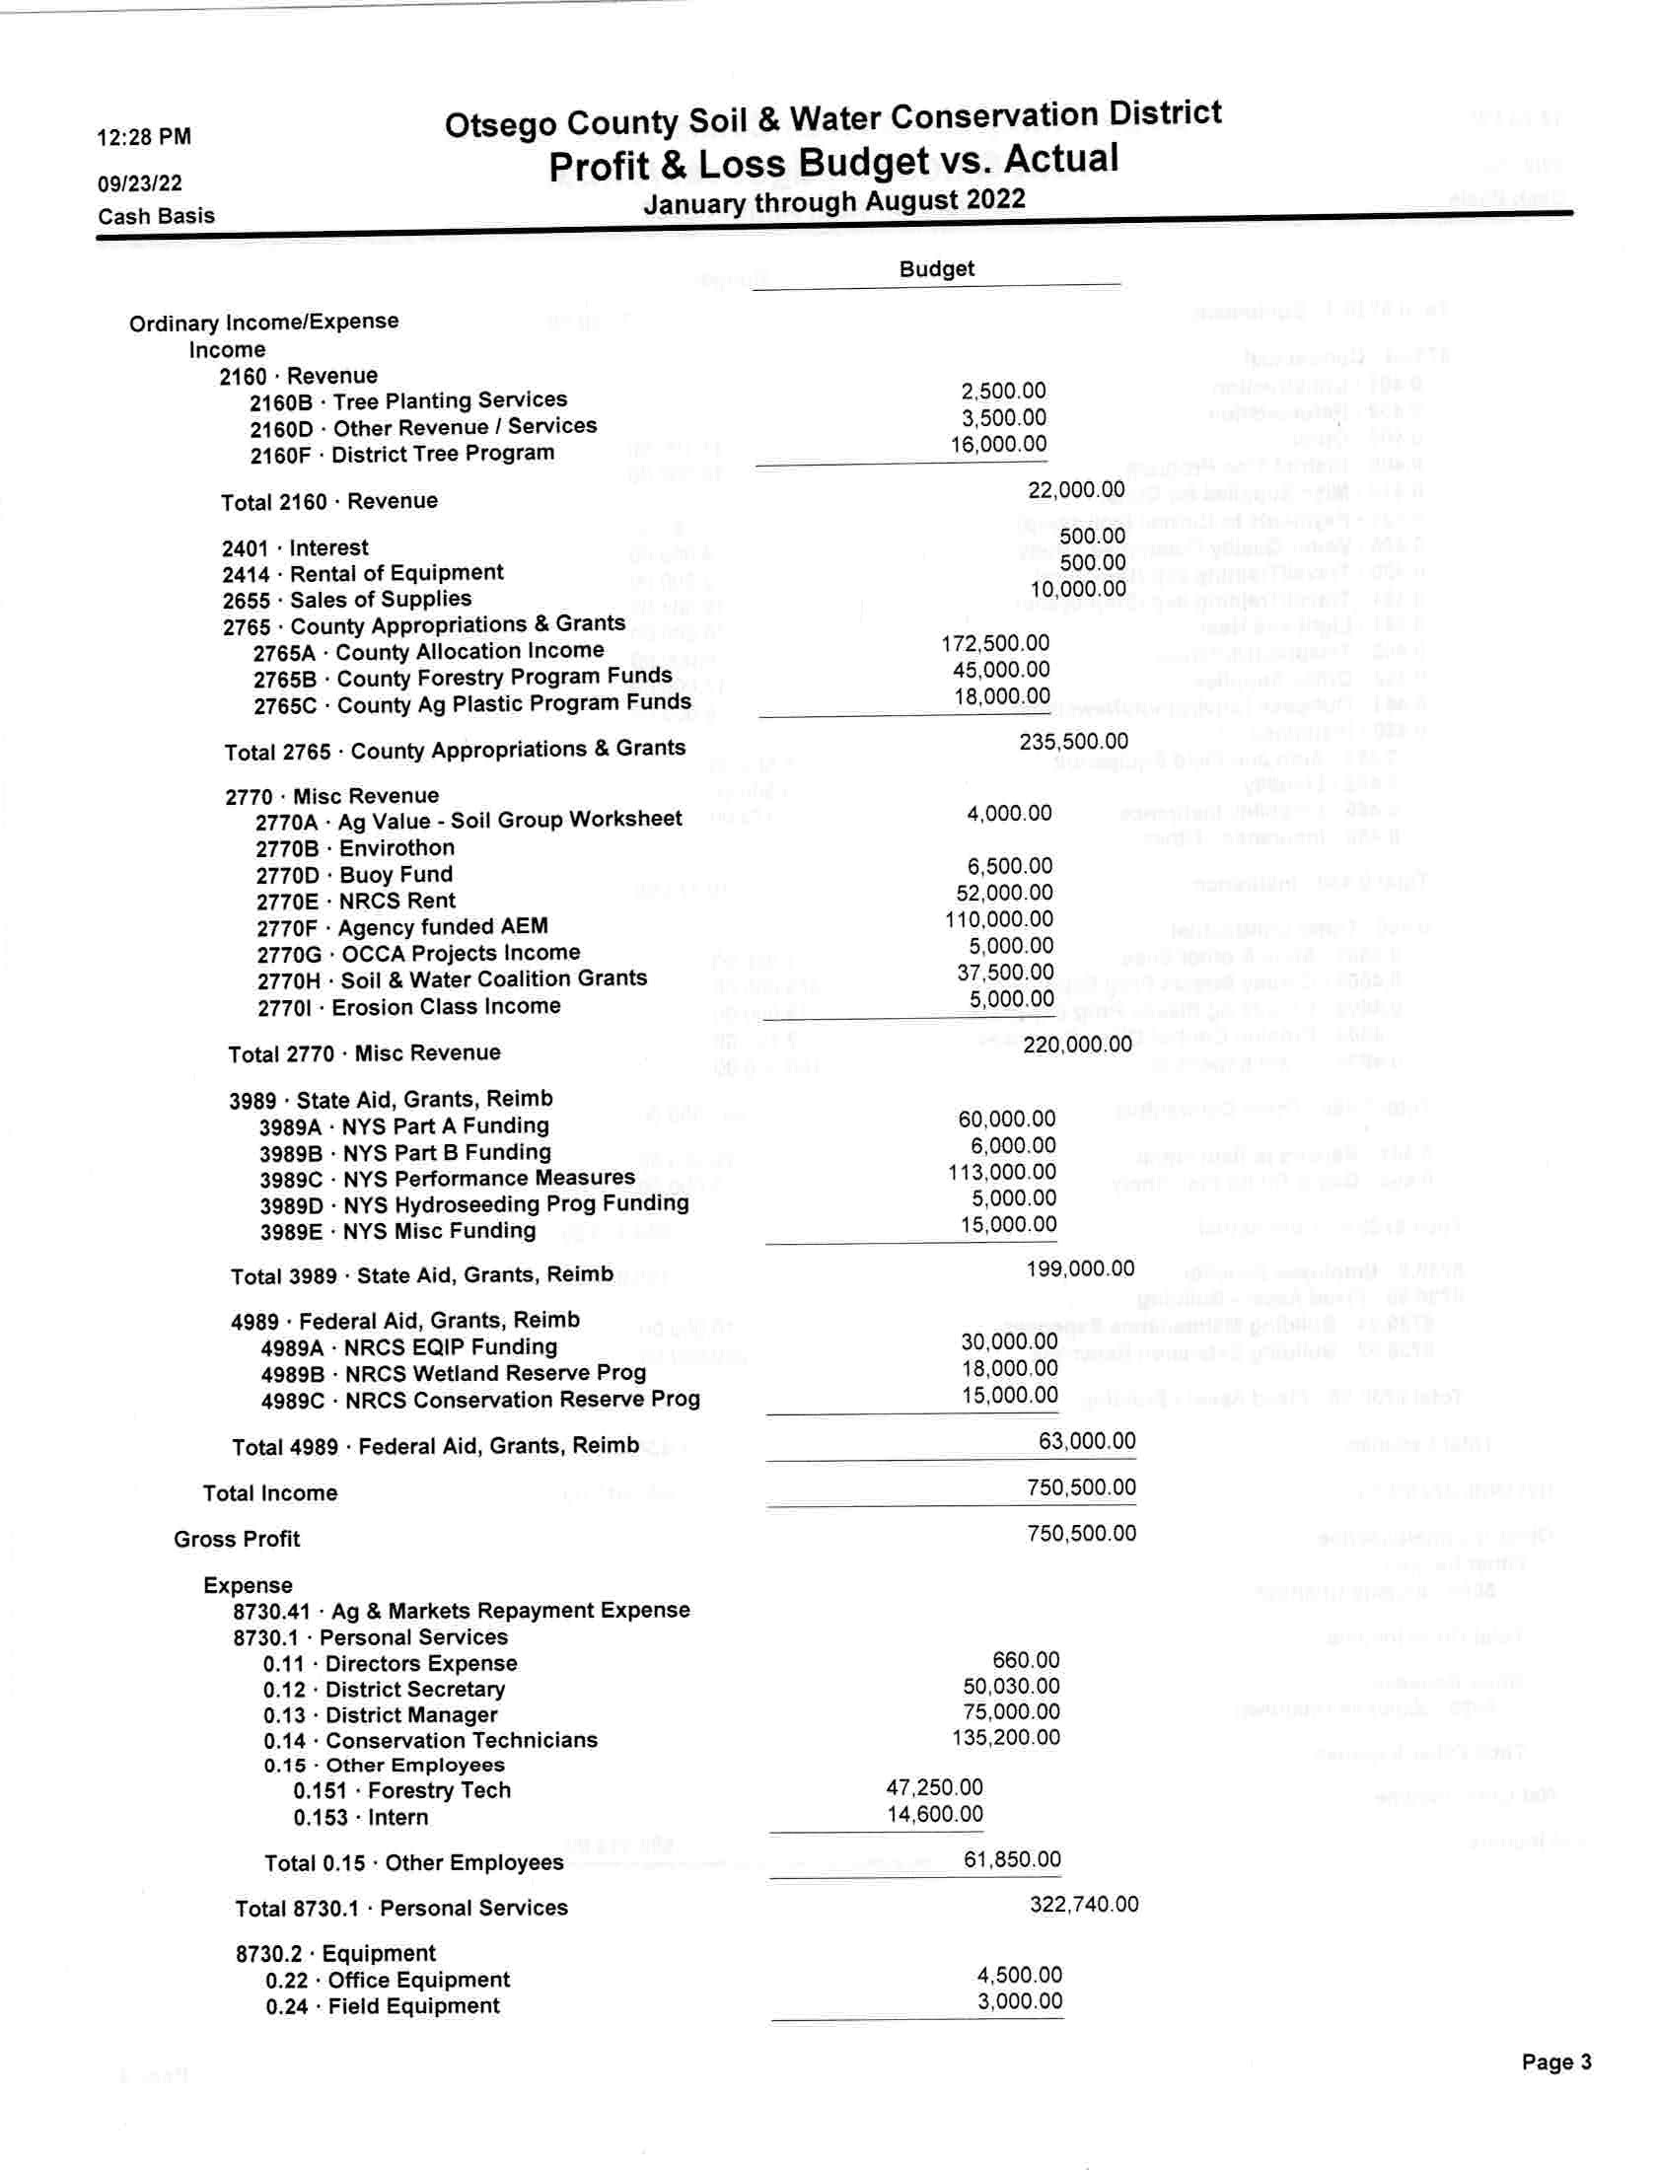
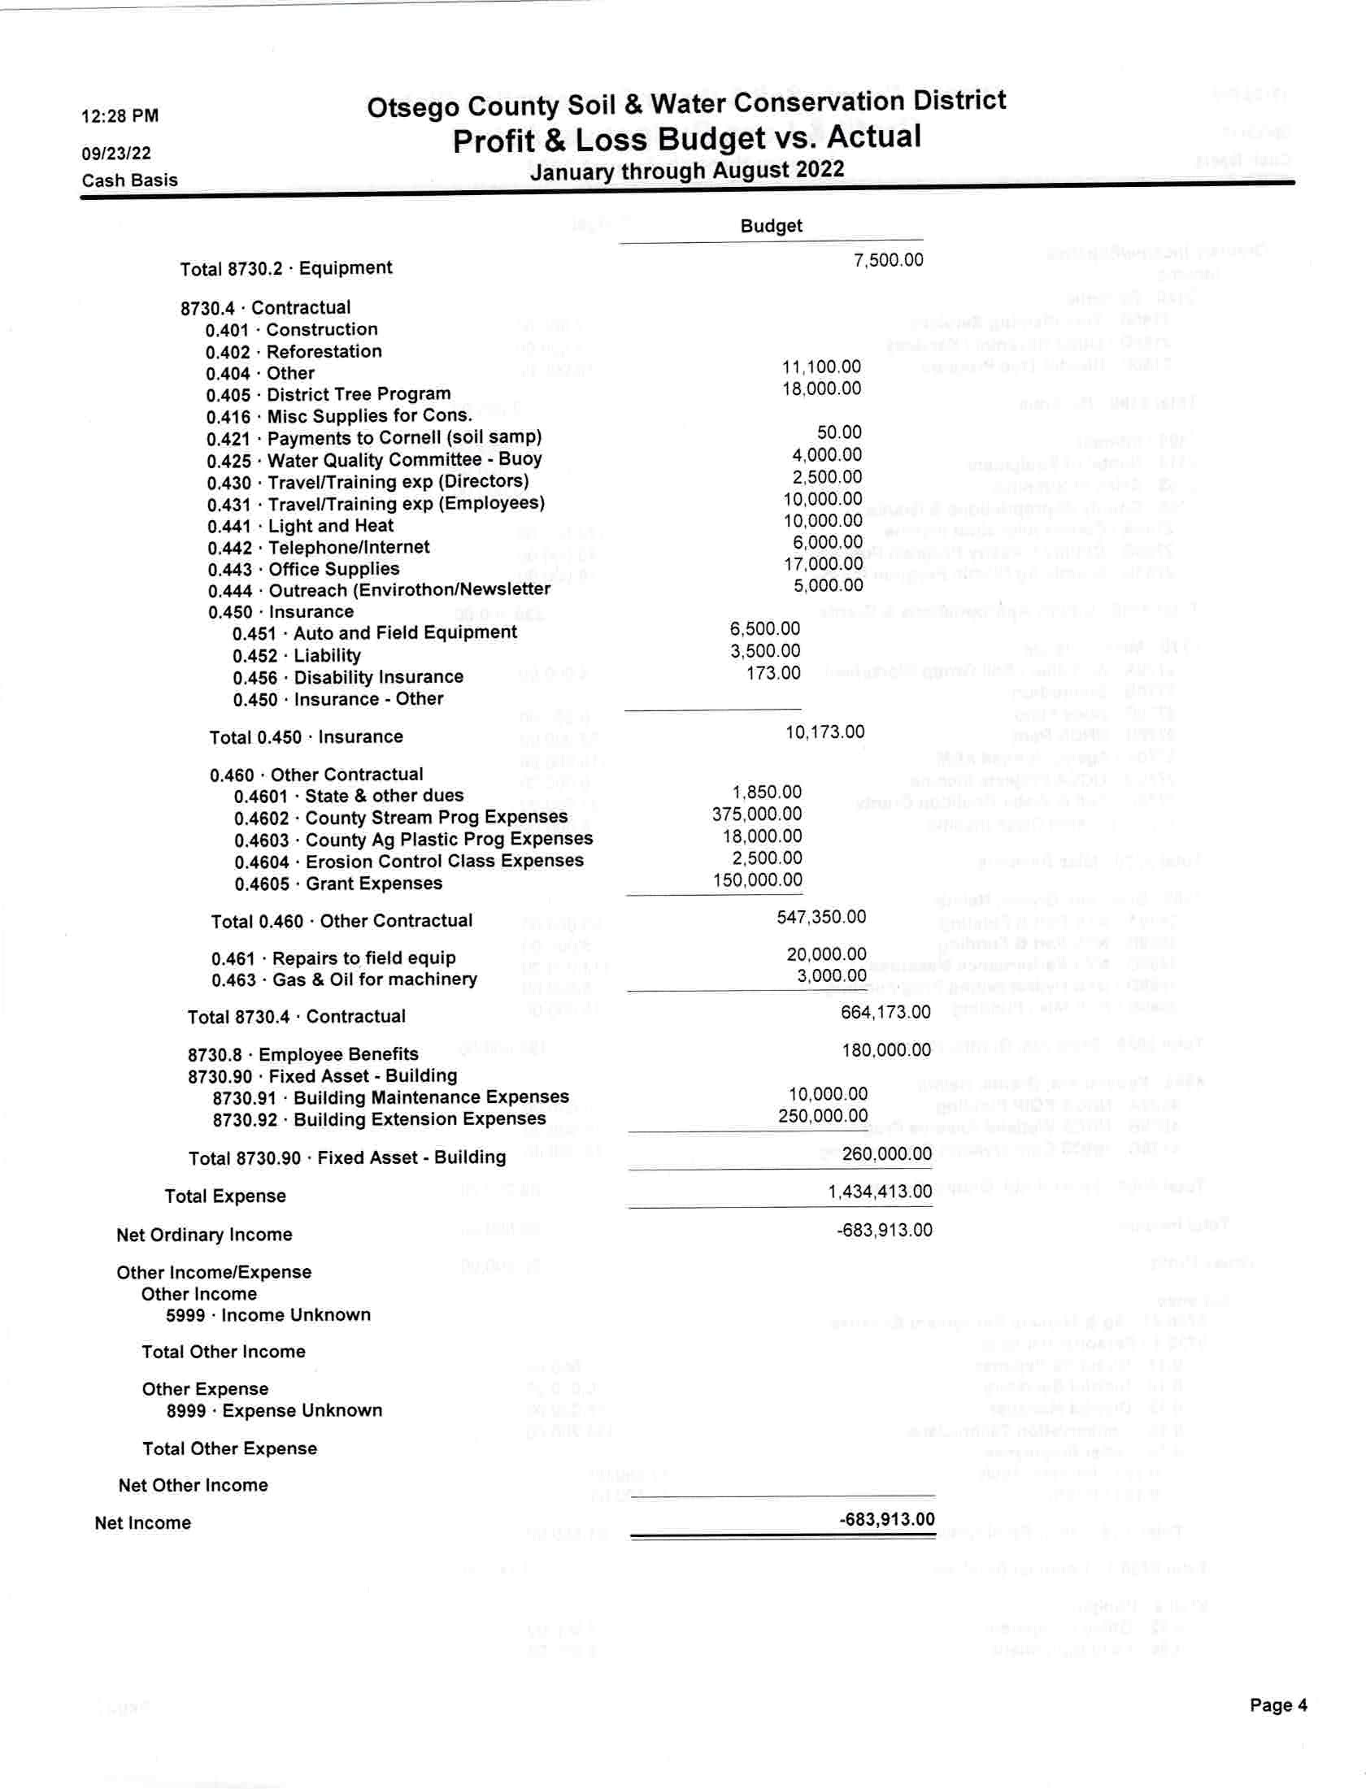
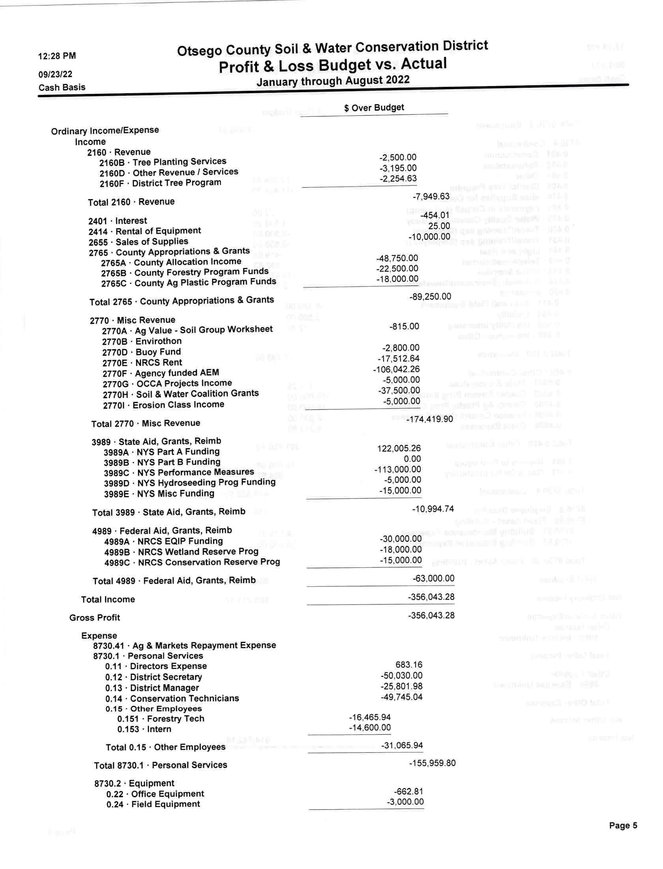
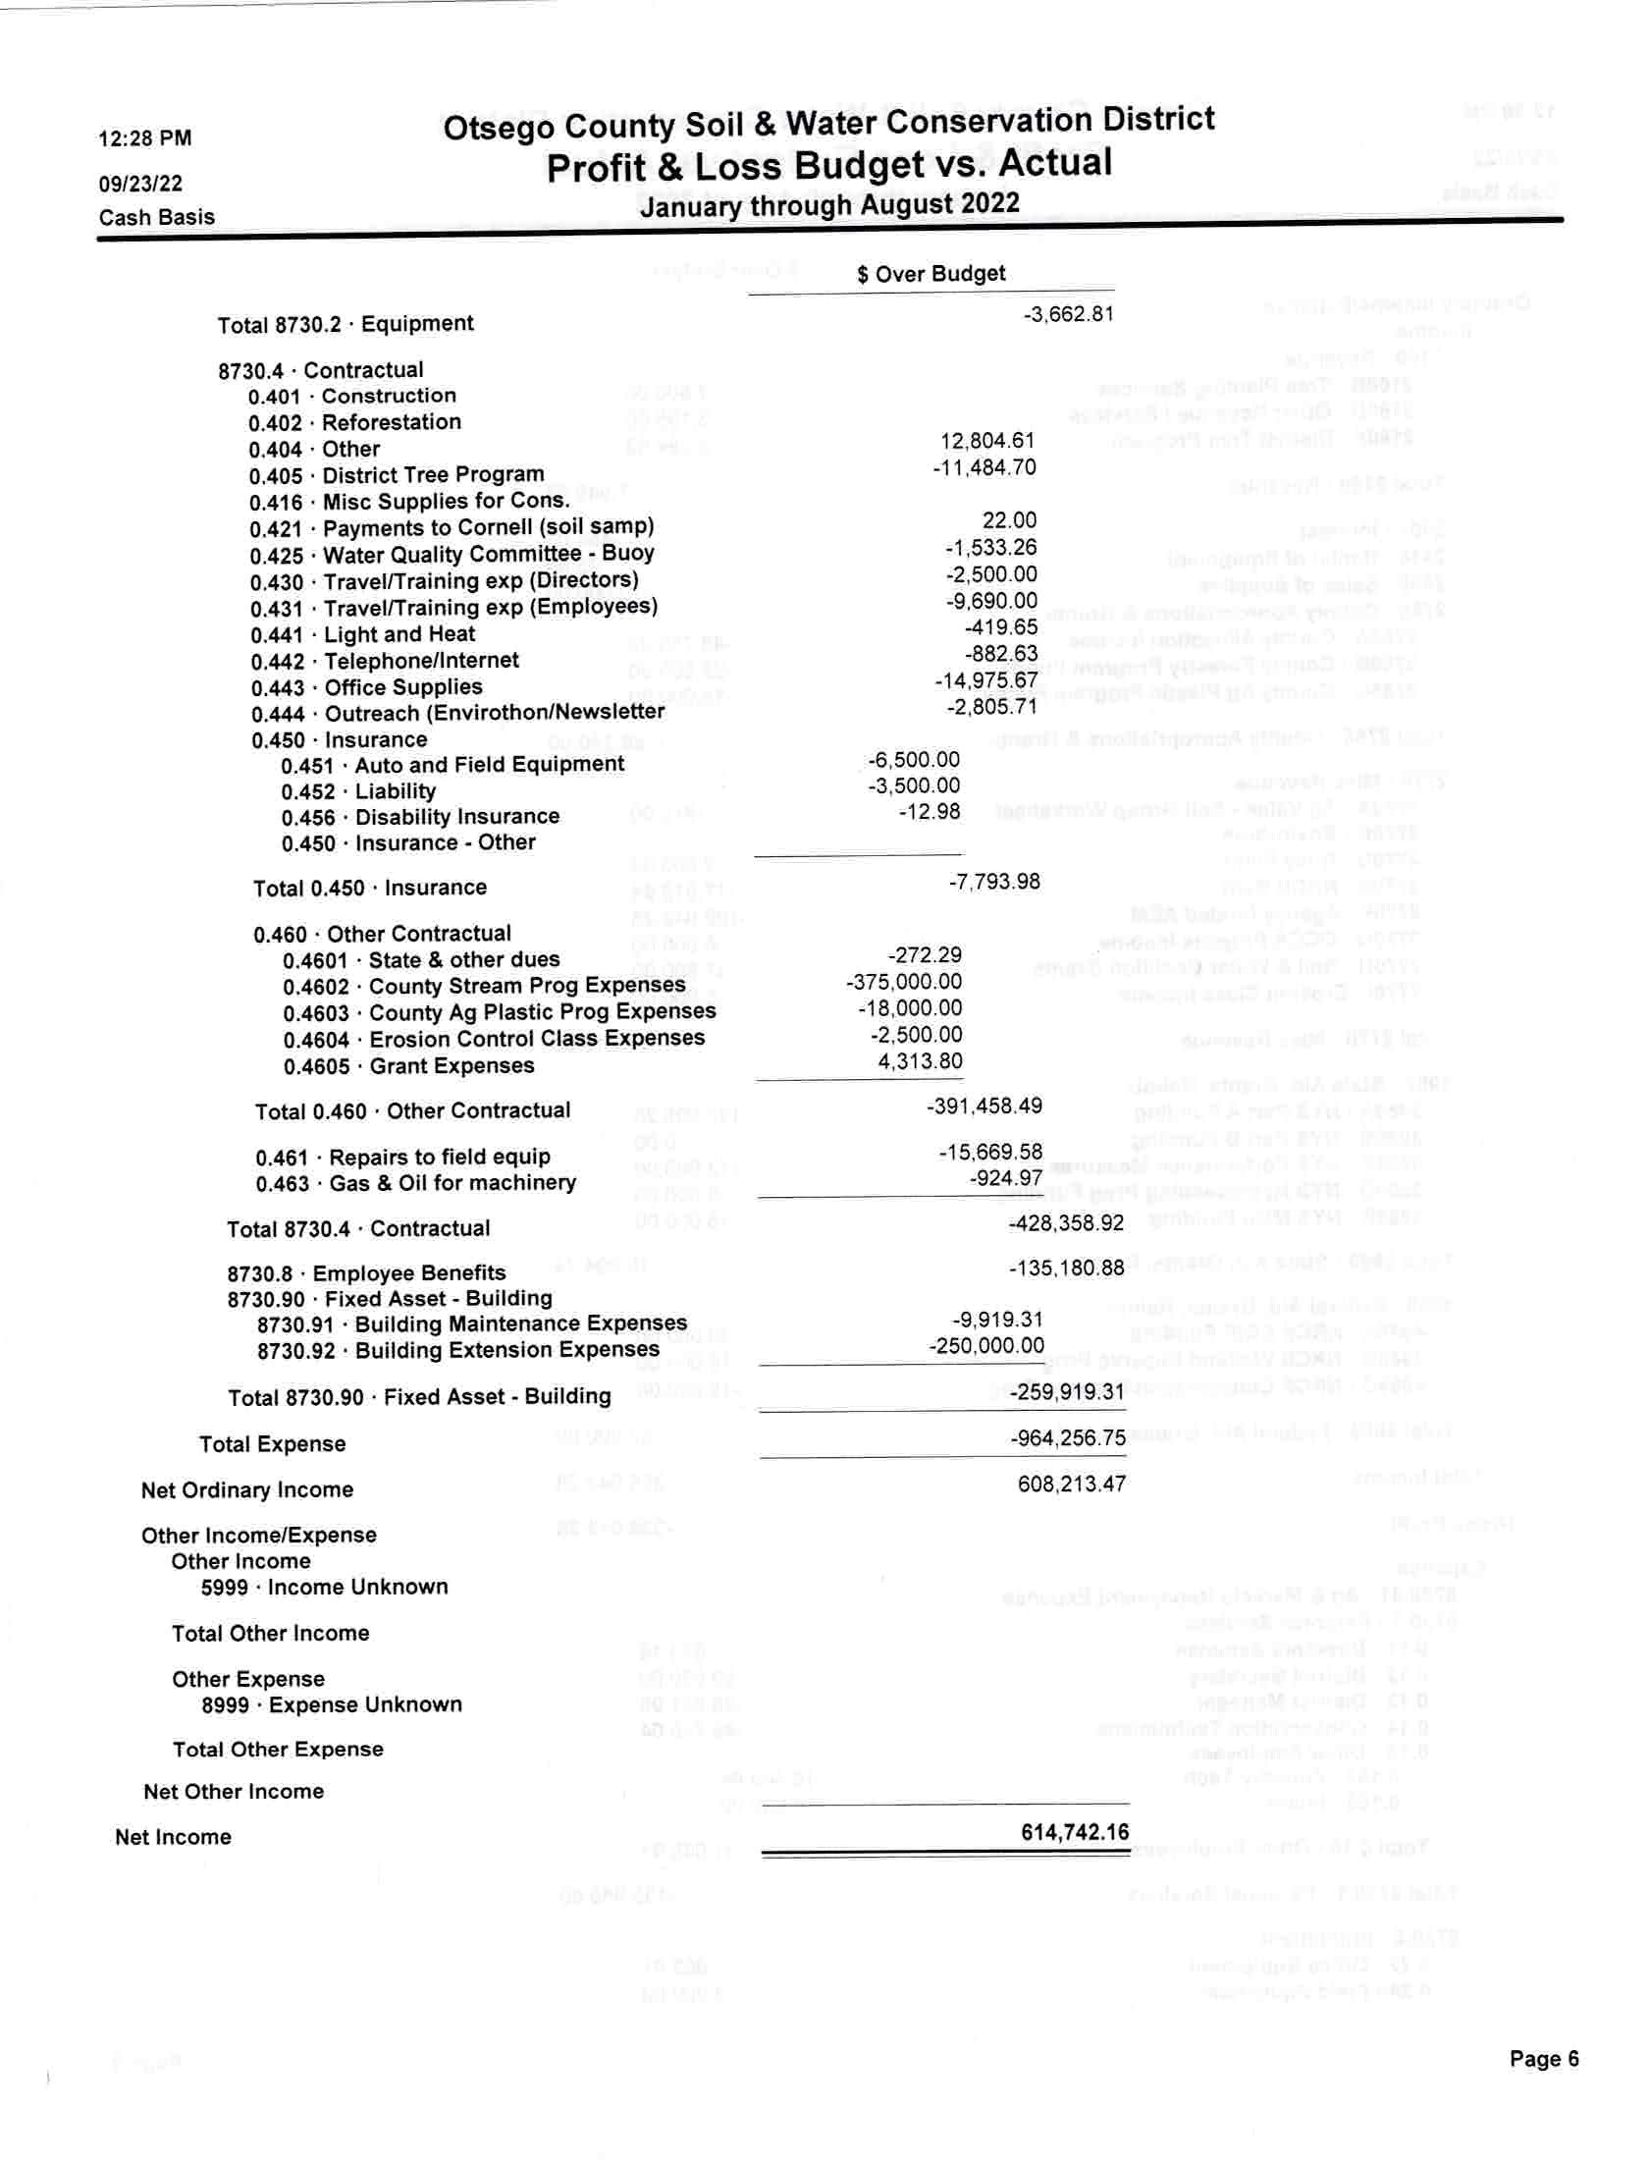

Performance Measure Evaluation Worksheet - Conservation Financial Assistance

Performance Measure (1): Extent and sufficiency of district board activity, which shall include the number of district board meetings held annually; training of board members and employees; annual audit; establishment and compliance with internal operational policies; and participation at State, Regional and National meetings and Functions.
Specific Performance Measure Criteria |  | 2019 Performance Standard (10) % |  | 2020 - 2022 COVID Performance Standard (0)%
1a) Hold regular meetings with a Quorum of District  Board Members Present |  | 8 or More Meetings |  | 8 or More Meetings (Remote meetings w/quorum are acceptable under EO 202.1 & EO 11.1)
1b) Training of District Board Members |  | 1. 2.  3. | Develop or update Training Plans and Budget(s) for Board Members  Current (within 3 Years) District Law Training for all Board Members**  Each Board Member must complete one training topic identified in the Board Member(s) Training Plan.** | 1. 2.  3. | Develop or update Training Plans and Budget(s) for Board Members  Current (within 3 Years) District Law Training for all Board Members**  Each Board Member must complete one training topic identified in the Board Member(s) Training Plan.**
1c) Training of District Employees |  | 1. 2. | Develop and/or update Training Plans and Budget(s) for all Employees  Each Employee must complete one training topic as identified in the Employee(s) Training Plan. | 1. 2. | Develop and/or update Training Plans and Budget(s) for all Employees  Each Employee must complete one training topic as identified in the Employee(s) Training Plan.
1d) Perform Annual Audit of District Financial Operations |  | Complete an annual audit. |  | Complete an annual audit.
1e) Establishment and Compliance with Internal  Operational Policies |  | Maintain the following policies:  - Director Attendance  - Human Resources  - Investment/Financial  - Procurement  - Freedom of Information Law (FOIL) |  | Maintain the following policies:  - Director Attendance  - Human Resources  - Investment/Financial  - Procurement  - Freedom of Information Law (FOIL)
1f) Hold organizational meeting of the District |  | Complete an organizational meeting. |  | Complete an organizational meeting.
1g) Participation at State, Regional and National Meetings and Functions |  | At least three (3) of the Directors have attended at least one (1) meeting or function. Each Director may choose from the following:  - NACD National or Regional Meeting  - NACD Legislative Conference  - NYACD Annual Meeting  - NYACD Division Directors Meeting  - SWCC Meeting  - SWCC Subcommittee Meeting  - SWCC Manager Meeting  - NACD Leadership Conference  - CDEA/SWCC Water Quality Symposium |  | At least three (3) of the Directors have attended at least one (1) meeting or function. Each Director may choose from the following:  - NACD National or Regional Meeting  - NACD Legislative Conference  - NYACD Annual Meeting  - NYACD Division Directors Meeting  - SWCC Meeting  - SWCC Subcommittee Meeting  - SWCC Manager Meeting  - NACD Leadership Conference  - CDEA/SWCC Water Quality Symposium
1g) Participation at State, Regional and National Meetings and Functions (Continued) |  | - CDEA Meeting  - CDEA Division Meeting  - Regional and/or State RC&D Meeting  - Organized Multi-County Watershed/Groundwater Initiative  - Forest Practice Board  - NYS Grange Annual Meeting  - FL-LOWPA Full Board Meeting  - NYS Fish & Wildlife Management Board Meeting  - NYS Farm Bureau Spring Conference  - Multi-County Watershed Boards  - County WQ Coordinating Committee  - NYSFOLA, Inc. Annual Conference  - NYSFOLA, Inc. Regional Conferences  - NY Regional Stormwater Conferences  - Soil and Water Conservation Society Annual Meeting  - USDA Regional Meeting  - PRISM Meetings  - Empire Farm Days  *Other (*Must be pre-approved by the SWCC to qualify for this section.) |  | - CDEA Meeting  - CDEA Division Meeting  - Regional and/or State RC&D Meeting  - Organized Multi-County Watershed/Groundwater Initiative  - Forest Practice Board  - NYS Grange Annual Meeting  - FL-LOWPA Full Board Meeting  - NYS Fish & Wildlife Management Board Meeting  - NY Farm Bureau Young Farmers & Ranchers Leadership Conference  - Multi-County Watershed Boards  - County WQ Coordinating Committee  - NYSFOLA, Inc. Annual Conference  - NYSFOLA, Inc. Regional Conferences  - NY Regional Stormwater Conferences  - NY Certified Organic Regional Meetings  - Soil and Water Conservation Society Annual Meeting  - USDA Regional Meeting  - PRISM Meetings  - Empire Farm Days  *Other (*Must be pre-approved by the SWCC to qualify for this section.)
 |  | **Board Members appointed within the last sixty (60) days of the calendar year are exempt from meeting the training requirements for Performance Measure 1b – Training of District Board Members. |  | **Board Members appointed within the last sixty (60) days of the calendar year are exempt from meeting the training requirements for Performance Measure 1b – Training of District Board Members.

Performance Measure (2): District reporting and outreach activities, which shall include presentations, reports, publications, public education and outreach and timely compliance with committee information requests, including an approved annual work plan and an annual report.

Specific Performance Measure Criteria |  | 2019 Performance Standard (10) % | 2020 - 2022 COVID Performance Standard (15)%
2a) Presentations, Reports, and Publications  For 2020 & 2021 2a & 2b are combined into 1 question |  | Seven (7) or more different items from the following list were completed that represent opportunities the SWCD took to communicate through presentations, reports, and/or publications:  - County Legislature  - Water Quality Coordinating Committee (WQCC)  - Newsletter  - Local Service Clubs and Organizations (e.g. Rotary, Farm Bureau, Kiwanis, etc.)  - Local Governments (e.g. towns, villages, and school districts)  - Media Reports  - District Brochure  - Website  - Facebook©, Twitter© or other social media  - Published Annual Summary of Activities (Annual Report)  - Conference Speaker  - Interviews  - Press Release  - Press Conference  - Authoring Periodical  - Federal Partners (e.g. NRCS, FSA, etc.)  - *Other (*Must be pre-approved by the SWCC to qualify for this section.) | Three (3) or more different items from the following list were completed that represent opportunities the SWCD took to communicate through presentations, reports, publications, education, and/or outreach:  - County Legislature  - Water Quality Coordinating Committee (WQCC)  - Newsletter  - Local Service Clubs and Organizations (e.g. Rotary, Farm Bureau, Kiwanis, etc.)  - Local Governments (e.g. towns, villages, and school districts)  - Media Reports  - District Brochure  - Website  - Facebook©, Twitter© or other social media  - Published Annual Summary of Activities (Annual Report)  - Conference Speaker  - Interviews  - Press Release  - Press Conference  - Authoring Periodical  - Federal Partners (e.g. NRCS, FSA, etc.) *continued below
2b) Public Education and Outreach  For 2020 & 2021 2a & 2b are combined into 1 question |  | Five (5) or more different public education and outreach activities from the following list were conducted:  - Envirothon  - Conservation Field Days  - Farm Day  - Annual Banquet  - Tours  - Arbor Day  - Staffed Education Booths (e.g. County Fair, State Fair)  - Classroom Education  - Outdoor Education Events  - Workshops  - Water Week Events  - County Participant in Government (Intern) Program and/or School sponsored internship  - Coordination and Promotion of Environmental Cleanups  - Adult Education  - Earth Day Events  - Soil Health Workshop  - National Environmental Holidays  - 4-Hour Erosion & Sediment Control Training  - *Other (*Must be pre-approved by SWCC to qualify for this section.) | cont’d  - Envirothon  - Conservation Field Days  - Farm Day  - Annual Banquet  - Tours  - Arbor Day  - Staffed Education Booths (e.g. County Fair, State Fair)  - Classroom Education  - Outdoor Education Events  - Workshops  - Water Week Events  - County Participant in Government (Intern) Program and/or School sponsored internship  - Coordination and Promotion of Environmental Cleanups  - Adult Education  - Earth Day Events  - Soil Health Workshop  - National Environmental Holidays  - 4-Hour Erosion & Sediment Control Training  - *Other (*Must be pre-approved by SWCC to qualify for this section.)
2c) Timely Submittal of Information to the  State Committee, including an approved Annual Plan of Work (APOW) and Annual Report. |  | - Reports and information shall be timely filed and submitted.  - 2020 Annual Plan of Work (APOW) due to State  Committee Staff by November 1, 2019 for recommended approval by State Committee by December. | - Reports and information shall be timely filed and submitted.  - 2023 Annual Plan of Work (APOW) is due to Regional  AEAs by November 1, 2022 for recommended approval by State Committee by December SWCC meeting. (Timely submittal of the APOW within the reporting period.)

Performance Measure (3): Ability of the district to use the funding to leverage additional funds from local, federal and private sources, which shall also include the district’s demonstrated ability to foster partnerships with other entities to further natural resource conservation and provide assistance to governmental and nongovernmental entities.

Specific Performance Measure Criteria |  | 2019 Performance Standard (30) % | 2020 - 2022 COVID Performance Standard (35)%
3) Leveraging Additional Funds and Fostering  Partnerships |  | Complete three (3) or more different items from the following list:  - Apply for one (1) grant, cooperative agreement or other external funding agreement to Advance Local District  Priorities.  - Develop and/or Maintain Partnerships with four (4) different Local, State, Federal, or private entities other than a Conservation District.  - Maintain or Increase County Appropriations.  - Work in partnership with one or more Conservation District(s) to jointly deliver a program or project.  - Receive at least one (1) grant, cooperative agreement or other external funding agreement that was obtained by leveraging the previous year's performance funds. This must be a cash award.  - Initiate one (1) new program or project utilizing the previous year’s performance funds.  - Work in partnership with Private Sector to deliver a program or project. | Complete two (2) or more different items from the following list:  - Apply for one (1) grant, cooperative agreement or other external funding agreement to Advance Local District  Priorities.  - Develop and/or Maintain Partnerships with two (2) different Local, State, Federal, or private entities other than a Conservation District.  - Maintain or Increase County Appropriations.  - Work in partnership with one or more Conservation District(s) to jointly deliver a program or project.  - Receive at least one (1) grant, cooperative agreement or other external funding agreement that was obtained by leveraging the previous year's performance funds. This must be a cash award.  - Initiate one (1) new program or project utilizing the previous year’s performance funds.  - Work in partnership with Private Sector to deliver a program or project.

Performance Measure (4) Delivery of State natural resource conservation programs, which shall include the quality of service provided (e.g., staff implementing State programs seek and maintain appropriate certifications, job approval authorities and training as established by the committee), completion of projects, and compliance with reporting requirements for such programs.

Specific Performance Measure Criteria |  | 2019 Performance Standard (40) % | 2020 - 2022 COVID Performance Standard (50)%
4) State Natural Resource Conservation Programs |  | Five (5) or more different State Natural Resource  Conservation programs or elements of those programs from the following list were delivered consistent with program reporting requirements (if applicable) and implemented by staff or contractors with the appropriate training and/or necessary certifications.  - AEM  - CAFO Permits  - CREP  - Farmland Protection/ Open Space  - Stormwater MS4  - Stormwater Phase II Construction  - State Natural Resource Permits  - Agricultural NPS  - Non-Agricultural NPS (WQIP)  - Agricultural Value Assessment  - Invasive Species Management  - Stream Corridor Management  - Emergency Stream Intervention (ESI)  - Climate Resilient Farming (CRF)  - Agriculture Emergency Response  - Ecosystem-Based Management (EBM)  - DEC American Eel Project  - DEC Rotating Integrated Basin Studies (RIBS)  - DEC Lake Classification and Inventory (LCI) or Citizens Statewide Lake Assessment Program (CSLAP)  - DEC Water Assessments by Volunteer Evaluators (WAVE)  - DEC Professional External Evaluations of Rivers and Streams (PEERS)  - North Atlantic Aquatic Connectivity Collaborative (NAACC)  - Hazard Mitigation Planning, Development, & Implementation | Three (3) or more different State Natural Resource Conservation programs or elements of those programs from the following list were delivered consistent with program reporting requirements (if applicable) and implemented by staff or contractors with the appropriate training and/or necessary certifications.  - AEM  - CAFO Permits  - CREP  - Farmland Protection/ Open Space  - Stormwater MS4  - Stormwater Phase II Construction  - State Natural Resource Permits  - Agricultural NPS  - Non-Agricultural NPS (WQIP)  - Agricultural Value Assessment  - Invasive Species Management  - Stream Corridor Management  - Emergency Stream Intervention (ESI)  - Climate Resilient Farming (CRF)  - Source Water Buffer Program (SWBP)  - Agriculture Emergency Response  - Ecosystem-Based Management (EBM)  - DEC American Eel Project  - DEC Rotating Integrated Basin Studies (RIBS)  - DEC Lake Classification and Inventory (LCI) or Citizens Statewide Lake Assessment Program (CSLAP)  - DEC Water Assessments by Volunteer Evaluators (WAVE)  - North Atlantic Aquatic Connectivity Collaborative (NAACC)  - Hazard Mitigation Planning, Development, & Implementation  - *Other EPF (*Must be pre-approved by SWCC to qualify for this section.)  - *Other State Natural Resource Conservation Programs (*Must be pre-approved by SWCC to qualify for this section.)
- *Other EPF (*Must be pre-approved by SWCC to qualify for this section.)
- *Other State Natural Resource Conservation Programs (*Must be pre-approved by SWCC to qualify for this section.)
NOTES: 1) For purposes of Performance Measure 4 State Natural Resource Conservation Program means any natural resource program funded or required by the
State.

Performance Measure (5) The ability to promote partnerships and assist local governments and non-governmental organizations (NGO). Non-governmental organizations (NGO) are usually non-profit, voluntary citizens’ group which are organized on a local, national, or international level such as associations, foundations, charities, and conservation/sportsman groups.

Specific Performance Measure Criteria |  | 2019 Performance Standard (10) % | 2020 - 2022 COVID Performance Standard (0)%
5) Partnerships with local governments and NGOs. |  | Complete the following:  - The District is a partnership builder. The purpose of partnerships is for joint problem-solving, coordination and coalition building. A partnership brings together institutional capabilities and human resources in the form of skills, experiences, ideas to tackle a common problem that are often beyond the capabilities of a single organization or group. Describe a project or program that took place within the reporting period that demonstrates the District as a partnership builder.  - Develop and/or Maintain partnerships with local government or NGO. Please list existing or new partnership between the SWCD and a local government or NGO.  - Assist a local government or NGO by working in partnership to jointly deliver a program or project. Does the partnership have a clear purpose, add value to the work of the partners, and be carefully planned and monitored? | Complete the following:  - The District is a partnership builder. The purpose of partnerships is for joint problem-solving, coordination and coalition building. A partnership brings together institutional capabilities and human resources in the form of skills, experiences, ideas to tackle a common problem that are often beyond the capabilities of a single organization or group. Describe a project or program that took place within the reporting period that demonstrates the District as a partnership builder.  - Develop and/or Maintain partnerships with local government or NGO. Please list existing or new partnership between the SWCD and a local government or NGO.  - Assist a local government or NGO by working in partnership to jointly deliver a program or project. Does the partnership have a clear purpose, add value to the work of the partners, and be carefully planned and monitored?

Submit by Email Print Form
2021
Performance Measure Evaluation Report For
Conservation Financial Assistance
Reporting Period 1/1/2021 - 12/31/2021
REVIEW PROCESS:
Performance Measure Evaluation Reports are submitted to the NYS Soil and Water Conservation Committee to qualify for performance based conservation financial assistance (Part C - Performance Measures) under State Aid to Districts (District Law 11-a. 1(c)). Any report that does not result in meeting all the performance measures will be followed-up on by staff. The applicant who signs the report certifying its accuracy will be notified by Email and provided three (3) business days to provide clarification or amplifying information. Please review this report before submission for accuracy and completeness.
County Soil and Water Conservation District
Otsego
Performance Measure 1 (0%): Extent and sufficiency of district board activity, which shall include the number of district board meetings held annually; training of board members and employees; annual audit; establishment and compliance with internal operational policies; and participation at State, Regional, and National meetings and functions.
1a) District Board Meetings (under EO 202.1 & legislation S.50001/A.40001 remote meetings with a quorum are acceptable)
Please identify the number of Board Meetings held with a Quorum during this reporting period. 12
Please list the dates of those meetings:
*You must convene 8 or more board meetings to qualify.
 | Meeting Dates
1 | 01/15/2021
2 | 02/19/2021
3 | 03/19/2021
4 | 04/16/2021
5 | 05/21/2021
6 | 06/18/2021
7 | 07/16/2021
8 | 08/20/2021
9 | 09/14/2021
 | Meeting Dates
10 | 10/15/2021
11 | 11/19/2021
12 | 12/17/2021

1b) Training of District Board Members
Do all SWCD Board Members have current training plans and is there a budget and/or resources to support training? Yes
No
Please provide the name of each Board Member, the date they most recently received District Law Training, and the date of each Directors appointment. New Directors appointed in the last sixty (60) days of the calendar year are provided a one-time exemption for Director Training.
*Training must be within last 3 years to qualify.
Board Member | Date of District Law Training | Date of Director Appointment
Leslie Rathbun | 11/19/2021 | 12/31/2013
Margaret Kennedy | 11/19/2021 | 1/6/2021
Michelle Farwell | 11/19/2021 | 1/6/2021
Doris Moennich | 11/19/2021 | 12/03/2014
Edward Lentz | 11/19/2021 | 5/02/2016
Helene Kraham | 11/19/2021 | 1/6/2021
Vacant
Please provide one completed training topic for each Board Member. The training topic must be discernible as an educational course. Time spent on duties and oversight of the District such as Annual Plan of Work development, Strategic Planning Session, and meetings would not qualify as training. Training should be educational and enhance a Director's ability to serve the SWCD and the public. District Law can be listed as a training if received within the reporting period. Board Members who are unable to meet the training requirement due to medical reasons can write under Training Topic/Course Name "medical leave of absence" in place of the training topic.
*Topic must be identified in the Board Members' Training Plan.
Board Member | Date | Training Topic / Course Name | Training Description
Leslie Rathbun | 11/19/2021 | District Law | New York State conservation districts are  political subdivisions of state government. The Soil and Water Conservation Districts (SWCD) Law passed on April 23, 1940. The training reviews the responsibilities of the board. What it can and cannot do. Review of all rules and regulations that govern soil & water districts.
Board Member | Date | Training Topic / Course Name | Training Description
Margaret Kennedy | 11/19/2021 | District Law | New York State conservation districts are  political subdivisions of state government. The Soil and Water Conservation Districts (SWCD) Law passed on April 23, 1940. The training reviews the responsibilities of the board. What it can and cannot do. Review of all rules and regulations that govern soil & water districts.
Michelle Farwell | 11/19/2021 | District Law | New York State conservation districts are  political subdivisions of state government. The Soil and Water Conservation Districts (SWCD) Law passed on April 23, 1940. The training reviews the responsibilities of the board. What it can and cannot do. Review of all rules and regulations that govern soil & water districts.
Doris Moennich | 11/19/2021 | District Law | New York State conservation districts are  political subdivisions of state government. The Soil and Water Conservation Districts (SWCD) Law passed on April 23, 1940. The training reviews the responsibilities of the board. What it can and cannot do. Review of all rules and regulations that govern soil & water districts.
Edward Lentz | 11/19/2021 | District Law | New York State conservation districts are  political subdivisions of state government. The Soil and Water Conservation Districts (SWCD) Law passed on April 23, 1940. The training reviews the responsibilities of the board. What it can and cannot do. Review of all rules and regulations that govern soil & water districts.
Helene Kraham | 11/19/2021 | District Law | New York State conservation districts are  political subdivisions of state government. The Soil and Water Conservation Districts (SWCD) Law passed on April 23, 1940. The training reviews the responsibilities of the board. What it can and cannot do. Review of all rules and regulations that govern soil & water districts.
Vacant

1c) Training of District Employees
Do all SWCD employees* have current training plans and is there a budget and/or resources to support training? *excluding seasonal, contractual, and interns
Yes
No
Have all SWCD employees* received training during the reporting period? *excluding seasonal, contractual, and interns
Yes
No
Please list training received by employees during the reporting period excluding seasonal, contractual, and interns. Topics must be identified in Staff Training Plans. Training can include employee orientation and on-the-job training that is relevant to the position and may not be offered in a formal setting.
 |  | Training Topic / Course Name |  | Date | Training Description
+ | - | NY G & C |  | 03/08/2021 | The NYS Grown and Certified webinar will feature updates from Jessica Brooks (NYS Grown & Certified Manager) about accomplishments and future direction.
+ | - | And why should I care? Commun |  | 03/09/2021 | Telling your story isn't and option anymore. its a critical part of gaining public acceptance, correlating to our farmers, continued freedom to operate.
+ | - | Overview of Government Accoun |  | 03/10/2021 | This session will familiarize officials with he accounting process for Soil and Water Conservation  Districts and some of the unique elements of government accounting.
+ | - | Planet of the Apps |  | 03/11/2021 | Bring your smart phone or laptop along for an interactive afternoon showcasing some amazing apps. Become an editing wizard with PicMonkey and create epic visuals for your social media posts and newsletters.
+ | - | PGM planning tips and tricks |  | 03/08/2021 | In this workshop we will discuss some of he unique grazing planning and management information that can help you with livestock species other than dairy cows.
+ | - | Pollinator Habitat Benefiting Ag |  | 03/09/2021 | Learn about the agricultural benefits pollinator habitat provides through pollination services and supporting benefits pollinator habitat.
+ | - | Urban & suburban Agricultural Pr |  | 03/10/2021 | Led by instructors thahave hands on experience working with urban and suburban producers and  discuss their experience working in communities  where there are unique challanges
+ | - | Harmful Algal Blooms |  | 03/11/2021 | Please join experts from the NYS DEC, Finger Lakes  Water Hub along with other applied researchers as the discuss Harmful Algal Blooms in the Finger Lakes Region.
+ | - | Manure Handling |  | 03/11/2021 | This class will take a comprehensive look at some of the new technologies available for handling  manure. While how manure is stored is often most looked at, it is also important to recognize how manure is applied to the land.
+ | - | Communicating Soil Health |  | 03/08/2021 | This course will provide you with multiple pathways forward when discussing soil health with farmers  who have encountered obstacles to implementing soil health management practice systems.
+ | - | Current State of the Forest and L | a | 03/08/2021 | Overview of the climate change response framework and the forest adaption resources for  natural and urban ecosystems. Overview of spotted lantern fly, beech leaf disease and Asian jumping worm.
 |  | Training Topic / Course Name | Date |  | Training Description
+ | - | Managing NY's Forest in a chang | 03/10/2021 |  | The goal for the day is to identify climate change risks and adaptation actions for managing New York's forests and wetland ecosystems.
+ | - | Restoring Ecological and Product | 03/11/2021 |  | Woodlands provide at least dual outputs of ecological functions and productivity. Recent  studies have documented woodland impairment associated with increased abundance of invasive  plants, interfering vegetation, reduced volume of higher value trees, reduce advance reproduction, and social constraints on management options.
+ | - | Clerks Forum | 03/08/2021 |  | This is a great opportunity to network with your administrative colleagues. The forum will start with a meet and greet, followed by a mini-presentations with topics including minutes and grants record retention.
+ | - | Federal, NYS, and Payroll Finance | 03/12/2021 |  | This course will cover topics related to Federal and NYS tax law, including W-9's, ST-125s, issuing 1099s and 1098s and sales tax.

1d) Annual Audit
Please identify the date that an Annual Audit of the SWCD Financial Operations was completed during the reporting period. This audit may be performed by the District Board, County, State, and Federal agencies and/or a qualified third party.
Date of Annual Audit
9/28/2021

1e) Internal Operation Policies
Please check the box that corresponds to all policies maintained by the SWCD Board during the reporting period. Add any additional policies maintained by the SWCD during the reporting period. Note: The first five policies are required to qualify.
 |  | Policy | Check
 |  | Director Attendance Policy
 |  | Human Resources Policy
 |  | Investment/Financial Policy
 |  | Procurement Policy
 |  | Freedom of Information Law (FOIL) Policy
+ | - | Sexual Harassment Policy

1f) Organizational Meeting
Please list the date during the reporting period when your SWCD Organizational Meeting was held. 1/15/2021

1g) Participation at State, Regional, and National Meetings and Functions
Please list three (3) different District Board Members and choose from the drop-down list a State, Regional, and National meeting or function that they each attended during the reporting period. (Directors may attend the same meeting.) Meetings and functions should be directly related to and in support of Conservation District operations and mission.
*Please note NRCS Regional Working Group Meeting was revised to USDA Regional Meeting which can include regional meetings (including 2 or more different counties) of NRCS or FSA.
Board Member | Meeting/Function Attended
Margaret Kennedy | NYACD Annual Meeting
Edward Lentz | NYACD Annual Meeting
Michelle Farwell | NYACD Annual Meeting
Note: If "Other" is chosen please submit a copy of the pre-approved "Performance Measure Evaluation - Conservation Financial Assistance Special Request Form".
Performance Measure 2 (15%):District reporting and outreach activities, which shall include presentations, reports, publications, public education and outreach, and timely compliance with committee information requests, including an approved Annual Plan of Work and an Annual Report. Questions 2a and 2b were combined into one question. The District needs to check a total of 3 or more items from the lists below. The 3 items can come from 2a and/or 2b.

2a) Presentations, Reports, and Publications
Please check all the items from the list below, completed during the reporting period, that represent opportunities the SWCD took to communicate through presentations, reports, and/or publications.
County Legislature
Water Quality Coordinating Committee (WQCC)
Newsletter
Local Service Clubs or Organizations (e.g. Rotary, Farm Bureau, Kiwanis, etc.)
Local Governments (e.g. towns, villages, and school districts)
Media Reports
District Brochure
Website
Facebook, Twitter, or other Social Media
Published Annual Summary of Activities (Annual Report)
Conference Speaker
Interviews
Press Release
Press Conference
Authoring Periodical
Federal Partners (e.g. NRCS, FSA, etc.)
Other (Must be approved by SWCC to qualify)
Note: If "Other" box is checked please submit a copy of the pre-approved "Performance Measure Evaluation - Conservation Financial Assistance Special Request Form".

2b) Public Education and Outreach
Please check all the activities from the list below that represent public education and outreach activities completed by the SWCD during the reporting period.
Envirothon
Conservation Field Days
Farm Day
Annual Banquet
Tours
Arbor Day
Staff Education Booths (e.g. County Fairs, State Fair)
Classroom Education
Outdoor Education Events
Workshops
Water Week Events
County Participation in Government (Intern) Program and/or School Sponsored Internship
Coordination and Promotion of Environmental Cleanups
Adult Education
Earth Day Events
Soil Health Workshop
National Environmental Holidays
4-Hour Erosion & Sediment Control Training
Other (Must be approved by SWCC to qualify)
Note: If "Other" box is checked please submit a copy of the pre-approved "Performance Measure Evaluation - Conservation Financial Assistance Special Request Form".

2c) Annual Plans and Reports
Please indicate if the 2022 Annual Plan of Work (APOW) was submitted by November 1, 2021 to your Regional AEA for review and subsequently approved by the NYS Soil and Water Conservation Committee.
Yes
No
Performance Measure 3 (35%): Ability of the District to use the funding to leverage additional funds from local, federal, and private sources, which shall also include the District's demonstrated ability to foster partnerships with other entities to further natural resource conservation and provide assistance to governmental and nongovernmental entities.

3) Leveraging Additional Funds and Fostering Partnerships
Please fill in at least two (2) different items from 1-7 below to qualify. Completing all of the items that apply will increase the Districts ability to meet this Performance Measure.
- Please list one (1) grant, cooperative agreement, or other external funding agreement applied for during the reporting period to advance local District priorities.
Funding Agreement Applied for
The District applied for another cost share agreement with the NRCS agency to assist with the EQIP & WRP program.
Brief Description
We will enter into a 75-25 cost share agreement to perform certain duties through the EQIP & WRP programs. Site checks, design, applications are just a few of the parts we will with NRCS and the landowners. Our NRCS partners in Otsego County have shown the need for assistance and the long term partnership we have shared made this possible.
- Please list existing and/or new partnerships between the SWCD and two (2) different Local, State, Federal, or Private Entities other than Conservation Districts (e.g. ELIGIBLE same entity with different departments/divisions - Albany County Planning Dept., Albany County Hwy Dept. / NOT ELIGIBLE same entity with different program areas - NRCS EQIP, NRCS Dam Watch).
Partners | Brief Description
Partner 1
Entity | Natural Resources Conservation Service
Purpose | We currently have two cost share agreements with NRCS. Both WRP and CREP are programs that we assist NRCS in performing tasks to either deliver or verify that the landowners are abiding by there contracts.
Comments | The District has enjoyed this partnership for several years and strives to have it continue.
Partner 2
Entity | Otsego County
Purpose | The District and County have had a great working relationship. The county has found it worth while to invest funds in us for several years now and has experience steady increase for several years now.
Comments | The District and County strive continuously to work on our partnership and it seems to be becoming stronger as each year passes.
Partner 3
Entity | Otsego County Conservation Association
Purpose | The District and OCCA have enjoyed partnering on several projects. Such projects as the physical assessment and background report on the Butternut Watershed, Composting, Ag Plastic recycling, Earth day festival, citizen science.
Comments | The District has enjoyed a long working relationship with OCCA for several years now.
Partner 4
Entity | Otsego County Highway Department
Purpose | The District is currently in the 5th year of a five year contract. The Forestry department has been ran through the Highway department for several years now. The District saw an opportunity to provide a service and to strengthen a bound with the county. We have partnered on several other occasions with hydro seeding, culvert sizing, educational opportunities to name a few.
Comments | The District and County Highway department is probably the strongest partnership outside of our federal partners.
- Has the SWCD final 2021 County Appropriation been maintained or increased?
2021 County Appropriation was maintained or increased
- Please briefly describe a partnership with one or more Conservation District(s) to jointly deliver a program or project?
District(s) N.A
Brief Description
N.A
- Please list one (1) grant, cooperative agreement, or other external funding agreement obtained during the reporting period by directly or indirectly leveraging the 2020 (Part C) Performance Measure Award. This must be a cash award. Note: Also please include an explanation of how funds were leveraged using Part C funding, (e.g. matching, support of other grant elements, advance other grant objective components, etc.)
Title
N.A
Partners
N.A
Cash Award Amount
$0.00
Brief Description
N.A
- Please describe one (1) new project or activity initiated during the reporting period utilizing the 2019 (Part C)
Performance Measure Award. Note: This answer should be consistent with the Part C Performance Measure Financial Assistance Final Report that must be submitted to verify completion of a project/activity. Answering this question aids the District in qualifying for 2021 PM funds and does not replace submitting the Part C final project report. New Project or Activity Description
N.A
- Please describe one (1) program or project implemented in partnership with the Private Sector.
Partner Otsego County Conservation Association
Brief Description - Please include an explanation of how you are partnering
The District was successful in obtaining funding to provide training for area school science teachers to provide training to for them on several conservation initiatives. OCCA held three seperate training sessions where the district discussed district activities and how they could be incorporated into an educational experience for the students.
Performance Measure 4 (50%): Delivery of State Natural Resource Conservation Programs, which shall include the quality of service provided (e.g. staff implementing State Programs seek and maintain appropriate certifications, job approval authorities, and training as established by the committee), completion of projects, and compliance with reporting requirements for such programs.

4) State Natural Resource Conservation Programs
Please check three (3) or more different State Natural Resource Conservation Programs or elements of those programs from the following list that were delivered consistent with program reporting requirements (if applicable) and implemented by staff or contractors with the appropriate training and/or necessary certifications during the reporting period.
AEM
CAFO Permits
CREP
Farmland Protection / Open Space
Stormwater MS4
Stormwater Phase II Construction
State Natural Resource Permits
Agricultural NPS
Non-Agricultural NPS (WQIP)
Agricultural Value Assessment
Invasive Species Management
Stream Corridor Management
Emergency Stream Intervention (ESI) Climate Resilient Farming (CRF)
Source Water Buffer Program (SWBP)
Agriculture Emergency Response
Ecosystem-Based Management (EBM)
DEC American Eel Project
DEC Rotating Integrated Basin Studies (RIBS)
DEC Lake Classification and Inventory (LCI) or Citizens Statewide Lake Assessment Program (CSLAP)
DEC Water Assessments by Volunteer Evaluators (WAVE)
DEC Professional External Evaluations of Rivers and Streams (PEERS)
North Atlantic Aquatic Connectivity Collaborative (NAACC)
Hazard Mitigation Planning, Development, and Implementation
Other EPF* (Must be approved by SWCC to qualify)
Other State Natural Resource Conservation Program* (Must be approved by SWCC to qualify)
Note: If "Other" box is checked please submit a copy of the pre-approved "Performance Measure Evaluation - Conservation Financial Assistance Special Request Form".
Performance Measure 5 (0%): The ability to promote partnerships and assist local governments and nongovernmental organizations. Non-governmental organizations (NGO) are usually non-profit, voluntary citizens' group which are organized on a local, national, or international level such as associations, foundations, charities, and conservation/sportsman groups.
5) Partnerships with local governments and non-governmental organizations (NGO).
- Please describe one project or program that took place within the reporting period that demonstrates the District as a partnership builder. The purpose of partnerships is for joint problem-solving, coordination and coalition building. A partnership brings together institutional capabilities and human resources in the form of skills, experiences, ideas to tackle a common problem that are often beyond the capabilities of a single organization or group.
The District teamed with Cornell Cooperative Extension, and several non government entities to provide a on farm tour tour in October of 2021. At this tour we had several New York State legislatures and senators on the tour. Its important that the politicians learn what kind of services that are offered to the agriculture population. This tour bettered the interactions of politicians and the farming community. Ths is important so the understand what effects they have on the community.
- Please list an existing or new partnership between the SWCD and a local government or NGO. You may use a partnership already listed in the report.
Otsego County Highway Department, The District is currently in the 5th year of a five year contract. The Forestry
department has been ran through the Highway department for several years now. The District saw an opportunity to provide a service and to strengthen a bound with the county. We have partnered on several other occasions with hydro seeding, culvert sizing, educational opportunities to name a few.
- Please describe a partnership with a local government or NGO to jointly deliver a program or project. Please consider the following when describing the partnership; Does the partnership have a clear purpose, add value to the work of the partners, and is carefully planned and monitored?
Otsego County Highway Department, The District is currently in the 5th year of a five year contract. The Forestry department has been ran through the Highway department for several years now. The District saw an opportunity to provide a service and to strengthen a bound with the county. We have partnered on several other occasions with hydro seeding, culvert sizing, educational opportunities to name a few.

SWCD Certification
I hereby affirm under penalty of perjury that information on this form and attached statements and exhibits are true to the best of my knowledge and belief. False statements made herein are punishable as a Class A misdemeanor pursuant to Section 210.45 of the Penal Law.

REVIEW PROCESS: Upon review, any report that does not result in meeting all the performance measures will be followed-up on by staff. The applicant who signs the report certifying its accuracy will be notified by Email and provided three (3) business days to provide clarification or amplifying information. Please review this report before submission for accuracy and completeness.
Date
02/01/2022
Title
District Manager
of (entity)
Otsego County Soil & Water Conservation District
Signature

