Otsego County Forest #15
Hickory Hills
Forest Management Plan

Daniel Zimmerman
May 2023

Table of Contents

Introduction----------------------------------------------------------------------3
Forester Biography
Property Attributes
Well, Water Line Easement, Ad joiner, Property Lines----------------4
Survey Map Well, Water Line Easement----------------------------------5
Hickory Hills Access Map------------------------------------------------------6
Overview Map--------------------------------------------------------------------7
Hickory Hills Tax Map-----------------------------------------------------------8
County Aerial Tax Map---------------------------------------------------------9
Topographic Map---------------------------------------------------------------10
USGS Soils Map------------------------------------------------------------------11
USGS Soils Legend---------------------------------------------------------------12
Hickory Hills forest stand map-----------------------------------------------14
Desired Future conditions-----------------------------------------------------15
Goals and Objectives------------------------------------------------------------16
Inventory Methodology--------------------------------------------------------17
Stand Acreage and plot table-------------------------------------------------18
Forest Stand H1-------------------------------------------------------------------19
Forest Stand H2-------------------------------------------------------------------22
Forest Stand H3-------------------------------------------------------------------25

Introduction
Forest Management is a comprehensive science that allows for the maintenance of ecosystem health, sustainable growth and harvest of forest products, administration, aesthetics, and resource protection. Otsego County is dedicated to applying the principles of Silviculture to balance timber harvesting and forest growth to ensure the future viability of our forests. Otsego County forests are a public resource that is managed for timber production, outdoor recreation, wildlife, water, and natural resource conservation. By taking this multipurpose management approach we will be able to benefit the natural resources on county land and give residents the opportunity to enjoy their public land.
Forester Biography
Dan Zimmerman’s experience revolves around procurement and consulting Forestry having worked extensively with landowners, timber harvesters, Foresters both public and private, trucking and construction firms, and the forest industry with over 35 years of experience. Presently, chapter chair of The New York Forest Owners Association’s Central New York Chapter and past chapter chair of the Society of American Foresters Iroquois Chapter. Dan’s education: Graduate of Morrisville State College, SUNY Polytechnic Institute, the University of Phoenix and Leadership Mohawk Valley.
Property Attributes
59.99 acres more or less make up this Otsego County parcel located off Hickory Hills Road in the town of Otego. Public access is very limited with an access road going into the property from Hickory Hills Road. Power lines limit vehicle access also. There is a lack of road frontage. This property was harvested long ago, possibly before the county’s acquisition. Northern Hardwoods and plantation White Pine make up the forest type. A unique ecosystem exists within
Page 3

the properties boundaries consisting of Shagbark Hickory, Red Maple, Red Oak, and Eastern White Pine.

Well, Waterline Easement
Within Forest Stand #3 is a water line easement and well that have been surveyed by William Rasmussen Licensed Land Surveyor dated March 21, 2002.This 20 feet wide easement covers a distance ending in the center more or less of stand #3 and while being surveyed, is not marked. Any forest management activity has to take this into account and operate access to the west of the well and water line. Please see accompanying survey map.
Ad joiner
Thomas and Janine Fox own the well and water line easement that exists within Otsego #15 and constitutes a viable water source for their usage. Their ownership lies on the east of the county parcel and also the road frontage onto Hickory Hills road. They have expressed a desire to purchase Otsego #15 from the county of Otsego.
Property Lines
Overall, the property lines on Otsego #15 are not marked out and are very difficult to delineate. Some of the corners have been found. It is recommended that a survey of this property be undertaken and all of the property lines be marked out with blue blazes along with the water line easement.
Access
Entry into Otsego #15 Hickory Hills is through a dirt drive/road off of Hickory Hills Road as depicted in the following map.

Page 4

Survey Map Well & Water Line Easement
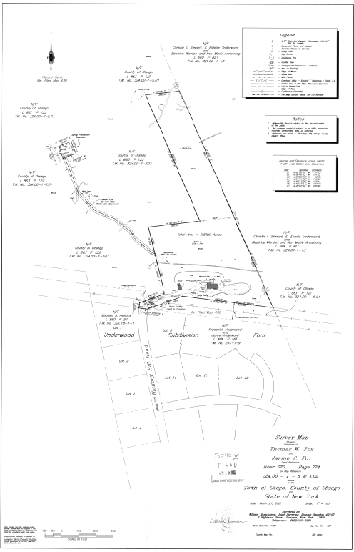 Page 5

Hickory Hills Access Map

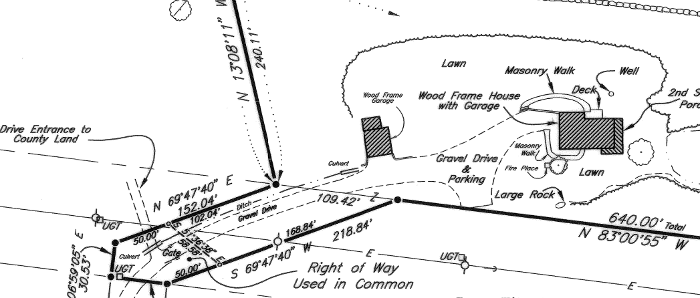

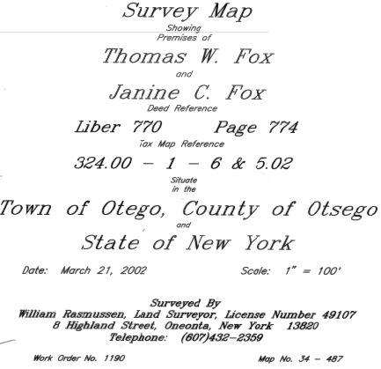
Page 6

Overview Map Hickory Hills
Otsego #15

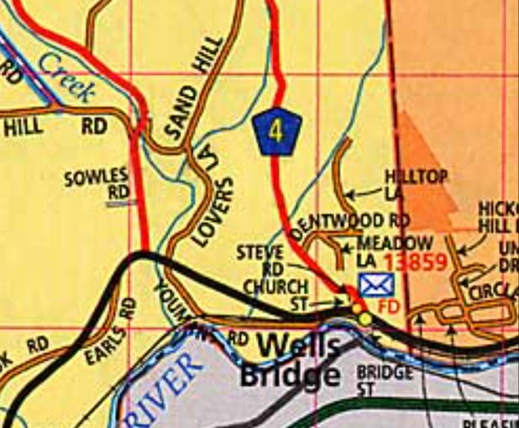

Page 7

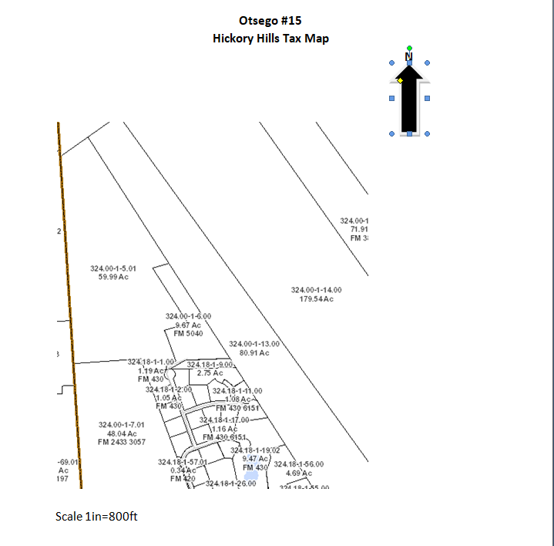

Page 8

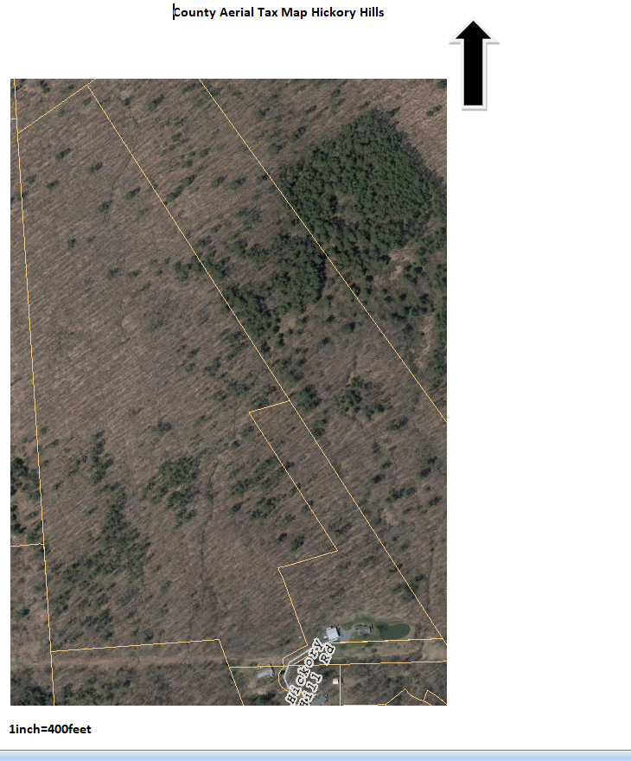
Page 9

Otsego #15 Hickory Hills
Topographic Map
N

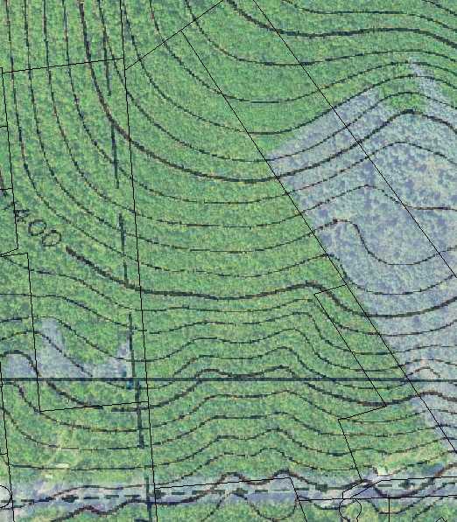
Scale: 1:6000

Page 10

USGS Soils Map
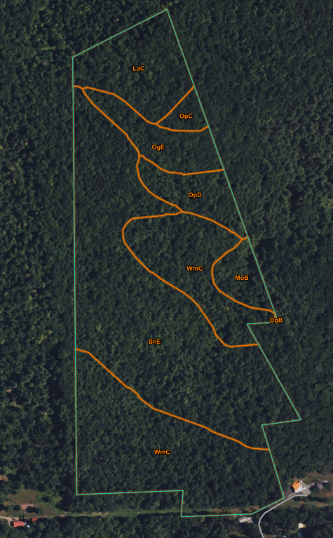
Scale 1:3590 Page 11

USGS Soils Legend
Map Unit Symbol | Map Unit Name
BhE | Bath and Lackawanna soils, 15 to 35 percent slopes, extremely stony Well drained
LaC | Lackawanna channery silt loam, 8 to 15 percent slopes well drained
MoB | Morris channery silt loam, 2 to 8 percent slopes poorly drained
OgB | Oquaga-Arnot complex, 1 to 8 percent slopes, rocky well drained
OgE | Oquaga-Arnot complex, 25 to 45 percent slopes, rocky well drained
OpC | Oquaga and Lordstown soils, 8 to 15 percent slopes, very rocky well drained
OpD | Oquaga and Lordstown soils, 15 to 25 percent slopes, rocky well drained
Page 12
USGS Soils Legend

Map Unit Symbol | Map Unit Name
OpD | Oquaga and Lordstown soils, 15 to 25 percent slopes, rocky well drained
WmC | Wellsboro and Mardin soils, 3 to 15 percent slopes, extremely stony moderately well drained

Page 13

Hickory Hills County Forest Stand Map

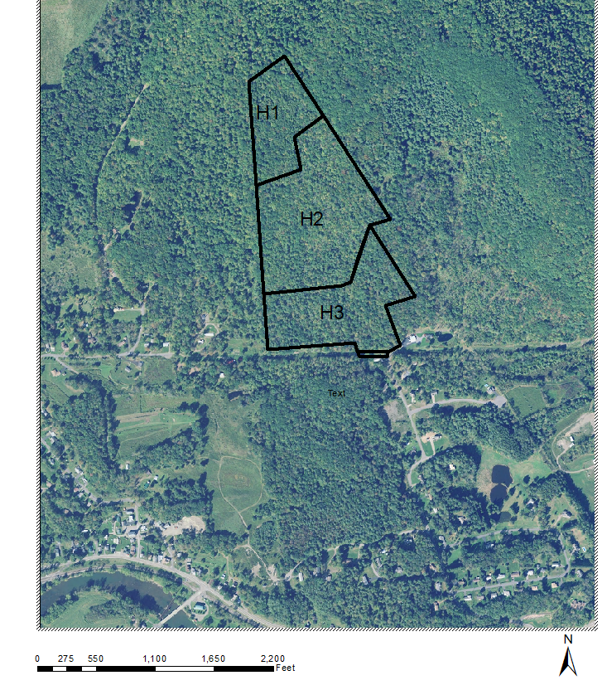
Page 14

Desired Future Conditions

The overall future condition of this property should focus on the continuous production of high quality forest products from commercially important softwood and hardwood species. Substantial amount of merchantable high quality and low value hardwood and softwood is present in this parcel in varying degrees of density in many of the forest stands. It is envisioned that a harvesting program be instituted for the whole parcel. Control of interfering vegetation: mainly American Beech should be a priority. Future end state would be: completed harvesting for the parcel as a whole, on a twenty year rotation before any additional substantial forest management activities. Encouraging and promoting biodiversity helps overall forest and ecosystem health. Resiliency of the forest through diversity is another future benefit in the face of possible threats from invasive species, native pathogens, and possible climate change. It is envisioned a future forest with three or more succession stages of forest stands.

Page 15

Goals and Objectives
Forest Inventory
Complete a comprehensive inventory of three forest stands. Inventory was completed December 2022 that included assessment of commercially important timber species, acceptable growing stock (AGS), and also low grade or pulpwood that also includes interfering vegetation.

Problem identification
Results of the inventory, together with observations of the Forester on any threats or impediments that would mitigate the overall effort to achieve the desired future condition of the parcel or stand will be identified in each individual forest stand write up. The “Keep Forests Healthy” scorecard by The Nature Conservancy, Cornell Cooperative Extension of Onondaga County will be implemented also.

Trail Maintenance
There is mainly a primary and several secondary skid roads on the property that are in good condition. A goal would be to continue the present condition or upgrade where needed and maybe mark possible hiking trails.

Recommendations
Prescriptions on individual forest stand to be outlined and aligned with future desired conditions. Recommendations to include implementation and alignment with desired future parcel conditions with the individual forest stand. Prescriptions will include considerations for basal area and trees per acre (TPA), volume (board feet and cords), Acceptable Growing Stock (A.G.S.), pulpwood, but also for species, vigor, invasive species, wildlife, ecology, and Forester experience.

Page 16

Inventory Methodology
Forest inventory was conducted on the three forest stands that compromise Otsego County Forest #15. Forest Stands were constructed based on species composition, basal area, forest cover type, geological considerations, and past cutting history. Each stand was inventoried by using variable plot radius data points with a 10 Basal Area Factor (BAF) wedge prism. Trees that fall into each data plot was measured for Diameter at Breast Height (DBH) with a Biltmore stick and their height was determined by the judgment of the Forester. Species of every tree in the data plot was recorded. Recorded data will be averaged throughout the stand to determine the stand’s basal area, trees per acre, species composition, product classification, and overall health. Each stand will have a different number of data plots based on their area measured in acres. The chart used to determine the number of data plots for each stand can be seen in Table 1.
Table 1 Ratio chart of plots in a stand
Acres | # Of Plots
0-4 | 3
5-7 | 4
7-10 | 5
10-15 | 7
15-25 | 10
26-30 | 14
31-40+ | 15

Page 17

Hickory Hills County Forest #15
Stand Acreage and Plot table
Stand Number | Acres | Plots
H1 | 11.5 | 7
H2 | 28.81 | 14
H3 | 19.58 | 10

Page 18

Forest Stand H1
Soil types: Lackawanna channery silt loam, 8 to 15 percent slopes well drained is primary, Oquaga-Arnot complex, 25 to 45 percent slopes, rocky well drained , and Bath and Lackawanna soils, 15 to 35 percent slopes, extremely stony Well drained. The ability to operate forest management equipment is very good. Stand. H1 is located in the most northerly terminus of Otsego #15 Hickory Hills. This is a northern hardwood stand that was harvested many years ago that apparently centered on the highest valued trees/species and did not take into account American Beech. Beech is very prevalent within this stand and constitutes the main problem. An addition, Popple or Aspen is found in unusual amounts within stand H1.

Forest Diversity and Composition
Seven tree species were sampled in H1 with three species accounting for 59 trees per acre out of 68 (67.72) total. Therefore species diversity can be assessed at average at best, if not below average. Species suitability to the growing site is judged to be good with good growth characteristics present in the top three species of Red Maple, Red Oak, and Popple. General tree health is good with the exception of American Beech which has the beech bark disease. The beech also shows poor growth habits and crown development leading to the conclusion of poor health in addition to the beech bark disease.

Forest Structure
This stand contains hardwood trees of varying sizes and forms multiple vertical layers mostly in the timber, sapling, and seedling classes. There is some pole timber class found with 8.18 trees per acre but does constitute some concern. Therefore structural diversity can be judged to be average or above average. Average amounts of standing dead trees and down dead wood, mostly American Beech was observed within this stand. Fauna and flora dependent upon these two observations should find acceptable habitat. Tree crown development is actually tied to spacing and was observed to be average especially in the Red Maple, Red Oak, and Popple (Trembling Aspen) species. The pulp class (all Beech)
Page 19
shows 24.13 trees per acre with a basal area per acre of 6.80 square feet, and 1.54 cords per acre that expresses concerns for slowing or retarding some crown future development.
Regeneration
Forest Stand H1 has a significant problem in the seedling class which represents the future forest. Most if not all the seedlings are American Beech. There are some saplings but not many. The beech constitutes an interfering plant that should be addressed. Beech thrives in shade and if allowed to continue will eventually dominate this stand. No desirable regeneration was observed. Beech suitability to the growing site is judged to be marginal. The prominence of American Beech in this stand could be the result of 1) past high grading logging practices, and also 2) deer browsing of desirable tree species.

Site Level Risks
Highest risk to this stand would be judged to be wind throw and/or ice storms. But due to the nature of this stands dynamics it is felt the chance of occurrence of the proceeding happening to be low. Moisture stress, drought, extreme rainfall are deemed to not constitute a threat to stand H1. Shorter and milder winters affect would be largely in accessibility.

Stand Prescription
American Beech is the main focus with the species dominating the regeneration and its dominance of the pulp classification as a result of beech bark disease. Preferably a summer cut centering on removal of the pulp class (leaving 5 to 6 cavity trees per acre for wildlife) together with scarifying (with logging equipment) to mineral soil where ever beech regeneration is substantial. Herbicidal treatment is possible also. An occasional Red Maple or Red Oak can be harvested so as to include monetary reward but only a few. Red Oak to be discriminated for where ever possible. This prescription should be undertaken in conjuncture with neighboring stand harvesting.

Page 20

Stand Data
Species | Trees per Acre (TPA) | Basal Ares per Acre (Sq.Ft) | Board Feet per acre (F.C. 78)
Red Maple | 19.14 | 31.72 | 2752
Red Oak | 11.01 | 21.57 | 2513
Popple | 28.90 | 11.38 | 1558
White Ash | 3.23 | 8.12 | 837
Eastern Hemlock | 2.64 | 4.94 | 451
Black Birch | 1.46 | 3.95 | 392
Sugar Maple | 1.34 | 1.07 | 188

Total | 67.72 | 82.75 | 8691
AGS | 8.19 | .70 | .21 cords
Pulp | 24.13 | 6.80 | 1.54 cords

Page 21

Forest Stand H2

Bath and Lackawanna soils, 15 to 35 percent slopes, extremely stony Well drained, Morris channery silt loam, 2 to 8 percent slopes poorly drained, Wellsboro and Mardin soils, 3 to 15 percent slopes, extremely stony moderately well drained, and Oquaga and Lordstown soils, 15 to 25 percent slopes, very rocky well drained are the soil types found within the confines of the approximate 28.81 acres of this stand. Most of this stand is well drained and lends itself well to forest management equipment. Located in the midsection of Otsego #15 Hickory Hills, this stand occupies the largest acreage and also diversity of species and growing sites. This stand was harvested long ago, approximately 40 to sixty years ago.

Forest Diversity and Composition

This stand has good species diversity with five species with five trees or more per acre, eleven species recorded overall. However, Red Maple is dominant with 33 trees per acre and 72 square feet of basal area, 4130 board feet per acre. Eastern White Pine has large size and boasts 43 square feet of basal area and 2200 board feet per acre. Species compatibility with the growing site is good with all exhibiting good growth characteristics. General and overall tree health is judged good also with no insect or disease factors observed.

Forest Structure

Complexity best describes stand H2 with trees of different sizes as well as multiple vertical layers. The southerly section of this stand features a mosaic form of varying vertical layering with Eastern White Pine and northern hardwoods intermixed. Average to lower occurrences of standing dead trees and downed dead wood were observed within this stand. Tree crowns were judged to be well developed with tree spacing becoming more dense and crowded.
Page 22

Regeneration

Complexity is a descriptive term also for this stands reproduction and hence the future forest. Variation is found throughout H2 with significant American Beech Saplings present in certain areas and in other areas Red Maple, Black Birch, and Sugar Maple saplings. Seedlings were not found in any significant amounts. Species suitability to the growing site is judged to be good. The main interfering plant is American Beech in varying densities. Deer browsing is significant throughout this stand as seen in the absence of desirable hardwood seedlings.

Site Level Risks

Being located on a hillside with mostly well drained soils the highest risk to this stand would be wind storms. However it is felt that the chances of this occurring is relatively low. Shorter and milder winters would have little effect on the management of this stand.

Stand Prescription

Given the high density of this stand of 175 square feet of merchantable basal area, and 9,693 board feet per acre, it is recommended that a timber harvest take place implementing a individual tree selection method, silvical system. Goals: 1) reduce basal area to plus or minus 120 square feet. 2) to center on Red Maple density reduction, 3) harvesting of only select very mature Eastern White Pine, 4) promotion of greater species diversity by taking advantage of the other hardwood species being left to occupy the micro site, 5) encourage optimal growth of the AGS pole timber, and 6) to effectively remove about 10 square feet of pulp give or take with cavity trees left where ever possible.

Page 23

Stand Data
Species | Trees Per Acre (TPA) | Basal Area (sq. feet/acre) | Bard Feet/acre (F.C. 79)
Red Maple | 33.53 | 72.33 | 4130
Eastern White Pine | 8.44 | 43.87 | 2277
Popple (Aspen) | 5.29 | 11.07 | 630
Red Oak | 2.08 | 8.63 | 506
Sugar Maple | 6.14 | 8.54 | 491
Shag Bark Hickory | 1.89 | 7.46 | 474
White Ash | 3.17 | 8.71 | 454

Black Birch | 6.1 | 6.55 | 393
Eastern Hemlock | .57 | 6.05 | 198
Black Cherry | 1.31 | .55 | 47
White Oak | .40 | 1.77 | 93
Total | 68.92 | 175.53 | 9693
AGS | 20.56 | 4.32 | 1.12 cords
Pulp | 13.67 | 19.19 | 1.34 cords

Page 24

Forest Stand H3

Wellsboro and Mardin soils, 3 to 15 percent slopes, extremely stony moderately well drained, and Bath and Lackawanna soils, 15 to 35 percent slopes, extremely stony Well drained are the two soil types that are found within the confines of Forest Stand H3’s 19.58 acres. Te ability to work with forest management equipment is good. Located in the most southerly section of Otsego #15 and bordering in part Hickory Hills Road, this stand is on a gradual side hill with a southerly aspect. Part northern hardwood and part mature White Pine plantation this stand boasts species diversity. In many areas, this stand also projects a park like appearance and an unusual ecosystem.

Forest Diversity and composition

Stand H3 boasts many tree species without a single tree species being overly dominant. Four hardwood species and one coniferous specie present significant basal areas within this stand. Species suitability to the growing site is good for the hardwoods, marginal for the White Pine. General tree health is good for the hardwoods and only fair for the White Pine which shows declining health and poorer growth in many individual trees. No insect or disease vectors were observed upon stand sampling.

Forest Structure

Good structural diversity exists with good vertical layers that contain varying sized mature timber, Pole timber (AGS), and saplings, especially in the hardwoods. Average amounts of standing dead trees and downed dead wood was observed within this stand. Tree spacing is good leading to large healthy crowns in the hardwoods. The White Pine shows over maturity with some higher density of spacing with poorer growth and crown development on some individual trees.
Page 25

Regeneration

Forest stand H3 boasts good desirable regeneration of primarily hardwood saplings and some seedlings. The regeneration represents the future forest and shows good species diversity within the hardwood sector and also resiliency for future climate change and wildlife. The reproduction is well suited to the growing site except for the Red Maple. Interfering plants wild grape and American Beech are found in various locations and densities within stand H3. Deer browsing within this stand is judged to be moderate.

Site Level Risks

Because of the southerly exposure, slope, and soil types, the highest risk is assigned to moisture stress during exceedingly dry conditions. Shorter and milder winters would not affect the viability of working within this stand.

Stand Prescription

A modest timber harvest is recommended for this stand utilizing the individual tree selection silvical method. Within the White Pine stand, removal of the poorer growing trees with periodic cutting of good quality over mature individuals to both recover value and promote adjacent quality tree growth. Not to exceed 10 square feet per acre. Retention of significant healthy White Pine residuals promotes diversity,
Within the hardwoods, removal of the Red Maple where ever mature is promoted. Favoring of nut trees oak and hickory for residuals is also encouraged where ever density and competing trees will allow. Promoting the AGS/Pole timber growth where ever possible is another goal. Basal area reduction of 10 to 20 square feet is recommended.

Page 26

Forest Stand H3 Data
Species | Trees per acre (TA) | Basal Area per acre | Boad Feet per acre F.C. 78
Shag Bark Hickory | 16.23 | 31.63 | 2662
White Pine | 9.07 | 33.15 | 2072
Red Maple | 17.11 | 22.00 | 1608
Red Oak | 11.86 | 18.55 | 1543
Sugar Maple | 4.39 | 12.07 | 465
White Ash | 2.13 | 3.94 | 286
Popple | .57 | 1.77 | 80

Black Birch | 1.27 | .79 | 71
Total | 62.63 | 123.90 | 8787
AGS | 55.40 | 5.32 | 2.33 cords
Pulp | 5.65 | 10.25 | .83 cords

Page 27

