SWCD Minutes 10/10/22 Approved 102422
SWCD Board of Directors’ Meeting October 10, 2022
In attendance:
Directors: Meg Kennedy (Ch), Helene Kraham, Jennifer Mickle, Ed Lentz
District staff: Others:
Minutes taken by Ed Lentz.
Chair Meg Kennedy opened the meeting at 10:00am.
A motion to approve the minutes of the 9/26/22 meeting was made by Jennifer, seconded by Helene and passed unanimously.
A motion to accept the July financial reports was made by Helene, seconded by Jennifer, and approved unanimously. Review of the August and September financial reports was deferred until the meeting on 10/24/22.
Performance Measures and the 2023 Annual Plan of Work (APOW) were discussed. Meg will draft responses for PM1 (Ed will review minutes for training at board meetings) and will ask the staff to draft responses for PM’s 2 through 5. Meg will also discuss the APOW with the staff and request staff to update the 2022 plan for 2023. There is consensus that we should not rush to renew applying for large grants, e.g., AgNPS, but instead should proceed cautiously until we are fully staffed and have our house in good order.
A motion was made by Jennifer and seconded by Helene to approve payment of the bills listed in Abstract # 4-2022. The motion carried unanimously.
Meg reported that Christos Galanopoulis and Jenna Utter will start in November. Ed will send background materials to Christos and Jenna, e.g., District Policies, the AGM SWCD Operations Manual, the 2022 Performance Measures, the 2022 Annual Plan of Work, and recent meeting minutes.
Grant closeouts were discussed. Re: Beecher, AGM requires more info re: the interest calculation and questions Parker Inv # 487 b/c it is not itemized and so it is not clear what Inv # 487 covers that is not already included in Inv # 467. Ed will send the invoices and bid to Meg for discussion with staff.
Re: Buffer, Karl’s meeting with Scott last week was postponed until Wednesday of this week.
Re: Hughes, this closeout remains in early stages.
Meg reported that she is making progress with Assemblyman Miller’s office re: reimbursement of the Town of Westford.
Page 1 of 2
SWCD Minutes 10/10/22 Draft, 101022
The subject of auditing was discussed. Ed reviewed the audit responsibilities as set out in the AGM District Operations Manual and the Corrective Action Plan. There was discussion about the financial review of the Tafel, Beecher, and McGrath closeouts by Insero and the operational audit being done by the Comptroller’s office (which identified financial irregularities but no evidence of malfeasance). There was consensus that a financial audit should be done and that the county can have it done when it has its own finances reviewed. Meg confirmed that the county had previously said they would do that but she will confirm with Treasurer Allen Ruffles.
The preliminary budget was discussed briefly and tabled for review and approval at the meeting on 10/24.
Upcoming meeting dates: 10/24/22 at 1:00pm, 11/24/22 at 10:00am, 11/28/22 at 1:00pm. Ed advised that he will be unable to attend the 11/14/22 meeting.
The meeting was adjourned on motion by Jennifer, seconded by Helene, and approved unanimously at 11:30am.
NEXT MEETING: October 24, 202, 1:00pm, Meadows Classroom B.
Page 2 of 2

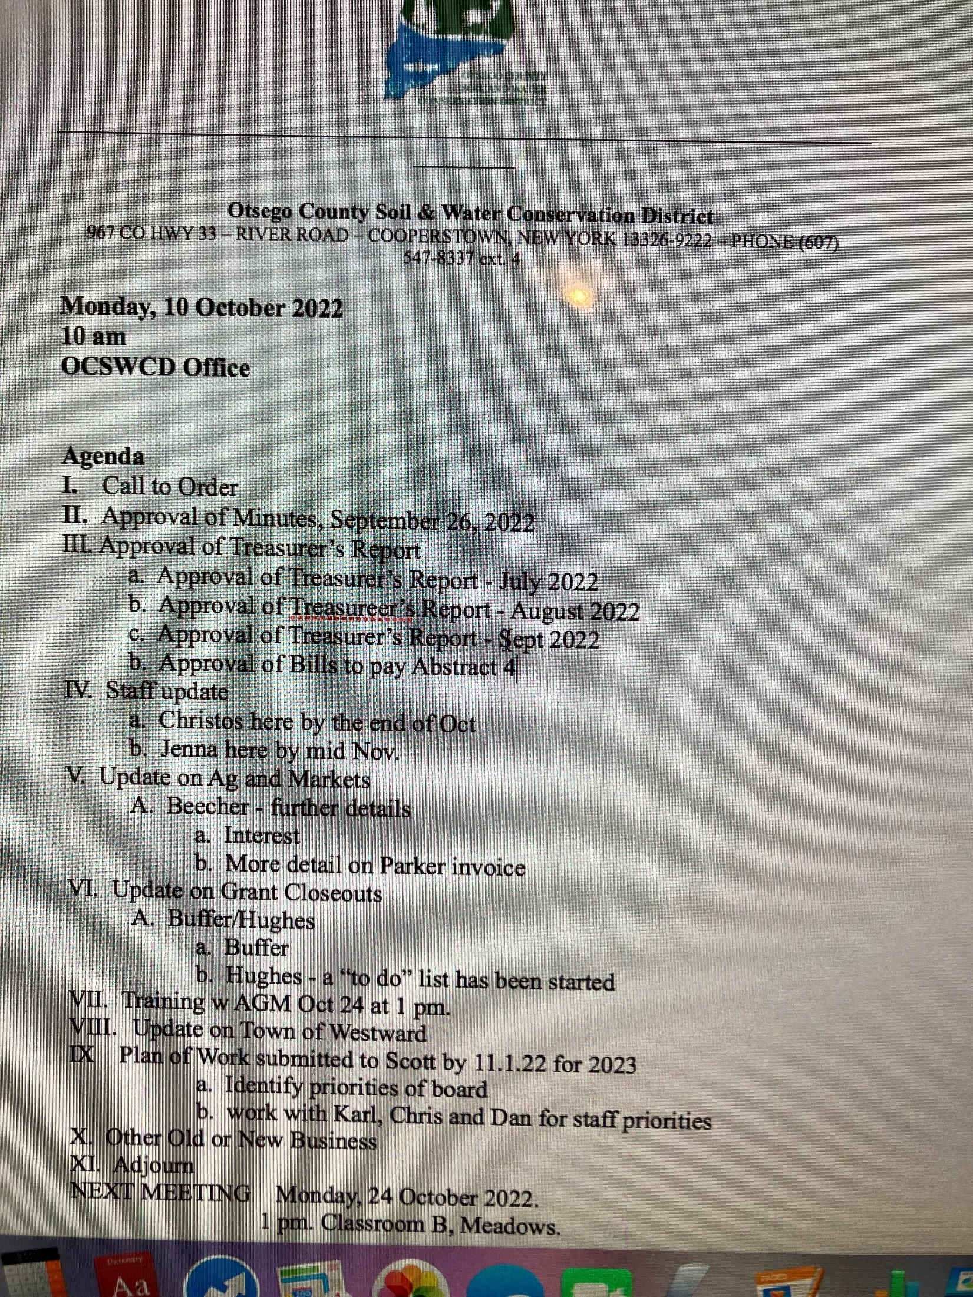
SWCD Minutes 10/24/22 Approved 12/19/22
SWCD Board of Directors’ Meeting October 24, 2022
In attendance:
Directors: Meg Kennedy (Ch), Darin Hickling, Helene Kraham, Jennifer Mickle, Ed Lentz District staff: Karl Jiroux Others:
Minutes taken by Ed Lentz.
Chair Meg Kennedy opened the meeting at ~1:10pm.
Bills were passed around for audit by the directors.
The minutes of the October 10 meeting were approved unanimously on a motion by Jennifer, seconded by Helene.
The Financial Reports (Balance Sheet and P&L) for August were were approved unanimously on a motion by Helene, seconded by Jennifer.
The Financial Reports (Balance Sheet, P&L-Detail and P&L) for September were were approved unanimously on a motion by Jennifer, seconded by Darin.
Chris A’s report of activities during the month of September was received on 10/10/2022. A copy is appended to these minutes.
Karl reported that he has been busy with his usual activities, including working on the grant closeouts.
With respect to the closeouts, Karl and Meg reported that we are in position to respond to AGM’s comments re: the Beecher closeout: (1) Parker issued a corrected invoice that makes clear that all work was completed; (2) Karl is fixing the interest statement and will provide an explanation. Karl will provide a draft of the response to Meg and Ed no later than the week of November 7.
Buffer: With Scott’s guidance, Karl is assembling a completed package for review by Meg and Ed no later than the week of November 7.
Hughes: Karl and Chris, with help from our USDA colleagues, are creating a file for use in preparing a closeout submission and now have a “to do” list.
Karl reported that he was unable to find checks written to our most recent (2020 or 2021) interns. Jennifer will look for them after the meeting.
Karl presented the AEM time sheet current as of 10/24/22. The board discussed the hours worked for AEM and agreed that we would try to get more hours this year and next year but at least we have covered our 25% advance.
A motion was made by Darin and seconded by Jennifer to submit a Part B request for purchase of hydroseeding materials. Following discussion of this and other possible
Page 1 of 2
SWCD Minutes 10/24/22 Approved 12/19/22
uses, the motion carried unanimously. Ed will prepare the Part B request for submission to Scott by October 31.
Meg reported that she received an inquiry from the Butternut Valley Alliance about minigrants. It was agreed that the mini-grants are a good idea and that we should include $10K to $15K in the 2023 budget for this purpose. Ed suggested a separate line item for this. The money would come from our Part C funds.
Other slight budget modifications were discussed, e.g., increasing State and Other Dues to cover NYACD and NACD.
Ed will modify the preliminary budget for review and approval by the board at the 11/14/22 meeting. Meg will then present the budget to SWECC at its meeting on 11/15/22.
The bills were discussed. Meg noted that the NYSEG bills which were overdue. Jennifer could not find checks in QB showing that they had been paid. NYSEG warned us of a possible disruption of service if the bills were not paid.
Bills for the printer/copier were also discussed. We have/had been being billed by Ed & Ed, DeLage and Leaf relating to the printer/copier but it’s not clear why. It also appears that we are still paying Verizon for phones that had been assigned to past employees. Meg will look into these apparent anomalies.
Ed noted that vouchers should be coded to match our QB codes to make sure payments get charged to the correct budget line items. Vouchers numbered 41 through 57 totaling $7,039.52, as shown in the attached abstract were unanimously approved for payment following a motion by Darin, seconded by Jennifer.
Ed recommended that we review a draft Performance Measures Evaluation Report in November, preferably early November so that we can self-evaluate achievement prior to submitting the report to AGM.
The 2023 Annual Plan of work was discussed. Using the 2021 APOW as a template, the board developed plans for 2023. Based on that discussion, Meg will draft the 2023 APOW for submission to Scott by October 31.
The meeting was adjourned at ~3:40.
Next Meeting: November 14, 10:00am, Meadows Classroom B
Page 2 of 2

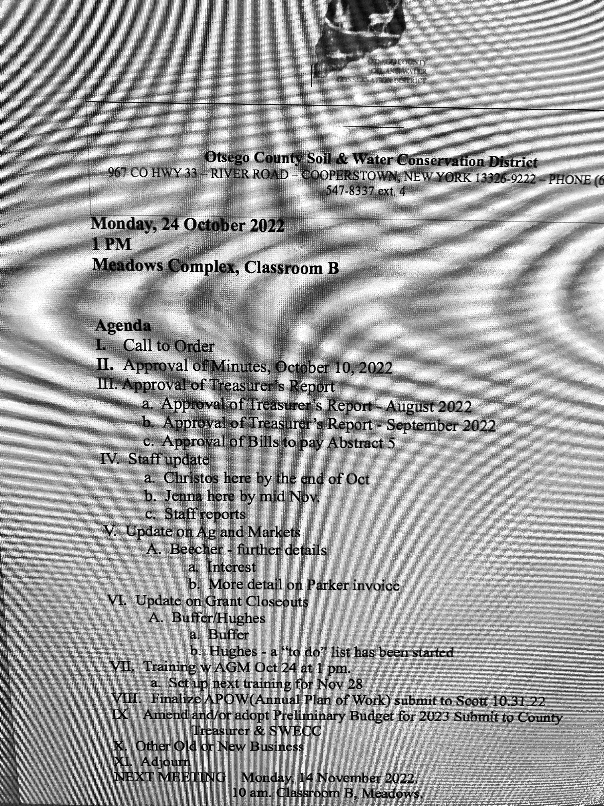

 | OCSWCD Abstract #5 - October 24, 2022
Inv # | Inv $ | Vendor | Brief Descr | Acct Code
41 | $26.76 | Ed & Ed | printer, copier | 8730.443
42 | $372.78 | Verizon | Mobile phones | 8730.442
43 | $775.00 | NACD | Dues | 8730.46
43 (2) | $125.00 | Soc Am Foresters | Dues | 8730.46
44 | $580.00 | Mike’s Cleaning | Cleaning | 8730.404
45 | $130.72 | Royal Ford | Auto Maintenance | 8730.461
46 | $110.00 | ASA-CSSA-SSSA | Training | 8730.43
47 | $1,656.00 | Cincinnati Insur Co | Insurance | 8730.452
48 | $327.20 | United Concordia | Dental Insurance | 8730.8
49 | $139.98 | Spectrum | Cable | 8730.442
50 | $64.99 | Key Bank
51 | $289.00 | Domain Membership Networks | Internet | 8730.442
52 | $51.91 | Russ Smith | Garbage Removal | 8730.404
53 | $345.00 | Green Circle | Accounting | 8730.404
54 | $474.71 | NYSEG x217 | Electric | 8730.441
55 | $121.16 | NYSEG Forestry | Electric | 8730.441
56 | $1,325.71 | NYSEG main | Electric | 8730.441
57 | $123.60 | Huan Welding
Total | $7,039.52
 | Approved for payment on 10/24/22.
1

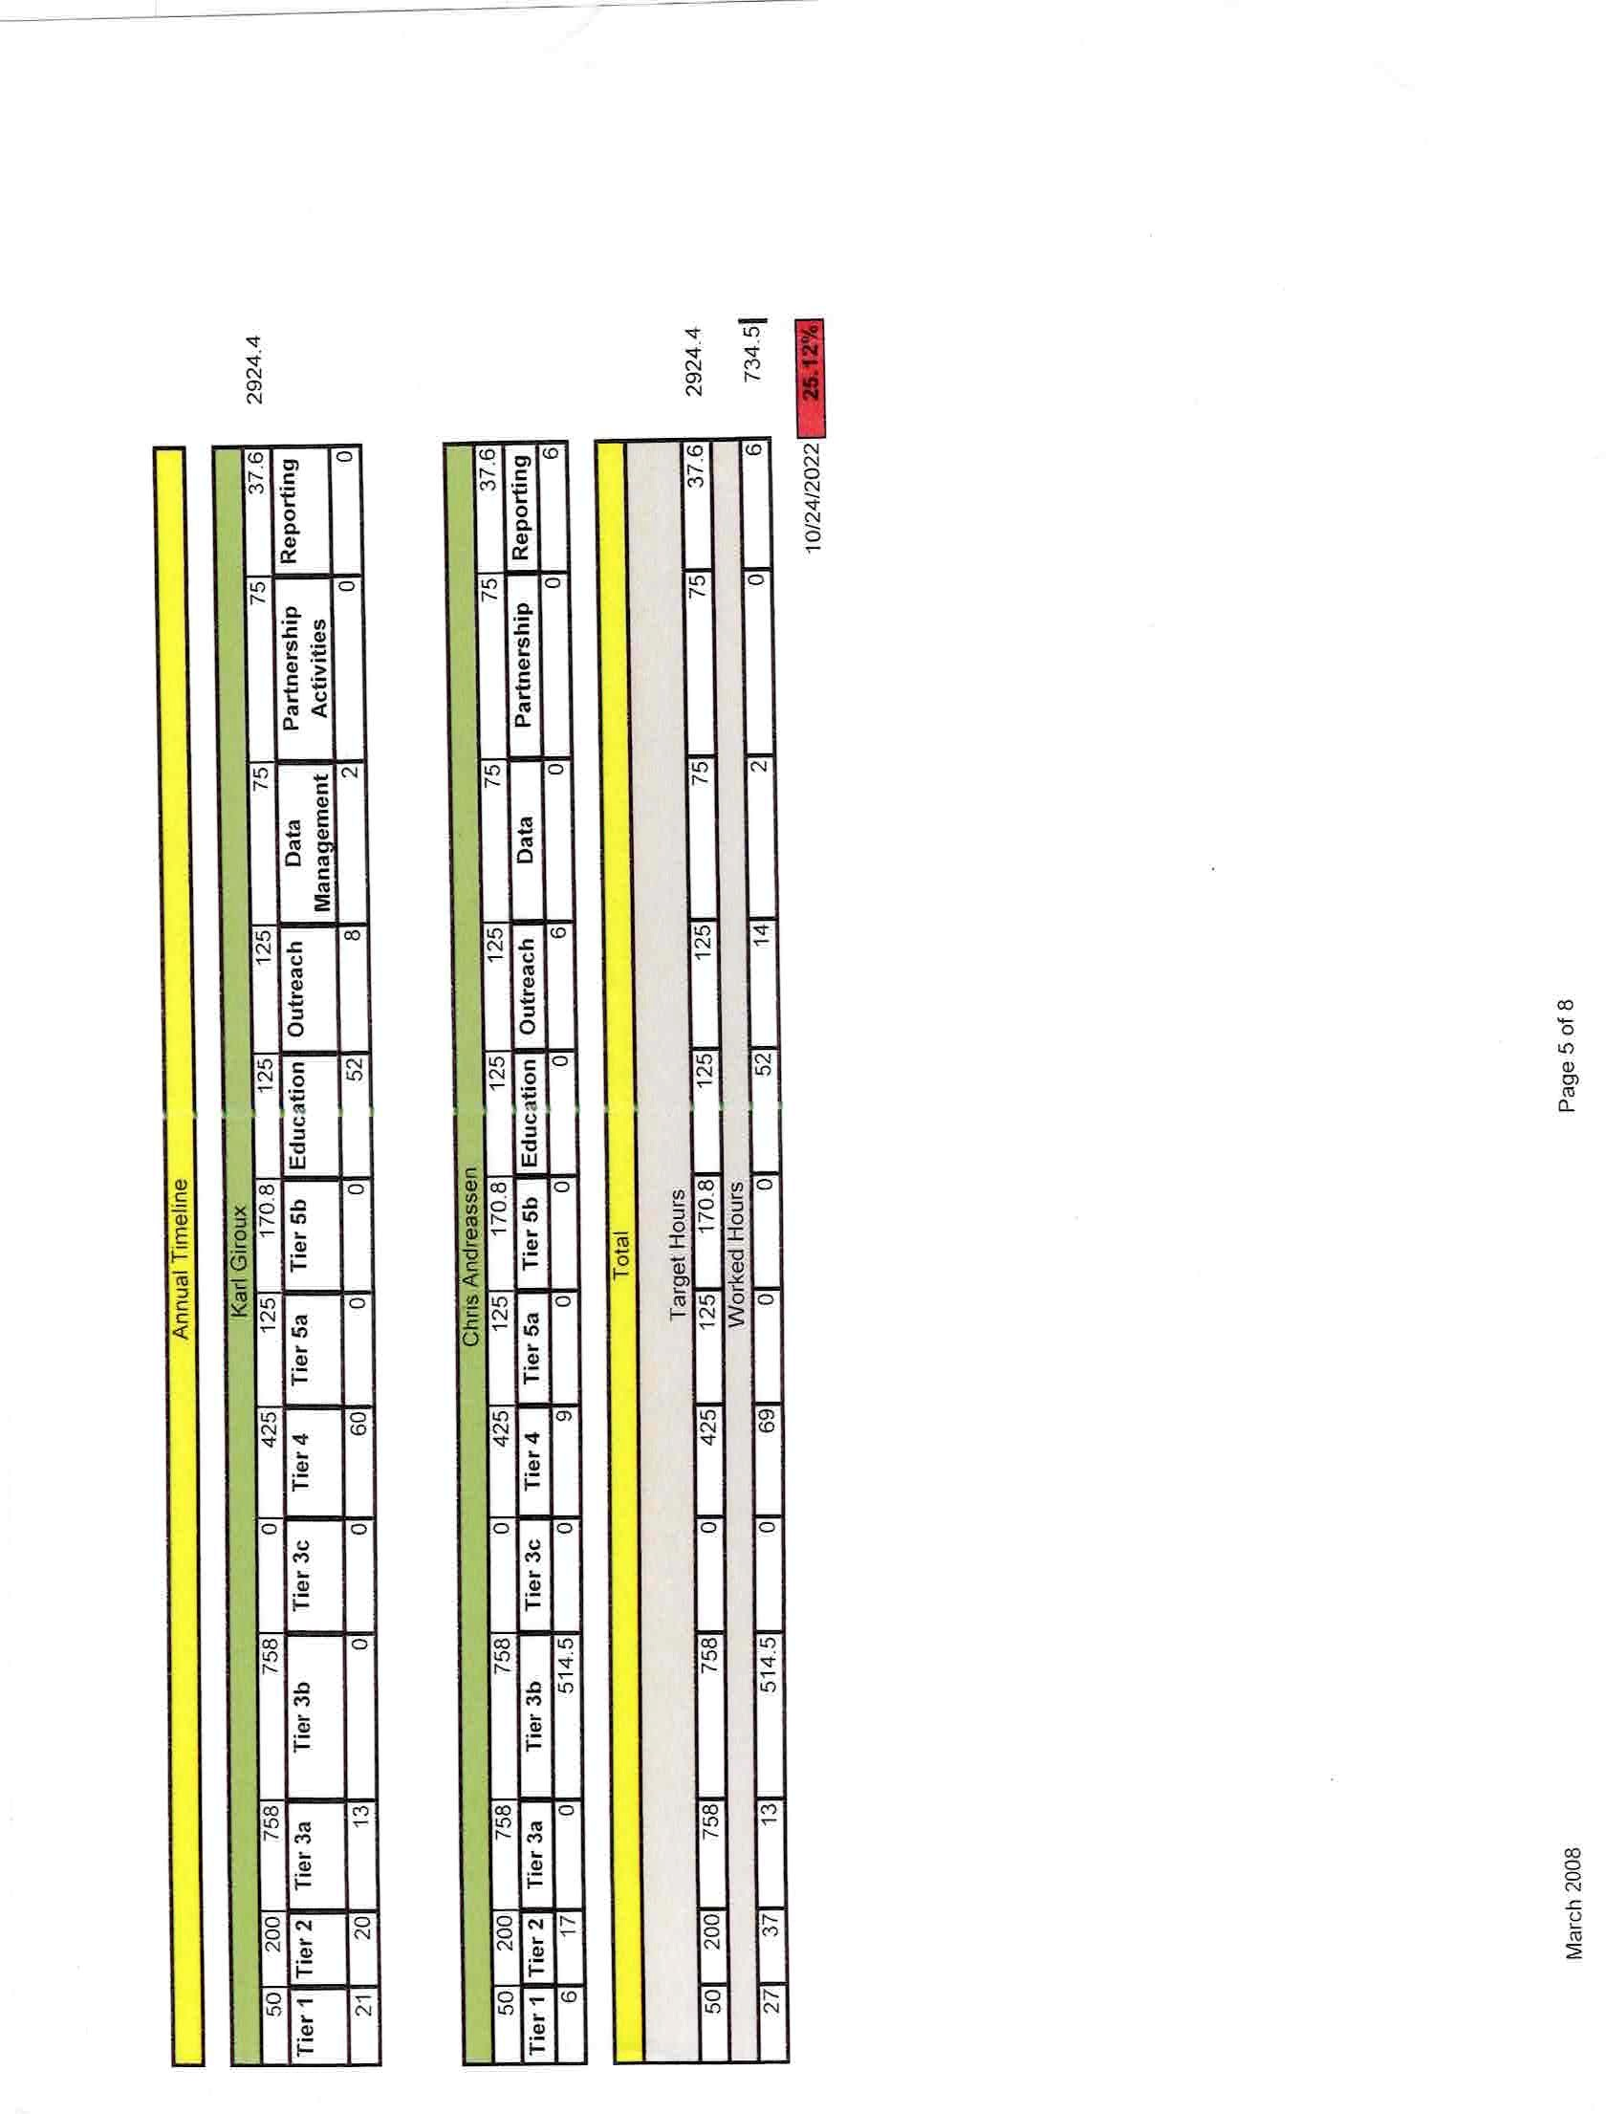

_________________________________________________________________________________

Otsego County Soil & Water Conservation District 967 CO HWY 33 – RIVER ROAD – COOPERSTOWN, NEW YORK 13326-9222 – PHONE (607) 547-8337 ext. 4

Chris Andreassen
Board Report
9/9-10/11/2022

AEM #077-0536 CNMP:
- Conservation Plan
- Nutrient Management Planning
- Cropland Planning
- Soil Sampling/prep/paperwork
- Farm Maps
- Farm Waterbodies Maps
- Manure Spreading Setback Maps
- Animal Waste Management Plan completed

AEM #077-0538 CNMP:
- Conservation Plan
- Nutrient Management Planning
- Cropland Planning
- Soil Sampling/prep/paperwork
- Farm Maps
- Farm Waterbodies Maps
- Manure Spreading Setback Maps
- Animal Waste Management Plan completed

AEM #077-0529 CNMP:
1. Animal Waste Management Plan completed

Misc.
- Buffer Grant (Seamon, Jordan, Mitchell)
- Lincpass/USDA computer updates
- AEM Hour Tracker

Trainings:
- Alternative Manure Management (WQS)
- Iodine as a Plant Nutrient (CCA Continuing ed)
- Overwintering Livestock: Opportunities, Challenges and Management Considerations (WQS)

CONSERVATION – DEVELOPMENT – SELF-GOVERNMENT

5 7-/ 2//
80 1
&
/7 /
2/-4371 371
7/ 3-/. 7.
C 7.
C & 2/-4371
C & 371
&8 5 7/ 3-/. 7.
/ 3-/. 7.
C) / 53B 88.37 371 866
C 8B 7.
C) / 53B 88.37 371 866 2/
&8 5 C) / 53B 88.37 371 866
C / 2/ 8-4371 7 3 2/-4371
C / 2/ 8-4371 -285 239
C 2/-4371&3/
7 --8 7
C & 7 00/
C & 7 12/
C & 7 - 2
C & 7 & 0/5
C & 7 B.8)
C & 7 54 4
C & 7 (
C & 7 B 00/
C & 7 B 00/
C & 7 //-2/ /
C & 7 8 7.
&8 5 7 --8 7
&8 5 / 3-/. 7.
C 5/ 371 8 / --8 7
&8 5 2/-4371 371
--8 7 /-/3 ,5/
C --8 7 /-/3 ,5/
&8 5 --8 7 /-/3 ,5/
2/ /7 /
B855 8 /-387
1

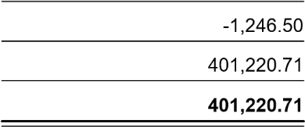
&8 5 2/ /7 /
&8 5 /7 /
& &
3 ,3533/
/7 3 ,3533/
--8 7 B,5/
C --8 7 B ,5/
&8 5 --8 7 B,5/ /.3 .
C /B 74 /.3 | .
&8 5 /.3 .
2/ /7 3 ,3533/
2 / 3-/ /.3 B6/7
& & &
5 7-/ 2//
80 1
1

B855 3 ,3533/
2
235. 998 /./ 5& A/ A-/55
C / /3/6/7 2 C 8 9 7 7-/ A-/55
C 7-86/& A
C /./ 5 7-86/& A
C 7-86/ A/- 387 235. 998
&8 5 B855 3 ,3533/

&8 5 2/ /7 3 ,3533/
&8 5 /7 3 ,3533/
&8 5 3 ,3533/
: 3B
C 7/ 3-/. / /
/ 7-86/
&8 5 : 3B
& & & &
803 8
1
1 7 1

.37 B 7-86/ A9/7 / 7-86/
C / /7 /
C 2/ / /7 / / 3-/
C 3 3- &// 81 6
&8 5 C / /7 /
C 7//
C /7 580 : 396/7 C 8 7B 99893 387 7
C 8 7B 558- 387 7-86/
C 8 7B 8/ B 81 6 7.
&8 5 C 8 7B 99893 387 7
C 3 - / /7 /
C 1( 5 / 835 8 9)84 2//
C 7 38287
C 8B 7.
C /7
C 1/7-B0 7./.
&8 5 C 3 - / /7 /
C / 3. 7 /36,
C 7.371
C 7.371
&8 5 C / 3. 7 /36,

&8 5 7-86/
8 803
A9/7 /
C 1 4/ /9 B6/7 A9/7 / C / 87 5 / 3-/
C 3/-8 A9/7 /
C 3 3- 7 1/
C 87 / 387&/-273-3 7
C 2/ 6958B//
C 8/ B&/-2
&8 5 C 2/ 6958B//
&8 5 C / 87 5 / 3-/
C : 396/7
C 003-/ : 396/7
&8 5 C : 396/7
C 87 - 5
C 87 -387
C /08/ 387
C 2/
C 3 3- &// 81 6
C 3 - 9953/ 08 87
C B6/7 8 87/55 835 69
C) / 53B 8663 // 8B
C& /5& 37371/A9 6958B//
C 312 7. /
C&/5/9287/ 7/7/
C 003-/ 9953/
C / -2 7 38287 / 5/ /
C 7 7-/
C 3 ,353B 7 7-/
C 7 7-/ 2/

803 8
1
1 7 1

&8 5 C 7 7-/

C 2/ 87 - 5
C / 82/ . /
C 7 A9/7 /

&8 5 C 2/ 87 - 5

C /9 3 803/5./: 39 C 3508 6 -237/B

&8 5 C 87 - 5
C 6958B// /7/03 C 3A/. / 35.371 C 35.371 37/7 7-/ A9/7 /
&8 5 C 3A/. / 35.371

/ .37 B 7-86/
2/ 7-86/ A9/7 / 2/ 7-86/
7-86/ 7478 7
&8 5 2/ 7-86/
2/ A9/7 /
A9/7 / 7478 7

&8 5 A9/7 /
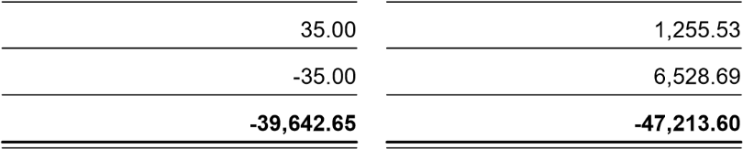
&8 5 2/ A9/7 /
/ 2/ 7-86/

/ 7-86/

Reconciliation Summary
200 · NBT Checking - 0768, Period Ending 08/31/2022
 | Aug 31, 22
Beginning Balance  Cleared Transactions |  | 26,491.44
Checks and Payments - 34 items | -44,095.00
Deposits and Credits - 6 items | 58,570.85
Total Cleared Transactions
14,475.85
40,967.29
-27,283.96
-27,283.96
13,683.33
Cleared Balance
Uncleared Transactions
Checks and Payments - 10 items
Total Uncleared Transactions
Register Balance as of 08/31/2022
New Transactions
Checks and Payments - 23 items | -25,229.05
Deposits and Credits - 3 items | 5,035.92
Total New Transactions
-20,193.13
-6,509.80
Ending Balance
Page 1

Reconciliation Detail
200 · NBT Checking - 0768, Period Ending 08/31/2022
Type Date Num |  |  | Name | Clr | Amount | Balance
Beginning Balance  Cleared Transactions  Checks and Payments - 34 items |  |  |  |  |  | 26,491.44
Bill Pmt -Check | 07/13/2022 | 9942 | Green Circle | X | -1,775.00 | -1,775.00
Bill Pmt -Check | 07/28/2022 | 9935 | Otsego County Trea... | X | -68.71 | -1,843.71
Check | 08/03/2022 | 9942 | IRS | X | -2,020.68 | -3,864.39
Bill Pmt -Check | 08/04/2022 | 9953 | Insero & Co. | X | -8,000.00 | -11,864.39
Bill Pmt -Check | 08/04/2022 | 9961 | SeedWay | X | -6,000.00 | -17,864.39
Bill Pmt -Check | 08/04/2022 | 9951 | Excellus BlueCross ... | X | -4,641.39 | -22,505.78
Bill Pmt -Check | 08/04/2022 | 9960 | Royal Ford Motors ... | X | -2,478.82 | -24,984.60
Bill Pmt -Check | 08/04/2022 | 9959 | Ross, Mike | X | -380.00 | -25,364.60
Bill Pmt -Check | 08/04/2022 | 9966 | Verizon | X | -372.18 | -25,736.78
Bill Pmt -Check | 08/04/2022 | 9957 | NYS Child Support ... | X | -370.00 | -26,106.78
Bill Pmt -Check | 08/04/2022 | 9955 | LEAF | X | -241.17 | -26,347.95
Bill Pmt -Check | 08/04/2022 | 9954 | Key Bank - Cardme... | X | -144.78 | -26,492.73
Bill Pmt -Check | 08/04/2022 | 9963 | Spectrum | X | -139.98 | -26,632.71
Bill Pmt -Check | 08/04/2022 | 9952 | Gillees auto Truck &... | X | -96.91 | -26,729.62
Bill Pmt -Check | 08/04/2022 | 9950 | Ed & Ed Business T... | X | -44.51 | -26,774.13
Bill Pmt -Check | 08/04/2022 | 9962 | Smith, Russ | X | -24.00 | -26,798.13
Bill Pmt -Check | 08/04/2022 | 9965 | United Concordia C... | X | -15.60 | -26,813.73
Check | 08/12/2022 | 9935 | Christopher M. Andr... | X | -1,623.39 | -28,437.12
Check | 08/12/2022 | 9936 | Clements, Jordan D. | X | -1,619.14 | -30,056.26
Check | 08/12/2022 | 9938 | Daniel M. Zimmerman | X | -1,492.29 | -31,548.55
Check | 08/12/2022 | 9937 | Karl A. Giroux | X | -1,081.39 | -32,629.94
Check | 08/12/2022 | 9937 | Karl A. Giroux | X | -142.00 | -32,771.94
Check | 08/17/2022 | 9939 | IRS | X | -2,020.70 | -34,792.64
Check | 08/17/2022 | 9940 | NY Department of T... | X | -749.86 | -35,542.50
Check | 08/23/2022 | 9971 | Verizon | X | -378.95 | -35,921.45
Check | 08/23/2022 | 9975 | NYSEG - 217 | X | -162.12 | -36,083.57
Check | 08/23/2022 | 9972 | Ed & Ed Business T... | X | -26.75 | -36,110.32
Check | 08/23/2022 | 9973 | Key Bank - Cardme... | X | -23.24 | -36,133.56
Check | 08/26/2022 | 9989 | Christopher M. Andr... | X | -1,623.38 | -37,756.94
Check | 08/26/2022 | 9990 | Clements, Jordan D. | X | -1,619.14 | -39,376.08
Check | 08/26/2022 | 9992 | Daniel M. Zimmerman | X | -1,474.81 | -40,850.89
Check | 08/26/2022 | 9991 | Karl A. Giroux | X | -1,081.39 | -41,932.28
Check | 08/26/2022 | 9991 | Karl A. Giroux | X | -142.00 | -42,074.28
Check | 08/31/2022 | 9999 | IRS | X | -2,020.72 | -44,095.00
Total Checks and Payments |  |  |  |  | -44,095.00 | -44,095.00
Deposits and Credits - 6 items
Bill Pmt -Check 05/20/2022 9901 |  |  | Excellus BlueCross ... | X | 0.00 | 0.00
Deposit 08/10/2022 |  |  |  | X | 54,259.24 | 54,259.24
Check 08/23/2022 9976 |  |  | LEAF | X | 0.00 | 54,259.24
Check 08/23/2022 9969 |  |  | Westlake Ace Hard... | X | 0.00 | 54,259.24
Deposit 08/27/2022 |  |  | USDA Treasury | X | 4,310.92 | 58,570.16
Deposit 08/31/2022 |  |  |  | X | 0.69 | 58,570.85
Total Deposits and Credits
58,570.85
58,570.85
14,475.85
14,475.85
Total Cleared Transactions
Cleared Balance  Uncleared Transactions  Checks and Payments - 10 items |  |  | 14,475.85 | 40,967.29
Check 04/20/2022 | 9885 | Weaver, Leslie | -75.00 | -75.00
Check 04/20/2022 | 9866 | Richtsmeier, William | -46.00 | -121.00
Bill Pmt -Check 06/22/2022 | 9930 | The Cincinnati Insur... | -2,219.00 | -2,340.00
Bill Pmt -Check 06/29/2022 | 9935 | Ross, Mike | -380.00 | -2,720.00
Bill Pmt -Check 06/29/2022 | 9934 | NYS Child Support ... | -370.00 | -3,090.00
Bill Pmt -Check 08/04/2022 | 9964 | SUNY Biological Fie... | -938.62 | -4,028.62
Bill Pmt -Check 08/04/2022 | 9958 | Otsego Co Highway ... | -172.46 | -4,201.08
Check 08/10/2022 | 9968 | Hunt, Frederick J. | -22,724.62 | -26,925.70
Check 08/23/2022 | 9970 | Westlake Ace Hard... | -218.28 | -27,143.98
Check 08/23/2022 | 9974 | Spectrum | -139.98 | -27,283.96
Total Checks and Payments |  |  | -27,283.96 | -27,283.96
Page 1

Reconciliation Detail
200 · NBT Checking - 0768, Period Ending 08/31/2022
Type Date Num Name Clr Amount Balance
Total Uncleared Transactions
-27,283.96
-27,283.96
Register Balance as of 08/31/2022  New Transactions  Checks and Payments - 23 items |  |  |  |  | -12,808.11 | 13,683.33
Bill Pmt -Check |  | 09/07/2022 | 9977 | NYS Child Support ... | -740.00 | -740.00
General Journal |  | 09/08/2022 | 73 | Ross, Michael | -725.00 | -1,465.00
Check |  | 09/09/2022 | 9993 | Christopher M. Andr... | -1,623.38 | -3,088.38
Check |  | 09/09/2022 | 9995 | Daniel M. Zimmerman | -1,493.30 | -4,581.68
Check |  | 09/09/2022 | 9994 | Karl A. Giroux | -1,081.37 | -5,663.05
Check |  | 09/09/2022 | 9994 | Karl A. Giroux | -142.00 | -5,805.05
Check |  | 09/13/2022 | 9983 | Excellus BlueCross ... | -4,641.39 | -10,446.44
Check |  | 09/13/2022 | 9980 | The Cincinnati Insur... | -2,529.86 | -12,976.30
Check |  | 09/13/2022 | 9985 | Green Circle | -1,731.50 | -14,707.80
Check |  | 09/13/2022 | 9979 | Ross, Mike | -725.00 | -15,432.80
Check |  | 09/13/2022 | 9981 | Verizon | -509.88 | -15,942.68
Check |  | 09/13/2022 | 9984 | LEAF | -482.34 | -16,425.02
Check |  | 09/13/2022 | 9982 | Otsego Co Highway ... | -87.49 | -16,512.51
Check |  | 09/14/2022 | 10000 | IRS | -1,279.41 | -17,791.92
Check |  | 09/15/2022 | 9996 | Christopher M. Andr... | -1,764.88 | -19,556.80
Check |  | 09/15/2022 | 9998 | Daniel M. Zimmerman | -1,617.80 | -21,174.60
Check |  | 09/15/2022 | 9997 | Karl A. Giroux | -1,189.53 | -22,364.13
Check |  | 09/15/2022 | 9997 | Karl A. Giroux | -142.00 | -22,506.13
Check |  | 09/20/2022 | 10001 | NY Department of T... | -875.67 | -23,381.80
Check |  | 09/21/2022 | 10002 | IRS | -1,390.51 | -24,772.31
Check |  | 09/26/2022 | 9988 | The Daily Star | -290.00 | -25,062.31
Check |  | 09/26/2022 | 9986 | Spectrum | -139.98 | -25,202.29
Check |  | 09/26/2022 | 9987 | Ed & Ed Business T... | -26.76 | -25,229.05
 | Total Checks and Payments |  |  |  | -25,229.05 | -25,229.05
 | Deposits and Credits - 3 items
Check | 09/08/2022 9978 |  |  | Ross, Michael | 0.00 | 0.00
General Journal 09/13/2022 73R |  |  |  | Ross, Michael | 725.00 | 725.00
Deposit 09/27/2022 |  |  |  | USDA Treasury | 4,310.92 | 5,035.92
Total Deposits and Credits
5,035.92
5,035.92
-20,193.13
-20,193.13
-33,001.24
-6,509.80
Total New Transactions
Ending Balance
Page 2

Reconciliation Summary
200 · NBT Checking - 0768, Period Ending 09/30/2022
 | Sep 30, 22
Beginning Balance  Cleared Transactions |  | 40,967.29
Checks and Payments - 28 items | -52,495.84
Deposits and Credits - 6 items | 105,036.63
Total Cleared Transactions
52,540.79
93,508.08
-4,085.35
-4,085.35
89,422.73
-48,829.38
-48,829.38
40,593.35
Cleared Balance
Uncleared Transactions
Checks and Payments - 10 items
Total Uncleared Transactions
Register Balance as of 09/30/2022
New Transactions
Checks and Payments - 3 items
Total New Transactions
Ending Balance
Page 1
Reconciliation Detail
200 · NBT Checking - 0768, Period Ending 09/30/2022
Type Date Num |  |  | Name | Clr | Amount | Balance
Beginning Balance  Cleared Transactions  Checks and Payments - 28 items |  |  |  |  |  | 40,967.29
Bill Pmt -Check | 08/04/2022 | 9958 | Otsego Co Highway ... | X | -172.46 | -172.46
Check | 08/10/2022 | 9968 | Hunt, Frederick J. | X | -22,724.62 | -22,897.08
Check | 08/23/2022 | 9970 | Westlake Ace Hard... | X | -218.28 | -23,115.36
Check | 08/23/2022 | 9974 | Spectrum | X | -139.98 | -23,255.34
Bill Pmt -Check | 09/07/2022 | 9977 | NYS Child Support ... | X | -740.00 | -23,995.34
General Journal | 09/08/2022 | 73 | Ross, Michael | X | -725.00 | -24,720.34
Check | 09/09/2022 | 9993 | Christopher M. Andr... | X | -1,623.38 | -26,343.72
Check | 09/09/2022 | 9995 | Daniel M. Zimmerman | X | -1,493.30 | -27,837.02
Check | 09/09/2022 | 9994 | Karl A. Giroux | X | -1,081.37 | -28,918.39
Check | 09/09/2022 |  | NYS & Local Retire... | X | -606.98 | -29,525.37
Check | 09/09/2022 | 9994 | Karl A. Giroux | X | -142.00 | -29,667.37
Check | 09/13/2022 | 9983 | Excellus BlueCross ... | X | -4,641.39 | -34,308.76
Bill Pmt -Check | 09/13/2022 | 9980 | The Cincinnati Insur... | X | -2,529.86 | -36,838.62
Check | 09/13/2022 | EFT |  | X | -966.00 | -37,804.62
Check | 09/13/2022 | 9979 | Ross, Mike | X | -725.00 | -38,529.62
Check | 09/13/2022 | 9981 | Verizon | X | -509.88 | -39,039.50
Check | 09/13/2022 | 9984 | LEAF | X | -482.34 | -39,521.84
Check | 09/14/2022 | 10000 | IRS | X | -1,279.41 | -40,801.25
Check | 09/15/2022 | 9996 | Christopher M. Andr... | X | -1,764.88 | -42,566.13
Check | 09/15/2022 | 9998 | Daniel M. Zimmerman | X | -1,617.80 | -44,183.93
Check | 09/15/2022 | 9997 | Karl A. Giroux | X | -1,189.53 | -45,373.46
Check | 09/15/2022 | 9997 | Karl A. Giroux | X | -142.00 | -45,515.46
Check | 09/20/2022 | 10001 | NY Department of T... | X | -875.67 | -46,391.13
Check | 09/21/2022 | 10002 | IRS | X | -1,390.51 | -47,781.64
Check | 09/30/2022 | 9981 | Christopher M. Andr... | X | -1,764.86 | -49,546.50
Check | 09/30/2022 | 9983 | Daniel M. Zimmerman | X | -1,617.81 | -51,164.31
Check | 09/30/2022 | 9982 | Karl A. Giroux | X | -1,189.53 | -52,353.84
Check | 09/30/2022 | 9982 | Karl A. Giroux | X | -142.00 | -52,495.84
Total Checks and Payments |  |  |  |  | -52,495.84 | -52,495.84
Deposits and Credits - 6 items
Bill Pmt -Check 06/22/2022 9930 |  |  | The Cincinnati Insur... | X | 0.00 | 0.00
Check 09/08/2022 9978 |  |  | Ross, Michael | X | 0.00 | 0.00
General Journal 09/13/2022 73R |  |  | Ross, Michael | X | 725.00 | 725.00
Transfer 09/20/2022 |  |  |  | X | 100,000.00 | 100,725.00
Deposit 09/27/2022 |  |  | USDA Treasury | X | 4,310.92 | 105,035.92
Deposit 09/30/2022 |  |  |  | X | 0.71 | 105,036.63
Total Deposits and Credits
105,036.63
105,036.63
52,540.79
52,540.79
Total Cleared Transactions
Cleared Balance  Uncleared Transactions  Checks and Payments - 10 items |  | 52,540.79 | 93,508.08
Check 04/20/2022 9885 | Weaver, Leslie | -75.00 | -75.00
Check 04/20/2022 9866 | Richtsmeier, William | -46.00 | -121.00
Bill Pmt -Check 06/29/2022 9935 | Ross, Mike | -380.00 | -501.00
Bill Pmt -Check 06/29/2022 9934 | NYS Child Support ... | -370.00 | -871.00
Bill Pmt -Check 08/04/2022 9964 | SUNY Biological Fie... | -938.62 | -1,809.62
Check 09/13/2022 9985 | Green Circle | -1,731.50 | -3,541.12
Check 09/13/2022 9982 | Otsego Co Highway ... | -87.49 | -3,628.61
Check 09/26/2022 9988 | The Daily Star | -290.00 | -3,918.61
Check 09/26/2022 9986 | Spectrum | -139.98 | -4,058.59
Check 09/26/2022 9987 | Ed & Ed Business T... | -26.76 | -4,085.35
Total Checks and Payments
-4,085.35
-4,085.35
-4,085.35
-4,085.35
Total Uncleared Transactions
Register Balance as of 09/30/2022  New Transactions  Checks and Payments - 3 items |  | 48,455.44 | 89,422.73
Bill Pmt -Check 10/04/2022 | New York State & L... | -47,178.00 | -47,178.00
Page 1
Reconciliation Detail
200 · NBT Checking - 0768, Period Ending 09/30/2022
Type
Date
Num
Name
Clr
Amount
Balance
IRS
-1,390.53
-48,568.53
9984
10/05/2022
Check
NY Department of T...
10/31/2022
9985
Check
-260.85
-48,829.38
Total Checks and Payments
-48,829.38
-48,829.38
Total New Transactions
-48,829.38
-48,829.38
Ending Balance
-373.94
40,593.35

