SWCD Board of Directors’ Meeting July 11, 2022
In attendance:
Directors: Meg Kennedy (Ch), Helene Kraham, Darin Hickling, Ed Lentz
District staff: Chris Andreassen, Dan Zimmerman, Karl Jiroux Others: Scott Fickbohm
Minutes taken by Ed Lentz.
Chair Meg Kennedy opened the meeting at 10:03.
A motion was made by Helene and seconded by Darin to approve the minutes of the 6/27/22 meeting. After discussion about a few minor edits, the motion was approved unanimously.
Tony Capraro reported on NRCS activities. NRCS has submitted some 40 to 50 applications for funding for various projects including high tunnels, stream restoration, forestry management plans for all three counties. NRCS also submitted a total of six applications for conservation stewardship positions and is expecting that all will be funded. There are three projects on hold b/c the District is currently ineligible for AgNPS funding. Tony is willing to approach USC to see if they would be the applicant instead of the District. A motion was made by Ed and seconded by Helene to approve working with and supporting USC as the applicant and, if funded, administrator, for AgNPS grants for the following projects: Jim Mumford, Mike Hulcher, and Ken Smith (Smith Dairy). After further discussion about how the arrangement would work and about the District’s capacity to perform the work required (the planning for which was largely already done by the District), the motion was approved unanimously. Tony offered to help with close outs including by providing supporting documentation and other information. Tony also advised the board that in other counties, the districts use the same scope of work and project costs as used by NRCS and accept an assignment of payment obligation from the landowner so they can pay contractors directly. There was a sense of the board that this is what the District should do for future AgNPS grant applications.
Kate Hemstreet reported on FSA activities. They are in the throes of “reporting season” and also of “election season” for the Local Administrative Area. Kate explained that farmers elect a representative to a county committee which functions similar to a SWCD board of directors. Each representative is elected for up to three three year terms. Kate inquired about payments to Rex Seamon by the district for the Buffer (277) grant project. Meg told Kate we will check as soon as we can get to that closeout and let her know. Kate also asked about payments to Koe for the Buffer II (339) grant project and was told that the district canceled that contract in 2021.
Chris Andreasson presented an activity report, which is summarized in the attached. A motion was made by Ed and seconded by Darin to approve use of the District’s Part B money ($6,000.00) to purchasing hydroseeding material from the lowest bidder, Seedway: 14 loads for a total of $6,032. Following discussion, the motion was approved unanimously. Meg requested that Chris order the materials with payment due on invoice after delivery. Darin suggested that an account with Seedway could be set up if that was required. Only as a last resort was it agreed that Chris could ask for a check to pay Seedway in advance of delivery.
Dan Zimmerman reported on his activities, as summarized in the attached. The cost to survey a single county forest would likely be >~$20K. Dan will draft a letter to adjoining landowners asking them to agree on which trees could be taken by the District if and when the District elects to log a given county forest for which the property boundaries are not indisputable. Before sending such letter to landowners, he willl have it reviewed by the County Attorney.
Karl Giroux reported that he has mostly been working on grant closeouts but has also been trying to keep up with his regular workload.
With respect to grant closeouts:
Meg, Ed, and Karl, under Scott’s guidance, have been concentrating on the Beecher closeout. It is now almost ready; all that is needed is the landowner’s signature on a revised Farm Expenditure Summary. At this time, it appears that the district may owe Beecher a little over $3K for reimbursement of engineering fees minus ~$290 in NRCS contribution that is not reflected in the invoices and payments made by NRCS. A claim for payment form is also need for reimbursement from AGM to the District. Meg led the board through a review of the Closeout Checklist, using the Monroe County Form, after which a motion by Darin and seconded by Helene to approve submission of the closeout package after these few remaining items are completed was made, discussed, and approved unanimously.
Scott reported that the McGrath closeout is under active review by AGM.
A motion was made Helene and seconded by Darin to approve sending a letter to Tafel like the one given to McGrath, stating that the District will not seek return of payments made by the District to Tafel. Meg will send the letter to him soon, perhaps as soon as today by email. Karl and Meg will follow up with Tafel by again asking him to sign the FES. Scott will let Bethany know that we are hopeful of getting the signed FES to her this month.
The closeout checklist for Hunt was reviewed at the 6/13 meeting using the Monroe County Form. Still need Procurement Checklists for Hunt and Johnson for our files. Still need the missing proof of payment for Johnson.
Hughes and Buffer (277) are up next.
Scott gave a report on State Committee activities, including various training opportunities, e.g., “Seeking Competition in Procurement” and “Soil Health” and on grant opportunities, e.g., “Farmland Protection.” Scott will forward the most recent State Committee report to Ed for distribution to the board with the draft minutes of this meeting. Scott also reported that the Governor extended the suspension of the OML requirement for in person meetings until July 14.
No financial reports were available for review. Bills with vouchers were discussed circulated for review, after which a motion was made by Helene and seconded by Darin to pay the bills, which motion was approved unanimously. Ed will revise the Closeout Checklist. Ed will contact Key Bank about getting access to the credit car account on line.
Meg reported that we have four applications for the EM position and none for the DS position. All agreed that we should continue to accept applications at least until the July 25 meeting and that between now and then we should step by distribution of the job descriptions. Ed will send the job descriptions to NYCON and to the SUNY Oneonta BFS.
At approximately 12:30. a motion was made by Helene and seconded by Ed to go into executive session to discuss matters leading to the appointment of a particular person(s) with Scott being in attendance. The board exited the executive session at approximately 12:55.
The meeting was adjourned at approximately 12:56.
Next Meeting: July 25, 1:00pm, The Meadows, Classroom B.

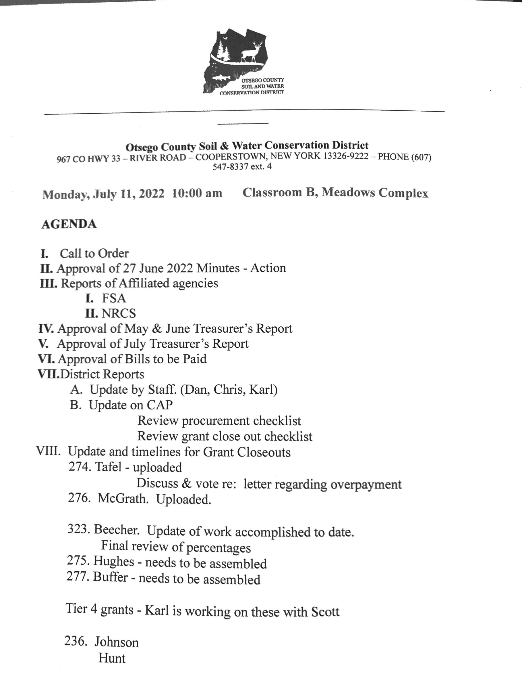
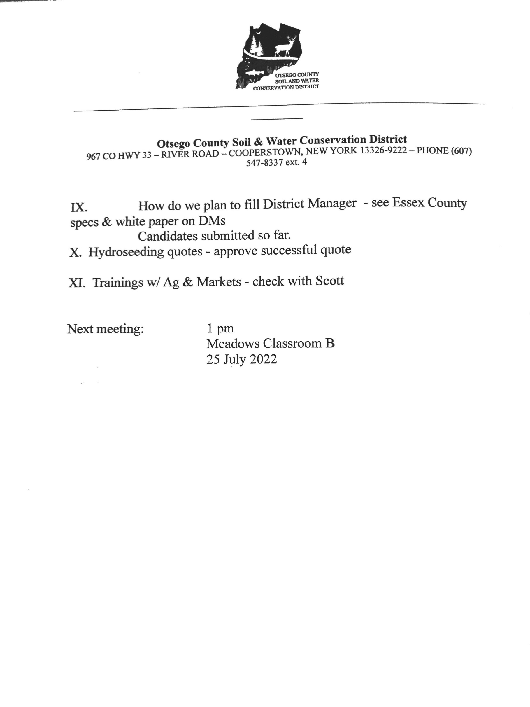

June 2022 Forestry Report
June 2022 centered most of the work on Chase Memorial Forest. Work was hampered due to lack of a vehicle as the ford ranger was inoperable. Where possible, individual stands were appraised for marketable Bmber. Not all stands have been appraised but Bmber has been idenBfied mostly hardwood. Coincidentally, Bmber occurrence is found in stands where the property line has not been adequately marked with the county blue blazes. Some lines have very old, infrequent blazes or paint, other stands no marking, sBll other stands have no blazes whatsoever but old stone walls with old barbed wire exist that corresponds to mapping and land glide app. It is proposed that a leJer be drawn up and mailed to the ad joiners to see if agreement can be reached on line locaBon. Where possible I have orange flagged where I believe the property line exists. I also spent work Bme on wriBng up six forestry issues that need to be addressed someBme in the future for board consideraBon. Discussed one Forestry issue with county aJorney. Wrote two arBcles that were published by the New York Forest Owners AssociaBon enBtled: AJributes of having a landowner property map and Forest Access Points to consider for landowners. Performed lawn mowing and weed whacking on the office and cabin soil and water properBes. Did recon of Arnold lake county forest for reported tree marking on county land. Took webinars and presentaBons on: Invasive species, Songy moth management, WRP, Regenerate New York Program, and SpoJed Lantern fly. Met and assisted Union College on HWA research project on county forest lands. Met with Wagner Lumber on Taylor Hill and reviewed Bmber contractual condiBons.
Daniel Zimmerman
July 11, 2022

SWCD Board of Directors’ Special Meeting July 25, 2022
In attendance:
Directors: Meg Kennedy (Ch), Helene Kraham, Jennifer Mickle, Ed Lentz (phone) District staff: Karl Jiroux Others: Scott Fickbohm
Minutes taken by Ed Lentz/Meg Kennedy.
Chair Meg Kennedy opened the meeting at approximately 1:09.
Minutes of prior meeting and Treasurer’s Report were deferred to regular August meeting.
Invoices from Royal Ford ($1,772.72), Insero ($8,000, $5,000) and the county ($58) were discussed. Jennifer noted that Insero’s estimate was $10K and that we still hadn’t received a final report. Ed opined that at this point a final written report is unnecessary and, in any event, that we shouldn’t pay more for a final written report. All vouchers (6 to 16) and invoices were circulated for review by the board.
Meg confirmed that the district received the Part A and Part C money from AGM and reviewed progress on the CAP. Ed & Meg, with Karl, used the closeout checklist on the McGrath closeout and made a few changes to the checklist; we have a SOP for auditing bills; we have a the procurement checklist that seems to work well.
wrt Closeouts, we’re still waiting to hear from Tafel after Meg sent him an email regarding the district’s intention not to seek payments from the landowner.
We received an email from AGM re: McGrath. It appears that AGM agrees with the bottom line amount but has made the following requests with a due date of August 5:
- Please provide a more detailed Final Report Narrative that explains what was accomplished through this grant and what occurred throughout the administration of this grant. The narrative should include an explanation of how the overpayments happened.
- The Final Report Narrative and Checklist are both signed by Jordan. These will need to be signed and dated by the Board Chair.
- The Interest Report provided is dated 6/21/2021 and the scan is difficult to read. Please provide a current interest report. If the interest amount has changed, please update the Claim for Payment – Returned Funds Cover Sheet.
- Please provide the first page of the Procurement Form. If you need a blank copy of the form please let PJ or Scott know and one of them can provide it to you.
- Procurement Form signed by Jordan on 5/31/2022. This will need to also be signed and dated by the Board Chair.
- We can confirm that the SWCD owes $87,509.82 back to the Department (this amount may change based on the current interest report). If the District is unable
to return this amount as a lump sum, please submit a letter to the Department requesting that a repayment plan be established.
Meg will begin to revise the narrative using the grant application and/or District-AGM contract, will countersign and date documents signed by Jordan, and will draft a letter requesting that repayment be deferred until the remaining closeouts are completed and the district receives reimbursements from AGM. Regarding the interest payments and report, we can run a new report and may have to update the CFP. Scott can provide a blank page 1 of the Procurement Form. We will do our best, and we expect to be able, to respond by August 5.
Beecher is nearly complete. Meg will prepare a fresh cover letter and will sign that letter and the CFP. She will also beef up the narrative in light of AGM’s requests discussed above and will ensure that any docs signed by Jordan are countersigned by her.
Meg reported that she discussed Buffer and Hughes with the staff at her weekly staff meeting that morning. Numerous documents and verifications are required for Buffer and Karl is helping to collect them. The district still owes reimbursement money to Seamon. Karl is just beginning to work on Hughes.
We need canceled checks from Johnson. Meg will send a letter.
The board reviewed a procurement checklist for Hunt and on motion by Helene seconded by Jennifer unanimously approved payment of $22,724.62 to Hunt, this amount being the contract percentage (87.5%) of the total cost ($25,971).
Meg went through all of the vouchers and invoices one by one after which, on motion by Helene seconded by Jennifer the board unanimously approved payment of all 11 invoices except that Insero would only be paid for its $8K invoice, Meg or Ed will speak with Insero about reducing the fees to $10K, and Meg will speak with Allen Ruffles about the county invoice.
Scott reported that Oneida County has offered to help the district.
At approximately 2:08, a motion was made by Helene seconded by Jennifer to go into executive session to discuss matters leading to the appointment of a particular person(s) with Scott being in attendance. The board exited the executive session at approximately 2:45.
The meeting was adjourned at approximately 2:50.
Next Meeting: August 8, 10:00am, The Meadows, Classroom B.

