SWCD Board of Directors’ Meeting February 4, 2022
Meeting called to order at approximately 1:00pm.
In attendance:: Meg Kennedy (Ch), Jennifer Mickle, Darin Hickling, Helene Kraham,
Doris Moenich, Ed Lentz, Jordan Clements, Scott Fickbohm, Larry Underwood, Kyle
Buel, Jay Czerniak, Patrick Emerick See, agenda, attached.
Larry, Kyle and Jay gave updates on the closeouts they are working on for us.
I.
Beecher (323): The reason for a questioned fund transfer was explained. See, attached portion of letter from SWCD. CFP submitted; understood that no action can be taken on the CFP until close-out is submitted.
Tafel (274): Landowner sig - Karl is going out on Tuesday; CFP sent back to Jordan b/c interest was put in wrong cell; Jordan will prepare a new form for signature by Ed, as Treasurer.
McGrath (276): Tom is coming in Wednesday. Procurement amount differed from contractor quote (Don Burton); Kyle contacted Don who said he will get back to him. Cover letter will be drafted after discussion w/ McGrath; the purpose of the letter is to explain how the district will repay the state.
II.
Hughes (275) and Buffer (277): Del Co s waiting for docs from Jordan. Jordan will scan and send them on Monday, 2/7.
AEM Johnson (236): BMP cert form completed; price solicitation record signed; contractor was paid so we need to reimburse Josh Johnson; Meg suggested we defer board approval until regular meeting. Ed requested a brief summary of each grant; PJ suggested that we look at SW3 (AgNPS, or Implementation budget form for AEM). AEM Hunt (236): Need a justification on the price; quote was $24,450; invoice was for 25971; difference may be b/c of an additional hydrant but need to confirm and need for Jeannine to certify, otherwise the overage would have to be covered by the landowner.
Scott reminded the board that the AEM projects are part of a larger project that includes technical assistance, staff time for which is normally reimbursable.
III.
The board was not aware that the contract extensions had been submitted.
Young (972): Larry is still doing some homework; so far, it looks like they do need another storage but he hadn’t yet come to that conclusion when the extension requests were sent in. Going forward would require tight coordination with NRCS. The farmer wants us to go ahead.
Scott suggested we look at our agreement to see what it says, if anything about a request extension being required. Meg questioned if the fact that the contract has not moved forward means the landowner did not do what needed to do. Larry said the storage may be required for his CAFO permit. Scott cautioned that even with an extension, it may not be feasible to complete the project. Larry suggested a meeting with all interested parties there to make sure everyone is on board - NRCS, Young, SWCD, CAFO Planner.
Tauzel (382): Larry questioned how $7,800 was spent given that the project wasn’t started. Jordan said the project has not gone forward b/c of recent transitions. Trout Unllmited has offered money. Jordan has no idea about how the $7,800 was spent. Scott suggested that if we go forward with an extension request, we should include details, e.g., who’s going to plant, where will the trees come from, etc. and suggested we should have a contractor selected. There was discussion about timing, which would be very tight with respect to both submitting the extension request and, if it’s granted, getting the work done. Jordan said there is not a lot for District to do; ot’s basically a passthrough.
Ed moved to withdraw the board’s approval of extension of Tauzel grant and to allow the contract to expire. Second by Doris. Passed unanimously.
Angelica’s contract will be discussed at the regular February meeting on 2/18.
Meeting was adjourned.

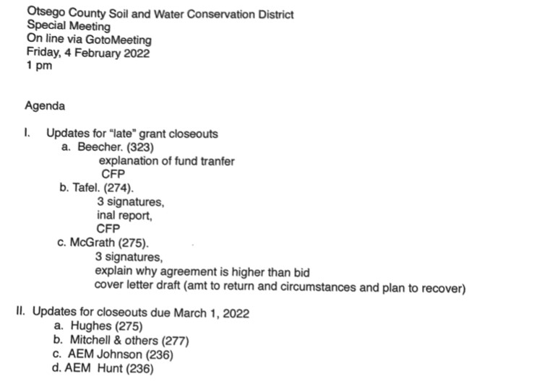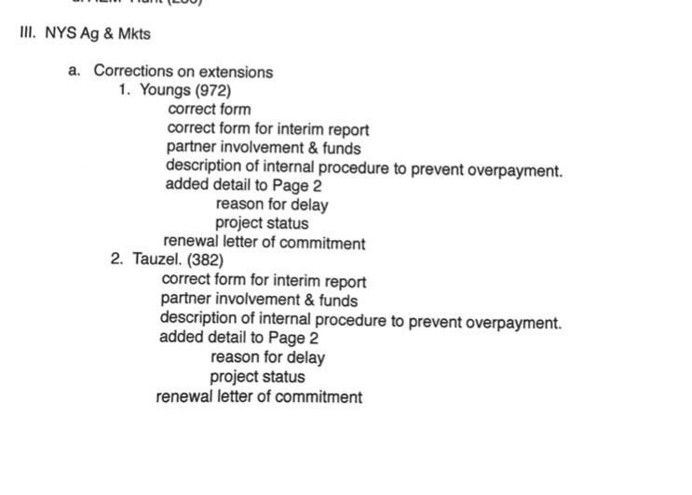
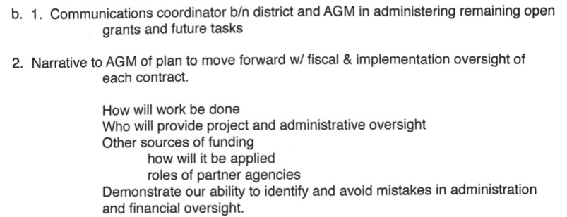
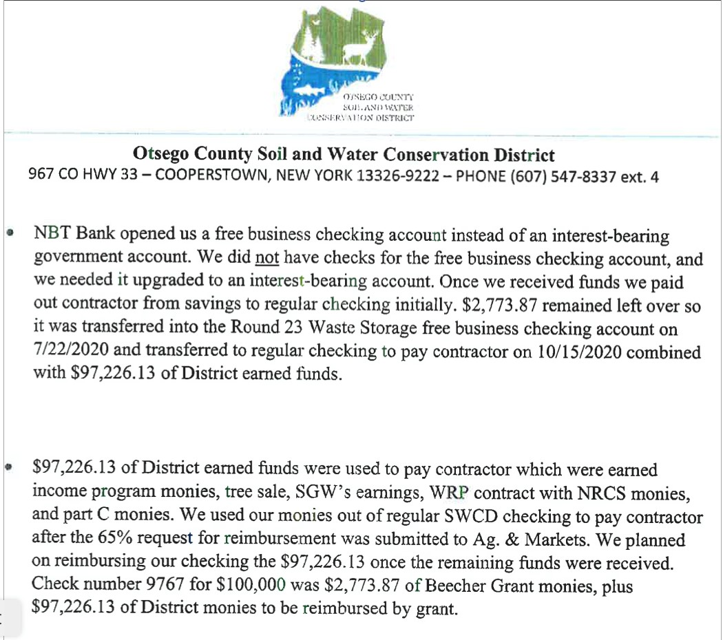

SWCD Board of Directors’ Meeting February 18, 2022
Meeting called to order at approximately 9:00am.
In attendance:
Directors: Meg Kennedy (Ch), Jennifer Mickle, Darin Hickling, Helene Kraham (late),
Doris Moenich, Ed Lentz
District staff: Jordan Clements
Others: Scott Fickbohm
Attending On Line: Larry Underwood, Kyle Buel, Jay Czerniak, Tony Capraro
Minutes taken by Ed Lentz.
Regarding the grant close outs that Del Co is helping us with, Larry, Kyle and Jay reported that reviewing our documents and preparing required submissions is a slow and arduous process, more difficult than they expected and it is taking longer than it does when they are working with their own files.
With regard to teach of the close outs:
Beecher (323): CFP, cover letter and closeout package was uploaded to Sharepoint on 2/17; DelCo believes this one is now complete and ready for AGM review.
McGrath was supposed to come to the office on Thursday, 2/17, to bring copies of canceled checks to Burton and to sign the Farm Expenditure form needed for closeout. Jordan had a pre-meeting with him the day prior, at which Jordan told McGrath what we need, including that we need him to sign docs. Following the pre-meeting, the meeting was postponed until Wednesday, 2/23, 9:00am, at McGrath’s request. Jordan told McGrath that Wednesday, 2/23, is a deadline. Chairwoman Kennedy plans to attend that meeting.
Larry will draft a letter to AGM for OC review and submission with the McGrath close-out package, explaining how the money we hope to get from the Beecher grant will be used to pay money owed to AGM on the McGrath grant. This explanation alone may not be enough for AGM to release funds to OC as there are other actions called for in our CAP.
Tafel (274): In a recent discussion between Karl and Tafel, Tafel said he does not agree that there was an overpayment. Karl/Jordan is arranging for him to come to the office to discuss this further and to ask him to sign the required docs. Chairwoman Kennedy plans to attend that meeting which hopefully will be on Wednesday.
Hughes (275) & Buffer (277): Jordan reported that he sent complete close out packages to Del Co on 2/17, except for an engineering sign-off on the Hughes project that he is pursuing.
Johnson (236): Del Co said they appear to have everything but for the checklist, which Jordan said he would send promptly.
Hunt (236): Del Co requested four items of which two have been received. Need justifications for why an expected bid was not received and why there was an invoice for $1,521 over the original quote. The extra hydrant does not explain the overage.
Young (972): Young does not want to proceed. This grant will expire and received funds will be returned to AGM.
Tauzel (382): This grant will expire and received funds will be returned to AGM. Work with NRCS will proceed.
Larry recommended that whenever an invoice amount is going to differ from a bid amount, the modification should be agreed on and documented in advance. This practice was added to the list of policy/procedure changes that OC has or will be adopting.
The Del Co team signed off after the discussion of the close outs.
Tony Capraro gave a report on NRCS activities. NRCS is working on EQIP apps; ~30 apps this year; wide range of types of projects, e.g., farmstead, forestry, habitat, and high tunnels. Staff comes into office when needed but no more than 75% at one time; may re-open fully on 5/28. Tony signed off shortly after giving his report.
Jordan gave a District Manager report. With regard to Covid, the district is following USDA’s policies, including no more than 75% in office at same time. Dan and Chris are in the forestry cabin on alternate days.
Five year forestry contract expires 12/31/22. Under the current contract, the county pays the district $45K/y, provides a truck, and leases the cabin to to us. The county maintains the cabin and pole barn but we pay electric and maintain the landscaping. Possible terms for a new contract were discussed. We may ask for up to $60K, instead of $45K, and for a percentage of logging revenue, e.g., 6% (which is what the county gave us for a logging contract that netted $318K) or higher.
Jordan is arranging a meeting with Nature Conservancy to discuss carbon credits. The advantage of selling carbon credits to them is that we would have a consistent annual revenue. The disadvantage is that there would be a cap on the dollar value of logging per year. Putting out a RFP for carbon credits was discussed.
Payment of $14,525 to engineer for Johnson (236) was discussed and approved after review of the checklist and supporting documentation. It was noted that this is the first time the board has used the new checklist; the board should receive the checklist prior to board meetings to have time to review them before the meeting; the checklist will be modified to add spaces for date, month and year of signatures and to add sig lines for at least two directors other than the Treasurer.
Jordan will send a .doc file of the checklist to Ed.
Envirothon will be in person. Six schools responded. Date will probably be May 3 or 4.
DASNY SAM grant for excavator is moving forward. The grant was previously awarded in the amount of $250K. If we get the grant and the excavator, it would be used for the stream program if that program gets off the ground. In the meanwhile, we would loan it to towns and villages. The need to ensure that the uses of it by the municipalities is in accordance with plans pre-approved by the district. The county will transport the excavator for us and maybe for borrowing municipalities. County attorney should be consulted about an inter-municipal agreement and about insurance and liability.
The district will hold stream restoration training by June as per a grant.
Ed’s email of 2/17, attached, was discussed. Jordan summarized the annual reports that were submitted. A 60 day extension was obtained for submission of our annual treasurer’s report (after the report was submitted and recalled) because our bookkeeper has not yet completed the year end review and because Ed had not had sufficient time to review the report and has questions about it. Jordan could not explain what the $25K transfer was but it might have been to put money into the checking account so bills could be paid. Angelica is running the usual finance reports and we will have them for the March meeting. Jordan will provide the missing bank statements. There are ongoing problems with service fees being charged by NBT; Jordan will have the charges reversed. The need to develop a budget was discussed.
A motion was made, seconded and approved unanimously to approve the bills to be paid.
Progress on the CAP was discussed. Insero, who was previously sent files for review, will be in next week to begin the audit. They will be doing a financial audit and they will be reviewing and recommending policies and procedures. The board will put the various policy and practice changes that have been discussed into formal policy documents.
Scott recommended that we undertake efforts to make the community aware of the AEM Tier IV grant to try to ensure that persons who benefit from it have a chance to participate. We should also have an objective ranking process to ensure fairness and transparency. The district will not put in for district staff time until we are back in good standing with NYS.
Doris inquired about mileage reimbursement and meeting stipend (if any) for 2021.
A motion to go into executive session to discuss the financial history of a particular person wrt to a landowner with whom the district has a relationship was made by Ed, seconded by Jennifer and passed unanimously.
Following a motion to end the executive session that was approved unanimously, the regular meeting resumed.
A motion was made, seconded and approved unanimously to approve the bills in the “aging” list except for the NYS retirement payment (~$42K).
There follow brief further discussion about the grant projects and about Jordan’s performance review, after which a motion was made and passed unanimously to go into executive session to discuss employment, promotion, demotion, discipline, suspension, dismissal or removal of a particular person.
Following a motion to end the executive session that was approved unanimously, the regular meeting resumed.
Jordan will do what needs to be done to remove Jessica Miller from our health insurance plan, based on Jessica’s notice that she has coverage with her new employer.
Jordan’s performance review will be taken up at a special meeting on March 4 at 1:00pm in Classroom B. Jordan will give notice via the website and the Daily Star Community Events.
The meeting was adjourned shortly before 1:00pm.

