8/8/22 Approved, 9/12/22
SWCD Board of Directors!"Meeting August 8, 2022
In attendance:
Directors: Meg Kennedy (Ch), Helene Kraham, Jennifer Mickle, Ed Lentz (phone)
District staff: Karl Jiroux, Chris Andreassen Others: Scott Fickbohm
Minutes taken by Ed Lentz and Jennifer Mickle.
Chair Meg Kennedy opened the meeting at approximately 9:15.
Board went into executive session to discuss matters leading to the appointment of a particular person(s) with Jenna Utter being in attendance. Executive session closed at approximately 10:00.
Minutes of July 11 and July 25 meetings approved. Helene moved, Jennifer seconded Treasurer’s Report deferred.
Staff reports presented by Karl Jiroux and Chris Andreassen following which, Chris left the meeting. A copy of Chris’s written report summary is appended hereto.
Grant close-outs were discussed. Beecher was uploaded. Responses to AGM requests re: McGrath of 7/25 are in progress; a letter addressing the repayment of overpaid amounts to AGM and an updated interest statement are needed. A letter confirming that the district will not seek payments from Tafel was sent; we expect him to sign the FES soon. Johnson/Hunt was submitted. Buffer/Hughes are getting started. Correction of the Young’s Dairy’s 1099 is in progress.
There was discussion about have a complete financial audit done. To date, we had a review done by Insero of the Tafel, Beecher, and McGrath closeouts and the NYS Comptroller is auditing our financial management procedures (during which the auditors are looking for and identifying apparent discrepancies and abnormal transactions). A decision on undertaking a full financial audit was deferred until we gain confidence that the district has sufficient funds to pay for it.
Ed left the meeting at approximately 11:0am.
A motion by Darin seconded by Helene to approve paying the bills was discussed and approved subject to confirming the cleaner bill before paying it.
Scott reminded the board that AGM had asked for a single point of contact other than Jordan. The board confirmed by consensus that the contact person is Meg. In response to comments by Scott regarding McGrath, the board confirmed that getting it closed out is a high priority.
Page 1 of 2
8/8/22 Approved, 9/12/22
Scott also reported that the suspension of the in person meeting requirement of the OML has been extended; there is a video link for observers to “attend” State Committee meetings. Scott also discussed upcoming state committee meetings, landowner agreements, Climate Resilient Farming (CRF) agreements, and farmland protection grants.
Scott also confirmed that at the August 22 meeting of the district board, P.J. Emerick will
present the SWCD training module entitled,“District Director Roles and Responsibilities.”
A motion to adjourn was made by Darin and seconded by Helene and passed unanimously. The meeting adjourned at 11:23.
Next Meeting: August 22, 1:00pm, The Meadows, Classroom B.
Page 2 of 2

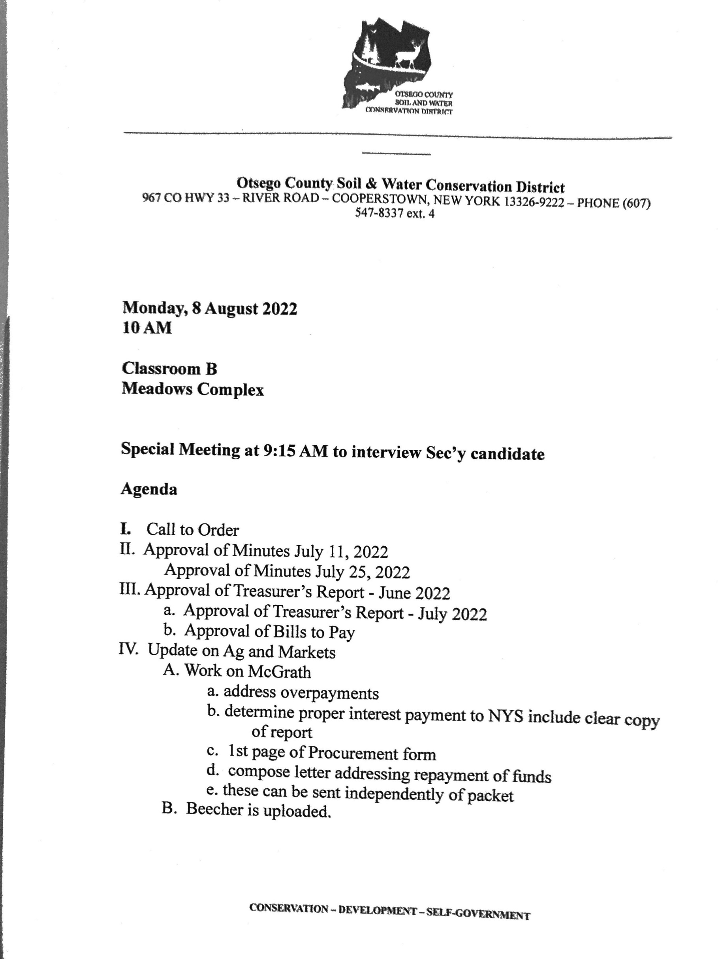
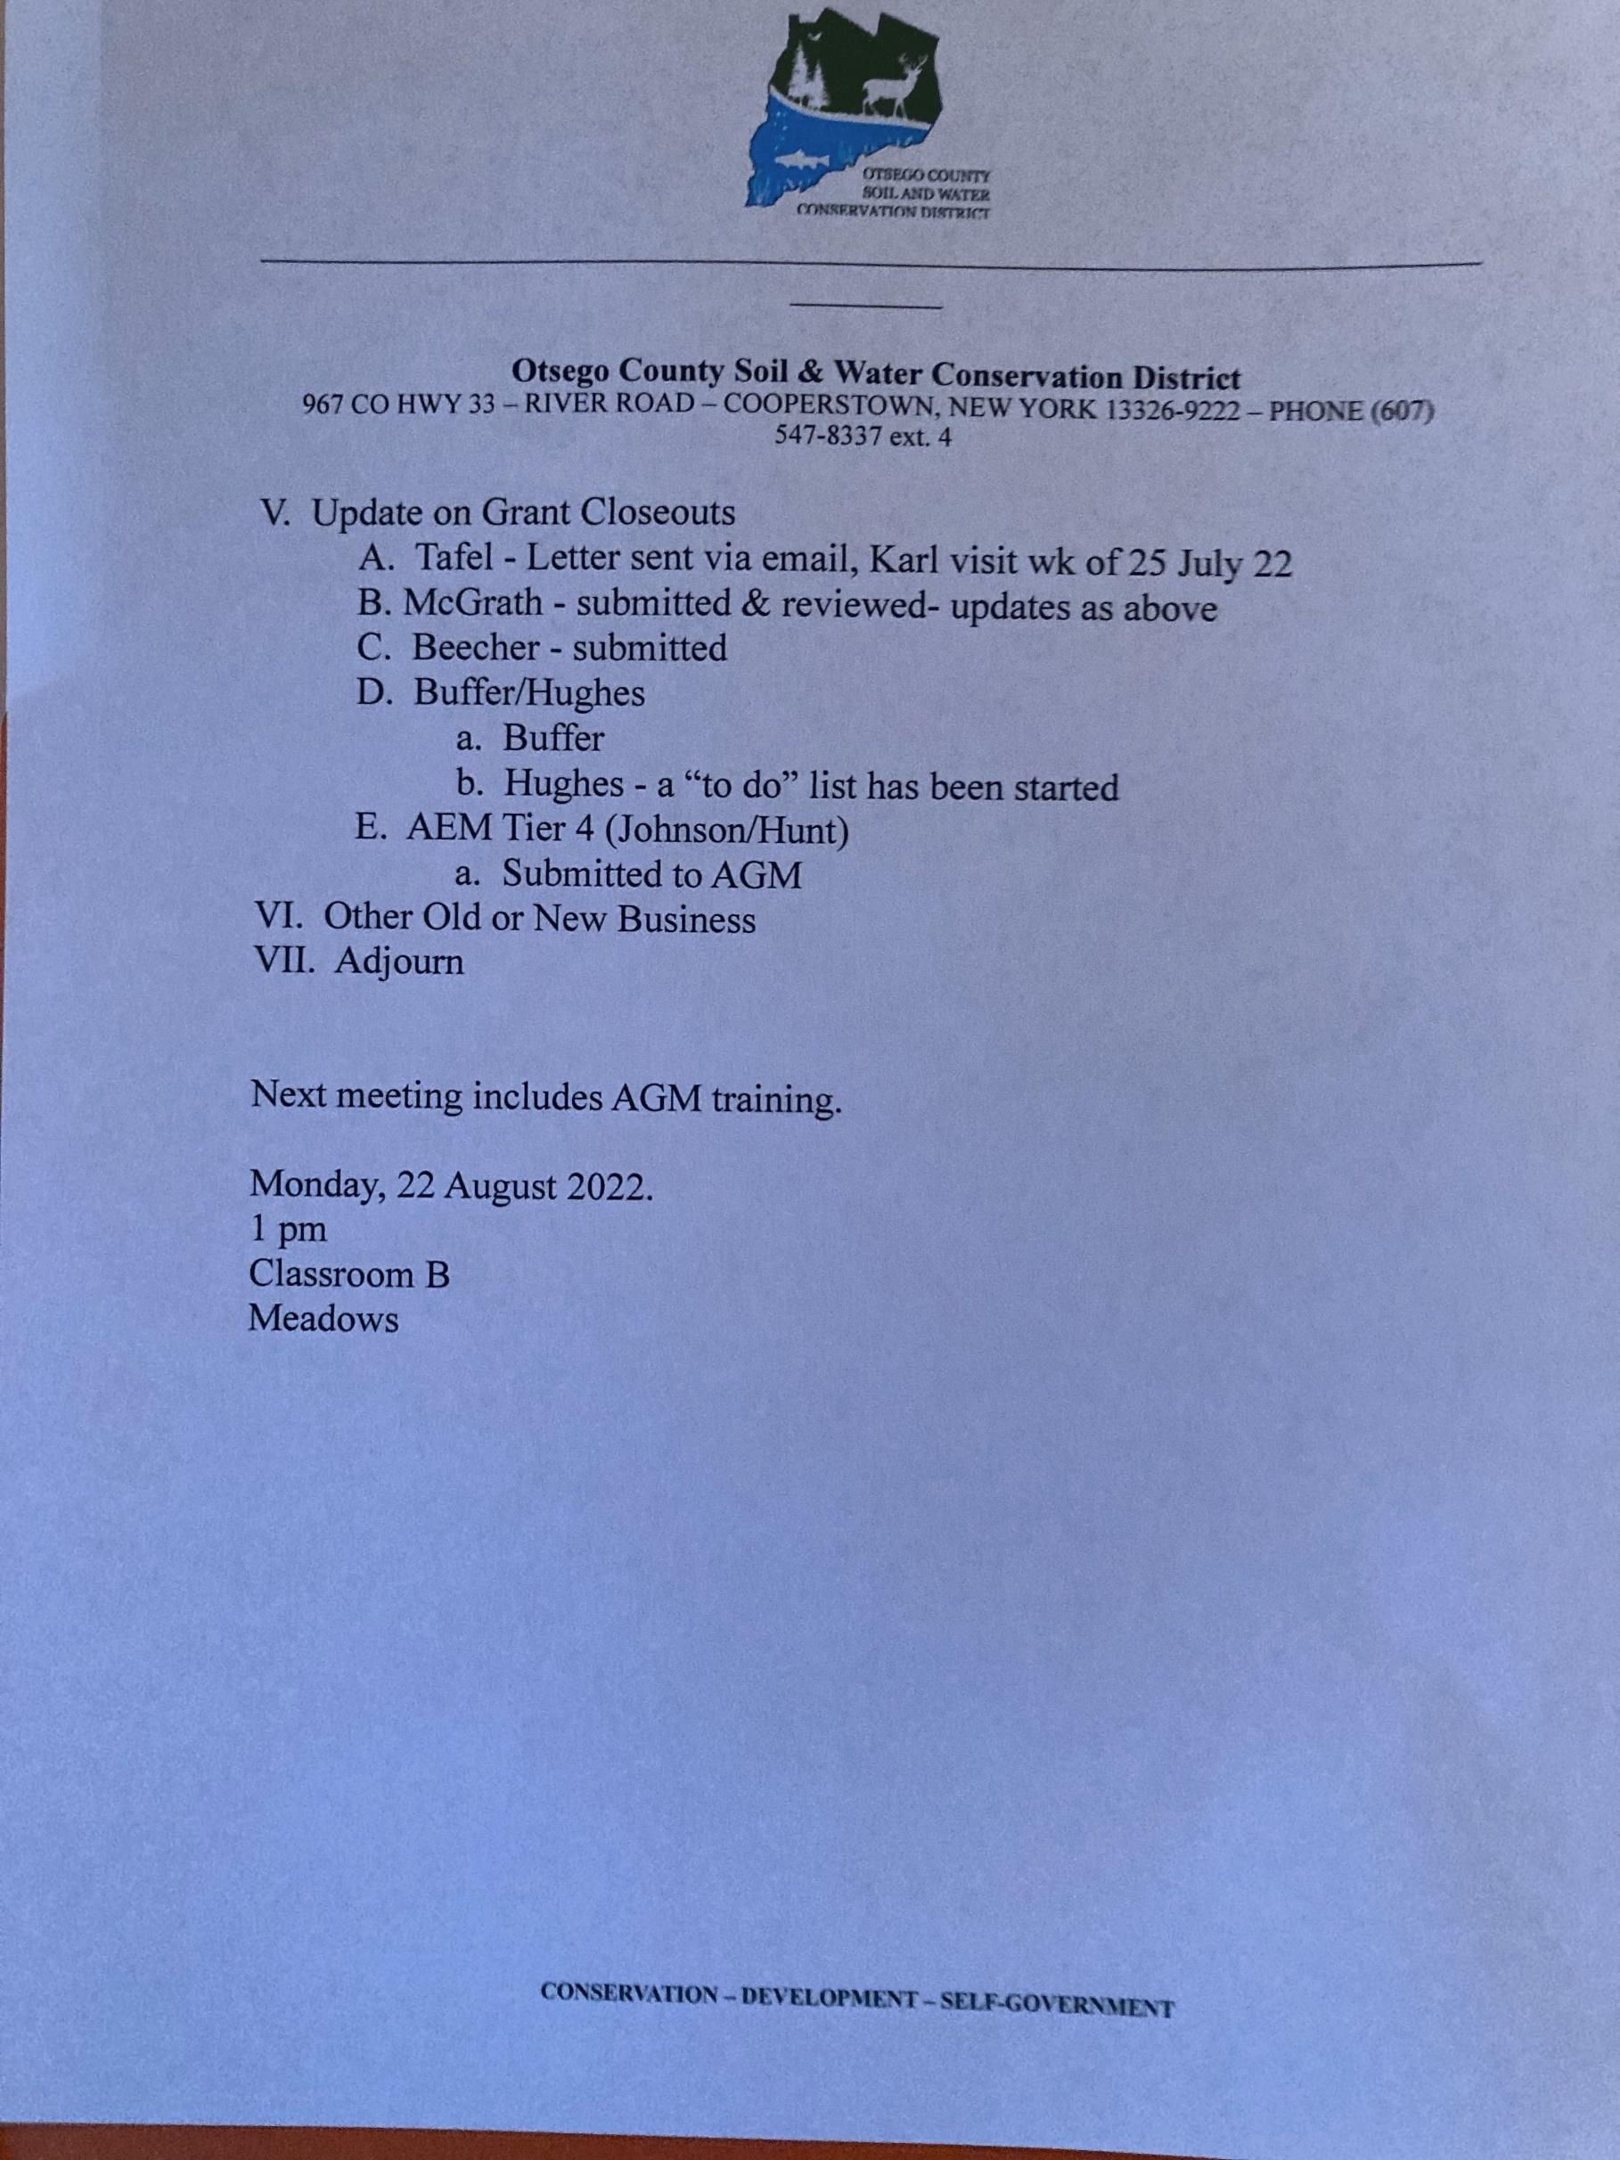

_________________________________________________________________________________

Otsego County Soil & Water Conservation District 967 CO HWY 33 – RIVER ROAD – COOPERSTOWN, NEW YORK 13326-9222 – PHONE (607) 547-8337 ext. 4

Chris Andreassen
Board Report
7/12-8/4/2022

Vacation (7/18-7/21)

WRP Contribution agreement:
- Completed WRP map PDFs, files downloaded/transferred to NRCS
- Data entry/WRP maps/photo waypoint spreadsheets for WRP’s monitored by Dan;
  - Rackmyer (7.12 Acres)
  - Harrington (5.01 Acres)
  - Hazzard (8.27 Acres)
- JGB Properties On-site WRP monitoring (82.2 Acres-16 hrs)
- Schanz On-site WRP monitoring (34.45 Acres-12 hrs)
- King/Beckingham WRP monitoring (159.57 Acres-16 hrs)

USC BMP Verification:
1. 20 updated/additional Farm BMP verifications

AEM #077-0536 CNMP:
- Conservation Plan (continuing)
- BMP Implementation Schedule (continuing)
- Animal Waste Management Plan (manure storage facility design)
- Manure Spreading Setback Map

Trainings:
1. 2022 Sustainable Agronomy Conference; (Certified Crop Advisor continuing education)
  - Utilizing Precision Agriculture for Sustainable Crop Management (2 hours)
  - Enhancing Sustainability through On-Farm Research and Metrics (2 hours)
  - Building Soil Health with 4R Nutrient Management (2 hours)

AEM Outreach:
1. County Fair booth
CONSERVATION – DEVELOPMENT – SELF-GOVERNMENT

SWCD Board of Directors’ Meeting August 22, 2022
In attendance:
Directors: Meg Kennedy (Ch), Helene Kraham, Jennifer Mickle, Ed Lentz, Darin Hickling District staff: Karl Jiroux
Others: Scott Fickbohm, P.J. Emerick
Minutes taken by Ed Lentz. Agenda is attached.
Chair Meg Kennedy opened the meeting at approximately 1:05.
Meg reported that Jenna Utter appears ready to accept our offer of the DS position. Meg will follow up with her.
Meg introduced P.J. Emerick who presented the SWCD training module entitled,“District Director Roles and Responsibilities.” A copy of the slides is attached.
Ed reported that the minutes for the 8/8 meeting were not ready for review. There was discussion about items that were discussed and that should therefore be included in those minutes. Chris’ written report will be attached. Karl was invited to submit a paragraph summarizing his report.
Ed asked to defer review of the July financial reports because he has questions about the bank accounts. Specifically, there are no July bank statements for Balance Sheet lines 262B, 263, and 261 and the Balance sheet line 200 shows an end of July balance of $21,557.73 whereas the end of July bank statement shows $26,491.44. Ed will discuss this with Angelica and report at the next meeting.
Ed moved and Helene seconded a motion to sweep money from accounts on Balance Sheet lines 255, 257, 259, 261, and 263 into the checking account (line 200) and to close those five accounts, after confirming that these projects are all closed. The motion was discussed and was then passed unanimously.
There was discussion about the practice of making payments for all grants out of the district checking account and transferring the money from the grant accounts into the checking account. Karl reported that we have checkbooks for most if not all of our checking accounts and that the NYS Comptroller’s Office auditor recommended that we pay direct from each grant checking account. After discussion, it was agreed that we should pay directly from each grant account whenever possible.
Meg is in discussion with Allen Ruffles about how to handle the two 3d quarter payments that we received from the county.
Jennifer moved and Darin seconded that we pay the NYS retirement bill as soon as practicable. The motion was discussed and was then passed unanimously.
With regard to aging receivables, Ed will check with OCCA to see if they can explain a receivable from them in the amount of $910.16. Karl is trying to track down an explanation for the receivable from Jordan Brothers in the amounts of $4,961.50 and $402.50.
With regard to unpaid invoices for ag assessments, we will create a list of persons who have unpaid invoice and refuse services in the future until those invoices are paid. Going forward, we will do ag assessments in person and collect the fee at that time but will allow remote assessments in exceptional cases if the landowner pays up front.
Grant-Close-outs:
McGrath: all requests by AGM were completed except for the determination of interest which Karl now has
Beecher: completed and submitted
Johnson/Hunt: completed and submitted; check cut for Hunt; Johnson was already paid; Scott will send a revised form to Karl
Buffer (277) - Seamon is mostly done; Jordan Bros has had substantial progress; Mitchell (Curtain Bros) is still in early stages
Tafel - FES submitted; expecting AGM letter closing it out
AEM C012384 - Rd 17 2022-23: $230,000: Helene moved and Jennifer seconded to authorize submission of a first claim for payment (25%); The motion was discussed and was then passed unanimously. Karl will give a report each month on hours spent on AEM work
Bills with vouchers were reviewed during the meeting. Meg prepared an abstract (#1) listing all bills, which totaled $956.32. A motion was made by Jennifer and seconded by Darin to pay the bills, which totaled $956.32. Following discussion about two of the payments being less than the total billed because the bills included charges already paid) the motion passed unanimously. Jennifer will enter the payments into QB tomorrow and Karl will print them out for Meg to sign.
Helene asked about the corrected 1099 for Young’s Dairy. Meg reported that Angelica sent the required paperwork to the IRS so it is out of our hands.
Protocol for time sheets: it was agreed that the DS will bring time sheets to the board each month for board approval.
Helene suggested we consider hiring a cleaner so we can be sure we are meeting the requirements of our lease with USDA. Meg will obtain a copy of the lease, after which we can discuss what we need to do to ensure compliance.
Scott discussed various items from the most recent SWCC meeting including:
Suspension of the Open Meetings Law requirement for in persons meetings is continued until 9/12
Greenfield Farms received the Leopold award ($10K, plus $1K for nominator); the award is made annually to reward particularly environmentally concscious farm operations. Scott encouraged the district to make a nomination in 2023
The state committee annual report is available; Ed will forward Blanche’s email of 8/8 with the report
The district 2023 annual plan of work is due November 1
Performance Measures: Scott reminded us that we should be tracking our progress towards achievement of the performance measures. Karl will send them out by email
NYACD meeting - 10/18-19
Training plan: each director should have a training plan; we should be able to cite to the plans when we report on training that we have had. Scott agreed at the request of the board to present the SWCD training module on District Law Training on 9/26 at 1:00pm
Registration for technician training: see attached
Scott advised us that other districts use MS Access or other time-keeping s/w, which makes it easier to sort and report on hours spent on specific matters. He also suggested that we invite NRCS and FSA reps to our meetings to report generally (which we usually do) but also to talk specifically about projects that we are collaborating on: time sheets. Scott is helping Karl with the Buffer (277) close-out.
There was discussion about the two board vacancies. Meg will ask Dave Bliss to put appointment of Doug Roberts (Grange) and Leonard Croote (Farmer) to the board.
District Law requires the following:
- two members of the county board
- three practical farmers. One grange, one farm bureau which they serve.
- one at large (representing the urban, suburban and rural non-farm landownership interest - one at large.
At about 4:00, Meg moved and Jennifer seconded to enter into executive session to discuss the matters leading to the appointment, employment, or promotion of particular persons, which motion was approved unanimously.
Scott, P.J. and Karl left the meeting
The Executive Session ended at about 4:15 on motion by Meg, seconded by Ed and carried unanimously.
With regard to the DM position, it was agreed that the board would conduct personal interviews with Dan, Karl, and Chris and with the candidates from Texas and Hamilton County. The candidate from Texas will be invited to interview via Zoom. Meg will talk to Vic Jones and Brian Pokorny about videoconference capability. The interviews will start at 8:30. Meg will ask Karl to publish notice of the early start time.
The meeting was closed on motion by Jennifer, seconded by Helene and carried unanimously at about 4:40.
Next Meeting: 9/12, 8:30.

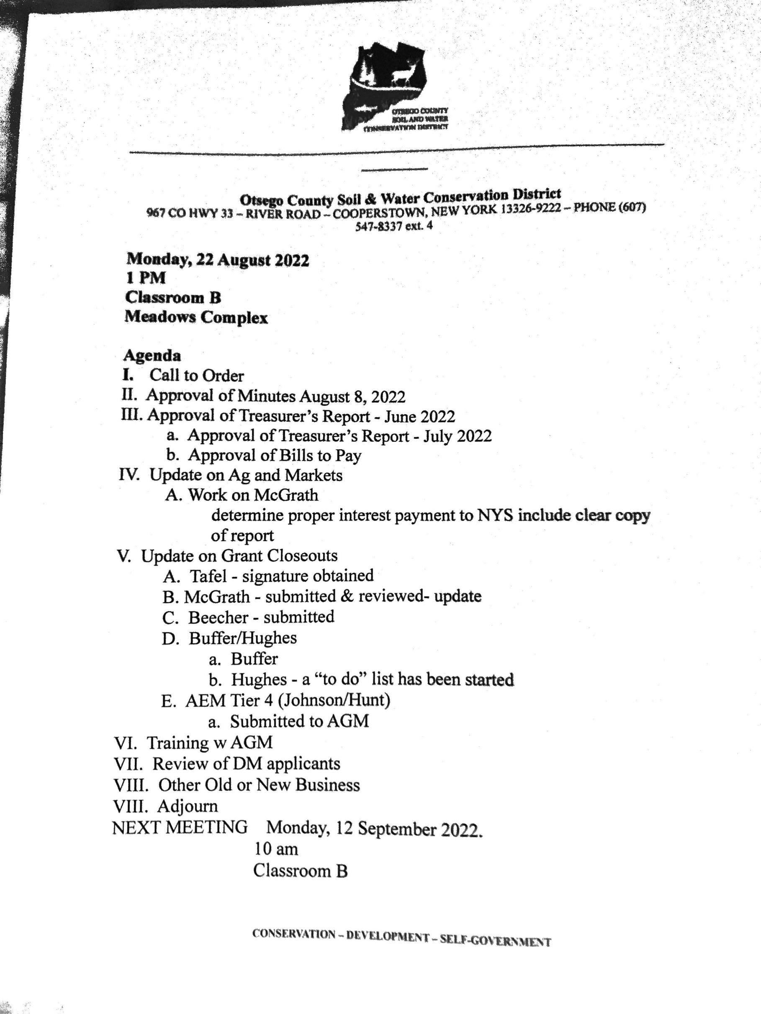

9:11 PM

08_{/19/22} A/P Aging Detail
As of August 19, 2022
Type Date Num Name Due Date Aging Open Balance
Total Current  1 - 30 |  |  |  |  |  | 733.00
Bill | 08/08/2022 |  | NYS Child Support Processi... | 08/18/2022 | 1 | 370.00
Total 1 - 30  31 - 60 |  |  |  |  |  | 370.00
Credit | 07/07/2022 |  | The Water Bottle |  |  | -22.00
Total 31 - 60  61 - 90 |  |  |  |  |  | -22.00
Bill Pmt -Check | 05/23/2022 | 9896 | Excellus BlueCross BlueShi... |  |  | -1,169.05
Total 61 - 90  > 90 |  |  |  |  |  | -1,169.05
Bill | 12/01/2021 |  | New York State & Local Ret... | 02/01/2022 | 199 | 42,747.69
Bill Pmt -Check | 05/20/2022 | 9895 | United Concordia Companie... |  |  | -0.05
Current
Bill
08/16/2022
C-256...
Voss Signs
08/26/2022
733.00
Total > 90
42,747.64
42,659.59
TOTAL
9:09 PM | Otsego County Soil & Water Conservation District
08/19/22 | A/R Aging Detail
As of August 19, 2022
Type
Date
Num
P. O. #
Name
Terms
Due Date
Class
Aging
Open Balance
Current
Total Current
Invoice | 07/28/2022 | 3997 |  | Justin Ostrowski |  | 07/28/2022 | 22 | 225.00
Total 1 - 30  31 - 60 |  |  |  |  |  |  |  | 225.00
Invoice | 06/22/2022 | 3994 | 2022 BMP Verifications | Upper Susquehanna ... | Due on re... | 06/22/2022 | 58 | 28,000.00
Invoice | 06/22/2022 | 3995 |  | Wilber, Daniel G. |  | 06/22/2022 | 58 | 190.00
Payment | 06/30/2022 | 043158 |  | Otsego County Treas. |  |  |  | -52,500.00
Invoice | 07/20/2022 | 3996 |  | Siddiqui, Mustafa |  | 07/14/2022 | 36 | 325.00
Total 31 - 60  61 - 90 |  |  |  |  |  |  |  | -23,985.00
Invoice | 06/08/2022 | 3989 |  | Miller, Marilyn |  | 06/08/2022 | 72 | 35.00
Total 61 - 90  > 90 |  |  |  |  |  |  |  | 35.00
Invoice | 02/24/2020 | 3762 | 3762 | OCCA | Due on re... | 02/24/2020 | 907 | 910.16
Invoice | 04/22/2021 | 3875 |  | Albert Pope | Due on re... | 04/22/2021 | 484 | 35.00
Invoice | 06/03/2021 | 3887 |  | Jordan Brothers | Due on re... | 06/03/2021 | 442 | 4,961.50
Invoice | 06/21/2021 | 3890 |  | Jordan Brothers | Due on re... | 06/21/2021 | 424 | 402.50
Invoice | 10/18/2021 | 3916 |  | Liz Monaco |  | 10/18/2021 | 305 | 35.00
Invoice | 10/18/2021 | 3917 |  | Jesse Brown | Due on re... | 10/18/2021 | 305 | 75.00
Invoice | 10/26/2021 | 3919 |  | Tom Simonds | Due on re... | 10/26/2021 | 297 | 35.00
Invoice | 12/06/2021 | 3923 |  | Saunders, Carlton K. ... | Due on re... | 12/06/2021 | 256 | 70.00
Invoice | 12/06/2021 | 3924 |  | Andrew Timmerman | Due on re... | 12/06/2021 | 256 | 35.00
Invoice | 12/07/2021 | 3926 |  | Mervin Byler | Due on re... | 12/07/2021 | 255 | 385.00
Invoice | 01/21/2022 | 3929 |  | Lojac, Vincent J |  | 01/21/2022 | 210 | 35.00
Invoice | 02/28/2022 | 3940 |  | Woerler, Judith |  | 02/28/2022 | 172 | 35.00
Invoice | 02/28/2022 | 3952 |  | Stevenson, James |  | 02/28/2022 | 172 | 70.00
Invoice | 02/28/2022 | 3955 |  | Flynn, Jeffrey |  | 02/28/2022 | 172 | 70.00
Invoice | 02/28/2022 | 3958 |  | Stroh, Leslie |  | 02/28/2022 | 172 | 35.00
Invoice | 04/06/2022 | 3979 |  | Landis, Theirry |  | 04/06/2022 | 135 | 35.00
Invoice | 04/06/2022 | 3980 |  | Wing, Marilyn |  | 04/06/2022 | 135 | 35.00
Invoice | 05/04/2022 | 3983 |  | Ondrick, Bethany |  | 05/04/2022 | 107 | 70.00
Invoice | 05/11/2022 | 3985 |  | Cotek, Stan |  | 05/11/2022 | 100 | 35.00
1 - 30
Total > 90
7,364.16
-16,360.84
TOTAL
Page 1
08/19/22 | Balance Sheet  As of July 31, 2022  ASSETS  Current Assets  Checking/Savings  Unrestricted Funds | Jul 31, 22
 | 199 · Part C Funds | 427.69
 | 200 · NBT Checking - 0768 | 21,557.73
 | 201 · NBT Savings | 188,018.14
 | Total Unrestricted Funds  Restricted Funds  203 · Water Quality Coordinating Comm | 210,003.56
 | 203B · Buoy Fund | 4,903.50
 | 203 · Water Quality Coordinating Comm - Other | 6,797.90
 | Total 203 · Water Quality Coordinating Comm | 11,701.40
 | 204 · Leatherstocking Envir Checking | 6,951.73
 | 205 · Leatherstocking Scholarship | 5,234.31
 | 206 · AEM Checking Tier 4 C012236  Grant Accounts | 3,601.35
 | 250 · NBT Grant C701277 Buffer-22 | 176,125.26
 | 251 · NBT Grant C701275 Hughes-22 | 1,201.39
 | 252 · NBT Grant C701276 McGrath-22 | 761.51
 | 253 · NBT Grant C701274 Tafel-22 | 1,059.48
 | 255 · NBT Grant C305251 Hydro WQ | 5,824.93
 | 257 · NBT Grant C701111 Elks Crk -19 | 1,142.82
 | 259 · NBT Grant C701182 -V&M - 20 | 0.07
 | 260 · NBT Grant Ot. Cty Buffer 3 | 0.49
 | 261 · NBT Grant Ot. Cty. Buffer 2 | 8.45
 | 262B · NBT Grant C701323 Beecher New | -19.00
 | 263 · NBT Grant Round 2 CAFO | -19.30
 | Total Grant Accounts | 186,086.10
 | Total Restricted Funds | 213,574.89
 | 999 · Clearing House Account | 155.00
 | Total Checking/Savings  Accounts Receivable | 423,733.45
 | 11000 · Accounts Receivable | -16,360.84
 | Total Accounts Receivable  Other Current Assets | -16,360.84
 | Payroll Corrections | -1,246.50
 | 12000 · Undeposited Funds | 52,755.00
9:08 PM
Total Other Current Assets
51,508.50
458,881.11
458,881.11
Total Current Assets
LIABILITIES & EQUITY
Liabilities
Current Liabilities
Accounts Payable
20000 · Accounts Payable | 60,648.42
Total Accounts Payable  Credit Cards | 60,648.42
25000 · Key Bank Credit Card | 752.22
Total Credit Cards | 752.22
TOTAL ASSETS
Other Current Liabilities

9:08 PM

08_{/19/22} Balance Sheet
As of July 31, 2022
Jul 31, 22

Payroll Liabilities
414 h 1,564.51
Child Support 2,590.00 Federal Ta es -403.48 E cellus BCBS 14,763.48
A718 · State Retirement - 414 h -1,604.99
A720 · Group Insurance - E cellus BCBS -6,008.32
A721 · NYS Income Ta 374.93 A722 · Federal Income Ta 2,424.16
A723 · Income E ecutions/Child Support -1,850.00
Total Payroll Liabilities
11,850.29
11,850.29
73,250.93
Total Other Current Liabilities
Total Current Liabilities
Total Liabilities 73,250.93
E uity
32000 · Unrestricted Net Assets 393,201.13
Net Income -7,570.95
Total E uity
385,630.18
458,881.11
TOTAL LIABILITIES & EQUITY
9:06 PM

08_{/19/22} Profit & Loss
July 2022
Ordinary Income/Expense  Income  2160 · Revenue | Jul 22 | Jan - Jul 22
2160D · Other Revenue / Services | 630.00 | 855.00
2160F · District Tree Program | 0.00 | 13,745.37
Total 2160 · Revenue | 630.00 | 14,600.37
2401 · Interest | 3.90 | 45.99
2414 · Rental of Equipment  2765 · County Appropriations & Grants | 0.00 | 715.00
2765A · County Allocation Income | 0.00 | 123,750.00
2765B · County Forestry Program Funds | 0.00 | 22,500.00
Total 2765 · County Appropriations & Grants  2770 · Misc Revenue | 0.00 | 146,250.00
2770A · Ag Value - Soil Group Worksheet | 0.00 | 3,535.00
2770B · Envirothon | 0.00 | 250.00
2770D · Buoy Fund | 0.00 | 3,700.00
2770E · NRCS Rent | 4,310.92 | 30,176.44
2770F · Agency funded AEM | 0.00 | 28,000.00
Total 2770 · Misc Revenue  3989 · State Aid, Grants, Reimb | 4,310.92 | 65,661.44
3989A · NYS Part A Funding | 182,005.26 | 182,005.26
3989B · NYS Part B Funding | 6,000.00 | 6,000.00
Total 3989 · State Aid, Grants, Reimb
188,005.26
188,005.26
192,950.08
415,278.06
Total Income
Gross Profit  Expense | 192,950.08 | 415,278.06
8730.41 · Ag & Markets Repayment Expense  8730.1 · Personal Services | 0.00 | 18,824.97
0.11 · Directors Expense | 0.00 | 1,343.16
0.13 · District Manager | 8,703.18 | 46,296.96
0.14 · Conservation Technicians  0.15 · Other Employees | 11,476.80 | 81,629.36
0.151 · Forestry Tech | 5,772.00 | 28,860.06
Total 0.15 · Other Employees | 5,772.00 | 28,860.06
Total 8730.1 · Personal Services  8730.2 · Equipment | 25,951.98 | 158,129.54
0.22 · Office Equipment | 405.60 | 3,648.59
Total 8730.2 · Equipment  8730.4 · Contractual | 405.60 | 3,648.59
0.401 · Construction | 0.00 | 14,400.00
0.402 · Reforestation | 0.00 | 3,957.74
0.404 · Other | 1,540.00 | 18,523.50
0.405 · District Tree Program | 0.00 | 6,515.30
0.416 · Misc Supplies for Cons. | 0.00 | 595.37
0.421 · Payments to Cornell (soil samp) | 0.00 | 72.00
0.425 · Water Quality Committee - Buoy | 938.62 | 2,466.74
0.431 · Travel/Training exp (Employees) | 0.00 | 310.00
0.441 · Light and Heat | 0.00 | 8,126.22
0.442 · Telephone/Internet | 139.98 | 4,463.46
0.443 · Office Supplies | 80.51 | 1,226.29
0.444 · Outreach (Envirothon/Newsletter  0.450 · Insurance | 0.00 | 2,194.29
0.456 · Disability Insurance | 0.00 | 160.02
0.450 · Insurance - Other | 0.00 | 2,219.00
08/19/22 |  | Profit & Loss  July 2022
 |  | Jul 22 | Jan - Jul 22
 | Total 0.450 · Insurance  0.460 · Other Contractual | 0.00 | 2,379.02
 | 0.4601 · State & other dues | 0.00 | 1,577.71
 | 0.4605 · Grant Expenses | 6,000.00 | 131,589.18
 | Total 0.460 · Other Contractual | 6,000.00 | 133,166.89
 | 0.461 · Repairs to field equip | 0.00 | 4,330.42
 | 0.463 · Gas & Oil for machinery | 172.46 | 2,075.03
 | Total 8730.4 · Contractual | 8,871.57 | 204,802.27
 | 8730.8 · Employee Benefits  8730.90 · Fixed Asset - Building | 6,597.68 | 43,926.64
9:06 PM
8730.91 · Building Maintenance Expenses 68.71 80.69
Total 8730.90 · Fixed Asset - Building
68.71
80.69
41,895.54
429,412.70
Net Ordinary Income  Other Income/Expense Other Income | 151,054.54 | 14,134.64
5999 · Income nknown | 0.00 | 7,784.22
Total Other Income  Other Expense | 0.00 | 7,784.22
8999 · Expense nknown | 0.00 | 1,220.53
Total Expense
Total Other Expense
0.00
1,220.53
0.00
6,563.69
151,054.54
-7,570.95
Net Other Income
Net Income

2160 · Revenue
2160D · Other Revenue / Services

2401 · Interest

2770 · Misc Revenue
2770E · NRCS Rent

3989 · State Aid, Grants, Reimb
3989A · NYS Part A Funding

3989B · NYS Part B Funding

8730.1 · Personal Services
0.13 · District Manager

0.14 · Conservation Technicians

0.15 · Other Employees
0.151 · Forestry Tech

8730.2 · E uipment
0.22 · O ice E uipment

8730.4 · Contractual
0.404 · Other

0.425 · Water uality Committee Buoy

0.442 · Telephone/Internet

0.443 · O ice Supplies

0.460 · Other Contractual
0.4605 · Grant E penses

0.463 · Gas & Oil or machinery

8730.8 · Employee Bene its

8730.90 · Fi ed Asset Building
8730.91 · Building Maintenance E penses
TOTA
151,054.54
Page 3

